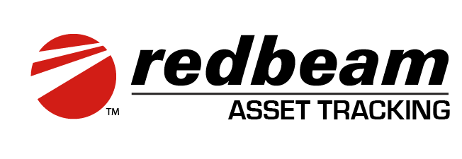

SaaS Edition
User Guide

Contents

Overview 4
Getting Started 5
Application Functions 7
Dashboard 10
Assets 11
Creating, Deleting and Editing Assets 11
Details 13
Accounting 14
Checked Out 14
Custom 15
Maintenance 15
Attachments 15
History 16
Import/Export 16
Printing Asset Labels 17
Transactions 19
Check Out 19
Check In 21
Inventory 24
Manage 24
Take 26
Reports 29
All Assets 31
Checked Out Assets 32
Checked In Assets 33
Transaction Reports 33
Inventory Reports 34
Setup 36
Locations 36
Companies 36
Buildings 37
Rooms 38
Asset Data 40
Departments 40
People 41
Projects 42
Asset Types 42
Manufacturers 43
Models 45
Vendors 45
Accounts 46
Conditions 46
Statuses 47
Custom Fields 48
Label Printing 48
Printer Setup Instructions 48
Label Templates 55
Sequential Printing 56
Caption Override 58
Users 59
API 60
Mobile Functions 61
Update 63
Details 64
Accounting 65
Checked Out 66
Custom 67
History 68
Transactions 69
Check Out 69
Check In 71
Inventory 74
Take 74
Mobile RFID Functions 78
Assign RFID 83
Update 85
Details 90
Accounting 91
Checked Out 92
Custom 93
History 94
Inventory 96
Take 96

Overview

The RedBeam Asset Tracking System SaaS Edition was designed to ensure fast and reliable collection of asset inventory data.

This is a software as a service (SaaS) application hosted by RedBeam in Google Cloud.

The full view of the software is accessed via a supported web browser through a PC, laptop or tablet and the mobile view through a handheld mobile computer or smart phone.

Using the full view, users can create assets through several means, check items in and out to users, manage inventories and run reports.

The mobile view allows users to update asset information, check items in and out to users and take a physical inventory by scanning barcoded assets in the field.

RedBeam Asset Tracking Management supports mobile readers from leading consumer and rugged mobile computer manufacturers.

System Requirements:

- Google Chrome on Windows, MacOS, or Android
- Safari on iOS
- Internet connection for data syncing

Getting Started

This user guide is organized in the order of the application’s menu.

If starting with a new system, and your organization has a spreadsheet or csv file of your assets and their metadata, start by importing the spreadsheet directly into the Asset grid.

If you do not have a spreadsheet, it is recommended to begin in the Setup section of this document that explains how to create asset metadata dropdown options.

The Setup section of RedBeam allows users to add locations, departments and people that your assets can be assigned to, as well as additional attributes (metadata) such as projects, asset types, manufacturers, models, vendors, accounts, conditions, statuses and custom-defined fields.

Once these attributes are created, users can add asset information using the full view of RedBeam which is detailed in the Assets section of this document or through the mobile view using the Update feature which is detailed in the Mobile Functions section of this document.

RedBeam works with an integrated barcoding solution. Whether assets have been previously labeled or will be labeled for the first time, it is important to ensure that the data entered as an asset’s Asset ID matches the value encoded in the barcode. The Asset ID is the unique identifier tied to each asset in the system. It can be alphanumeric with up to 100 characters, but most organizations opt for short numeric values.

A high-level overview of asset data can be viewed on the Dashboard. A detailed view of this data can be filtered, sorted and exported as detailed in the Reporting section of this document.

Typically, RedBeam users will add new assets and update other asset data on an ongoing basis either in the Assets tab or by using the Update function on the mobile device.

Assets can be checked in and out to People using the Check In and Check Out functions under the Transactions section.

The physical inventory function of RedBeam allows users to move throughout on-premise locations while scanning assets in order to track recovered vs Unfound assets. The system will generate reporting based on inventory findings for compliance and budgeting purposes.
Information on taking a physical inventory can be found in the Inventory section of this document.

Information about administrative functions such as creating additional system Users or implementing API connections to integrate RedBeam to other software can be found in the Setup section of this document.

Application Functions

Users can access the application on a PC, laptop or tablet through a compatible web browser by navigating to redbeam.com and clicking Login or by directly navigating to app.redbeam.com.

On the Login screen, users can enter their login credentials. If forgotten, users can reset their passwords from this screen.

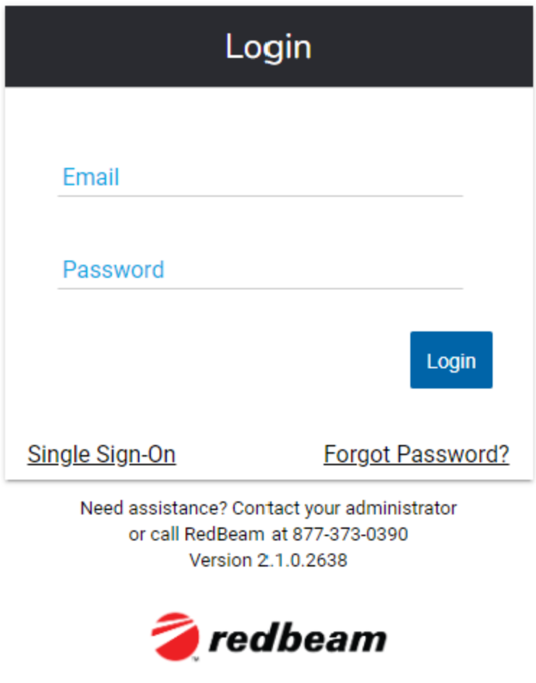

The application opens to the Dashboard​​ screen, which provides a high-level overview of key data in the system.

Additional functionality can be accessed using the tabs on the left.

Users with Administrator rights have access to the following functions:

- Dashboard
- Assets
- Transactions
  - Check Out
  - Check In
- Inventory
  - Manage
  - Take
- Reports
  - All Assets
  - Checked Out Assets
  - Checked In Assets
  - Transactions
    - All Transactions
    - Check Out History
    - Check In History
  - Inventory
    - Open
      - All Assets
      - Found
      - Unfound
      - New Room
      - New Serial
      - New Status
      - New Asset
    - Closed
- Set Up
  - Locations
    - Companies
    - Buildings
    - Rooms
  - Asset Data
    - Departments
    - People
    - Projects
    - Asset Types
    - Manufacturers
    - Models
    - Vendors
    - Accounts
    - Conditions
    - Statuses
    - Drop Down 1
    - Drop Down 2
    - Drop Down 3
    - Drop Down 4
    - Drop Down 5
  - Label Printing
    - Label Templates
    - Sequential Printing
- Caption Override
- Users
- API

Users with User rights have access to the following functions:

- Dashboard
- Assets
- Transactions
  - Check Out
  - Check In
- Inventory
  - Take
- Reports
  - All Assets
  - Checked Out Assets
  - Checked In Assets
  - Transactions
    - All Transactions
    - Check Out History
    - Check In History
  - Inventory
    - Open
      - All Assets
      - Found
      - Unfound
      - New Room
      - New Serial
      - New Status
      - New Asset
    - Closed
- Set Up
  - Locations
    - Companies
    - Buildings
    - Rooms
  - Asset Data
    - Departments
    - People
    - Projects
    - Asset Types
    - Manufacturers
    - Models
    - Vendors
    - Accounts
    - Conditions
    - Statuses
    - Drop Down 1
    - Drop Down 2
    - Drop Down 3
    - Drop Down 4
    - Drop Down 5
  - Label Printing
    - Sequential Printing

Dashboard

The Dashboard displays high-level system reporting.

Dashboard panels include:

- Assets by Asset Type – This is the total number of assets broken out by asset type.
- Assets by Building – This is the total number of assets broken out by building.
- # of Assets in Inventory – If an inventory, or multiple inventories, are open, this is the number of assets in the inventory. Users can sort through the multiple inventories. If no inventory is open, this panel will not display a number.
- Unfound Assets – This is the number of assets in the open inventory differentiated by Found and Unfound status. Users can sort through the multiple inventories. No data will display here if an inventory is not open.

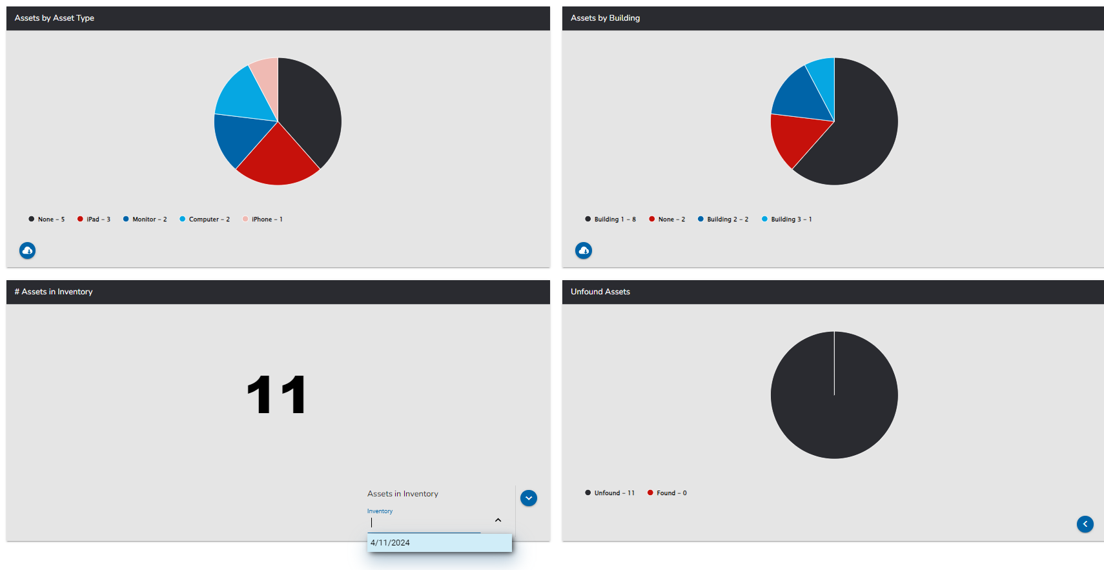

Assets

The Assets tab contains your asset database and allows users to create new assets as well as edit existing assets manually and batch-style via importing a spreadsheet or csv file.

Prior to creating assets manually, it is recommended to create the asset attribute data that will display in the drop-down fields within each asset record. For instructions, see the Setup tab section of this document.

Users can edit the asset grid view with the icon, allowing users to hide column visibility with the icon, and adjust column order by dragging the field names up and down.

Editing column order and visibility is per-browser, so one user’s view will not affect that of another user.

Creating, Deleting and Editing Assets

To create an asset manually, click the 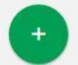 button. The only required field to create an asset is its Asset ID, the unique identifier tied to each asset in the system. It can be alphanumeric with up to 100 characters, but most organizations opt for short numeric values.

When done entering asset information, click the Save button to create the asset.

A copy of an existing asset’s metadata can be made by clicking the Copy button.

To delete the asset, click the Delete button. A warning message will be displayed prior to deletion.

To edit an existing asset, click the asset record in the grid. Assets in the grid can be searched using the 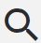 icon.

Users can batch import assets with a spreadsheet or csv file by selecting the icon.

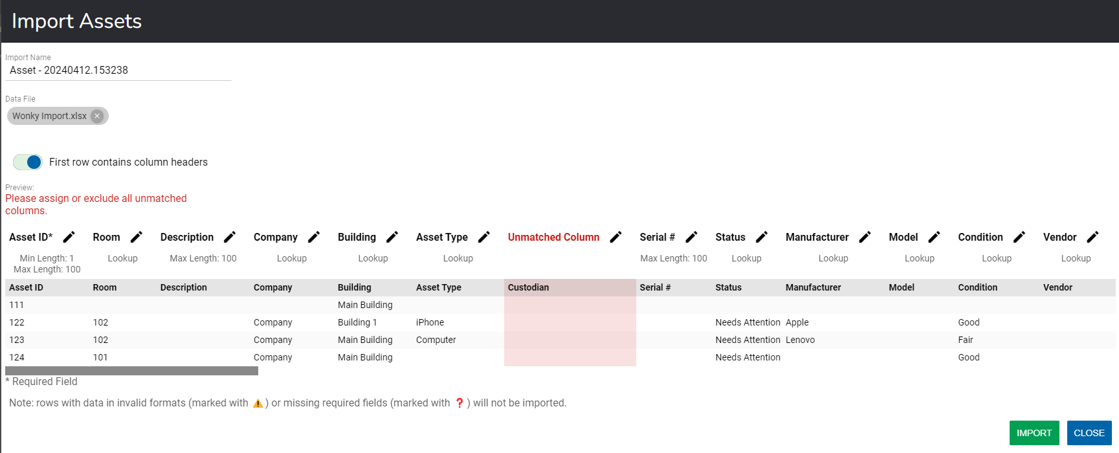

Once the user selects the desired file for import, the import tool will map the column headings of the file with the column headings in RedBeam. If anything does not align, the user receives the red error message above, and has the option to exclude the column or match the column to a field using the edit icon:
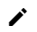
Once all columns are mapped, and the user selects “IMPORT,” RedBeam takes things a step further by letting the user know if records failed to import and why.

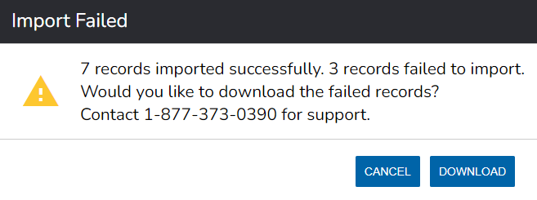
This option allows the user to download a file with information of which assets failed along with a clear error message as to why they failed. A common human error could be that cost was input as a negative value, for example.

Users can batch update assets by importing a spreadsheet or csv file. Importing will never duplicate or delete information. It will only create or update.

Details
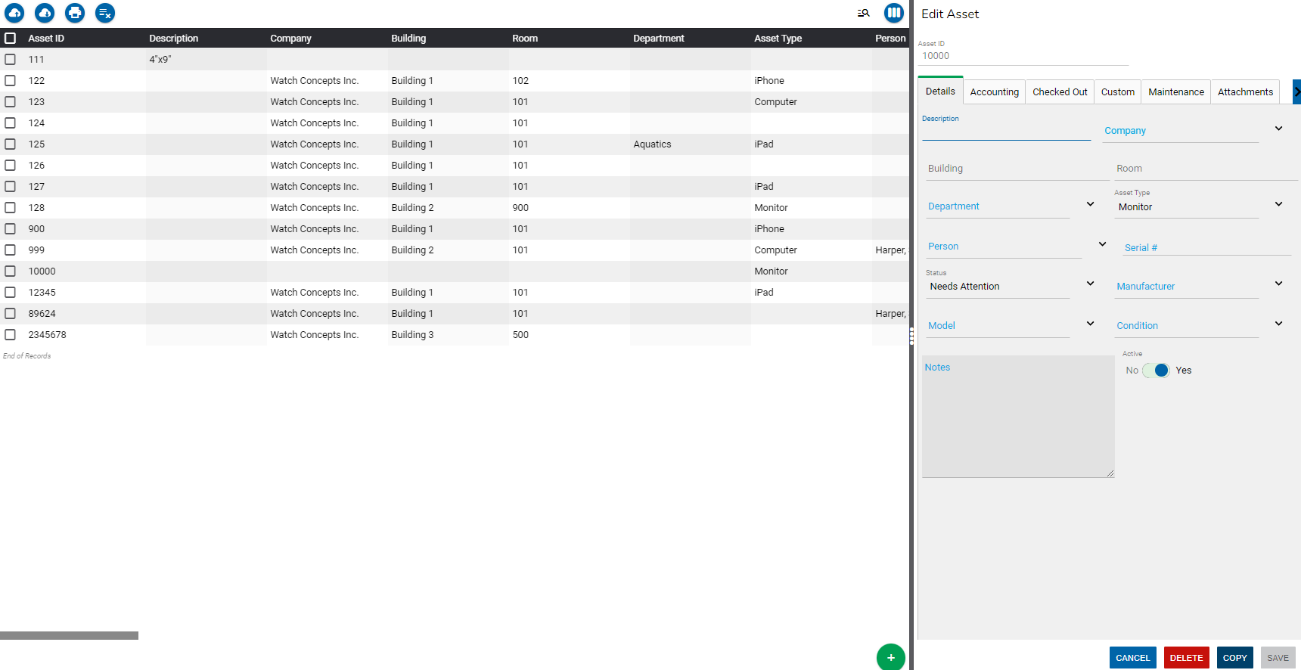

Enter asset information under the Details tab including:

- Asset ID – This is the number used to uniquely identify the asset. For barcode scanning to work properly, this complete number (including any leading zeros) should be encoded in printed barcodes used to tag the assets.
- Description – This is a description of the asset.
- *Company – This is the company to which an asset is assigned.
- *Building – This is the building in which an asset is located.
- *Room – This is the room in which an asset is located. Selecting a room is required when taking inventory.
- Department – This is the department to which the asset belongs.
- Asset Type – This is the asset category that generally describes the asset.
- Person – This is the person to whom the asset is assigned long-term.
- Serial # – This is the serial number of the asset. If an asset barcode is damaged or not visible, the user can scan or enter the serial number while updating or taking an inventory of the asset.
- Status – This is the status of the asset.
- Manufacturer – This is the manufacturer of the asset.
- Model – This is the model number of the asset.
- Condition – This is the condition of the asset.
- Notes – This is a free text field for additional information about the asset.
- Active – This is a Yes/No field. Assets marked as inactive will not show in an Inventory.

*Company, Building and Room belong to a three-tier, nested hierarchy in which a room belongs to a building and a building belongs to a company. See the Setup section for more details.

Accounting

Enter asset information under the Accounting tab including:

- PO # – This is the number of the purchase order on which the asset was purchased.
- Vendor – This is the vendor from whom the asset was purchased.
- Account – This is the financial reference account under which the asset was purchased.
- *Acquisition Date – This is the date on which the asset was purchased.
- *Cost – This is the price paid for the asset.
- *Recovery Period in Year – This is the period during which an asset is depreciated according to the manufacturer.
- *Scrap Value – This is the value an asset will be worth at the end of its life.
- *Depreciated Value – This is a calculated value that represents the cost minus the scrap value minus the amount deprecated.
- *Amount Depreciated – This is a calculated amount of how much money the asset has based on the current date when the user is accessing RedBeam.
- Warranty # – This is the number associated with the asset’s warranty.
- Warranty Start Date – This is the date that the asset’s warranty begins.
- Warranty End Date – This is the date that the asset’s warranty ends.
- Lease # – This is the number associated with the asset’s lease.
- Lease Start Date – This is the date that the asset’s lease begins.
- Lease End Date – This is the date that the asset’s lease ends.

*Depreciated value and amount depreciated are automatically calculated in RedBeam when a user inputs the acquisition date, cost, recovery period in years and optional scrap value. One month of the asset’s value is depreciated at the end of the first full month since the asset was acquired and subsequently at the end of each month after that until the asset is fully depreciated. The scrap value is subtracted from the cost prior to calculating depreciation.

Checked Out

The Checked Out tab shows information about the asset if it is actively checked out.

Check out information includes:

- Checked Out To – This is the Person the asset is checked out to.
- Checked Out Date – This is the date and time the asset was checked out.
- Reference # - This is the Reference # entered in the Check Out transaction.
- Project – This is the Project entered in the Check Out transaction.
- Due Date - This is the Due Date entered in the Check Out transaction.

Custom

The Custom tab includes additional date and time fields, open text fields, drop down fields and yes/no toggle fields.

Admin users can update the names of custom fields through Caption Override, further detailed in the Setup section of this document.

Maintenance

The Maintenance tab allows users to add maintenance logs for past, current or future dates and times.

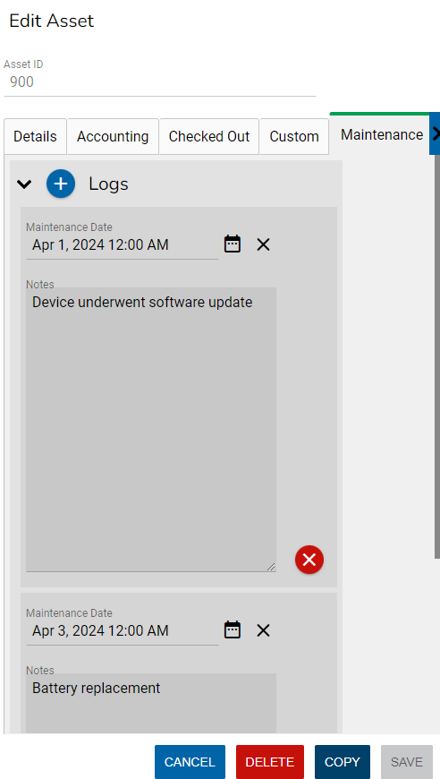

Attachments

Assets can also retain file attachments including but not limited to Excel files, Word documents and Images. Users may connect with the device camera to take photos of the asset in real time through RedBeam by selecting the icon.

To attach a file from the computer, select the file and save the asset.

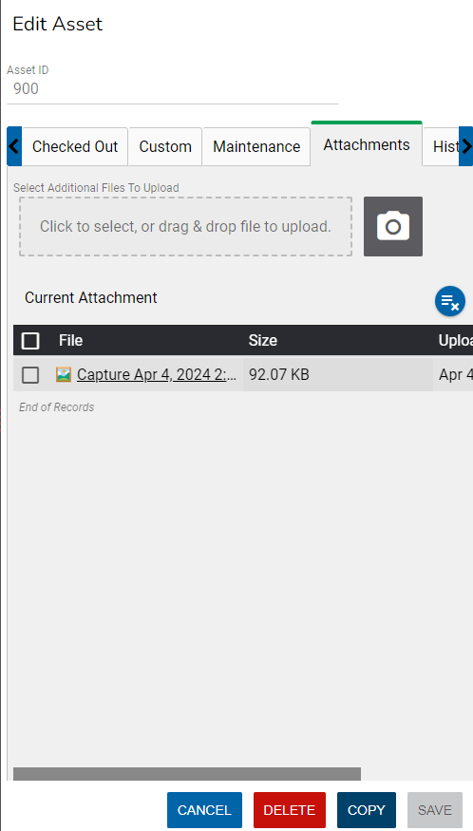

History

A full history of changes to an asset are displayed in the History tab. This tab captures what change occurred to the asset, when the change occurred and who made the change dependent on the logged in user.

Import/Export
Asset data can be exported using the icon.

Exported files will reflect the column order and visibility as specified by the user, which can be altered using the icon.

Users can export files in the following formats.

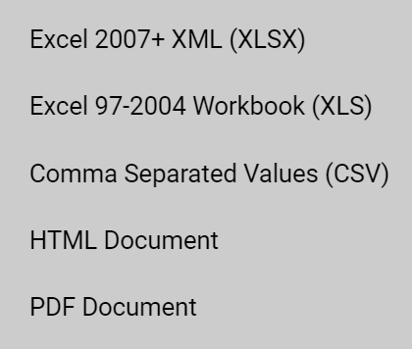

Choose the desired file format to export the data.

Printing Asset Labels

If using a supported label printer, asset labels can be printed from the Asset screen.

To print labels, check the boxes next to the desired assets.

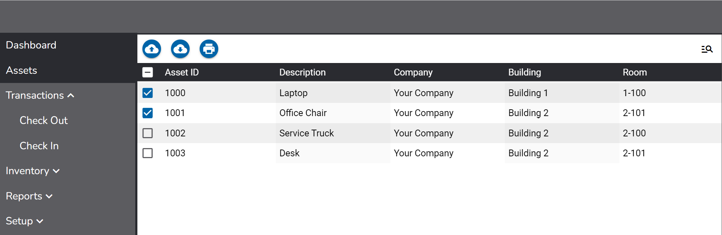

Then click the 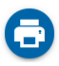 icon and select the desired Printer and Label Template.

For more information on creating customizable label templates and setting up your printer, see the Label Printing section of this document.

A preview of the labels will be displayed in addition to a count of the total number of labels that will be printed.

Click Print to print the labels.

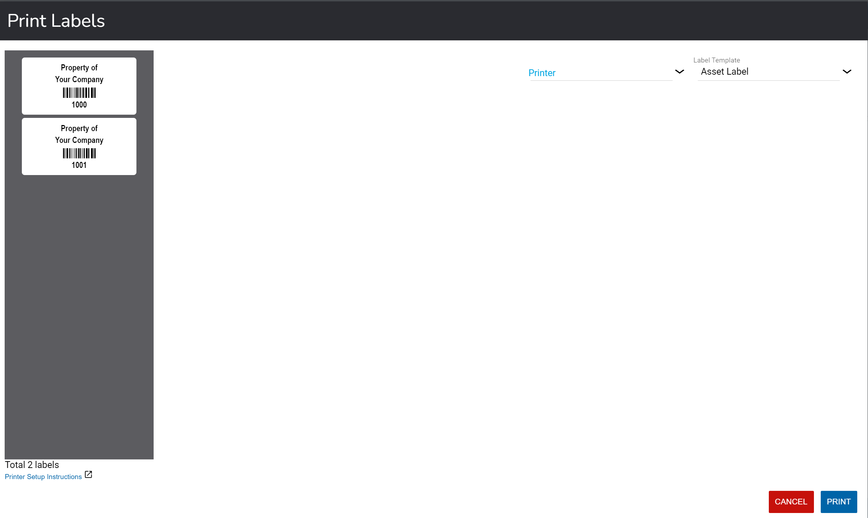

Transactions

The Transactions tab allows users to check items in and out to People. The person the asset is checked out to can differ from the person the asset is assigned to long-term in the Details section of the asset record.

Check Out

To check out an asset to a Person, go to the Check Out tab under Transactions.

Select the Person the assets will be checked out to in the To field with the dropdown list or type the name or Person ID to filter. Alternatively, users can scan a Person ID barcode while the cursor is positioned in the To field.

Next, enter or scan the Asset ID of the asset and click the check mark to add the asset to the grid. If scanning, program the scanner to perform a carriage return after each scan to add the asset to the grid without clicking the check.

Users can check out multiple assets at a time and can click the X next to the asset in the grid to remove it.

A total count of the assets is displayed on the screen.

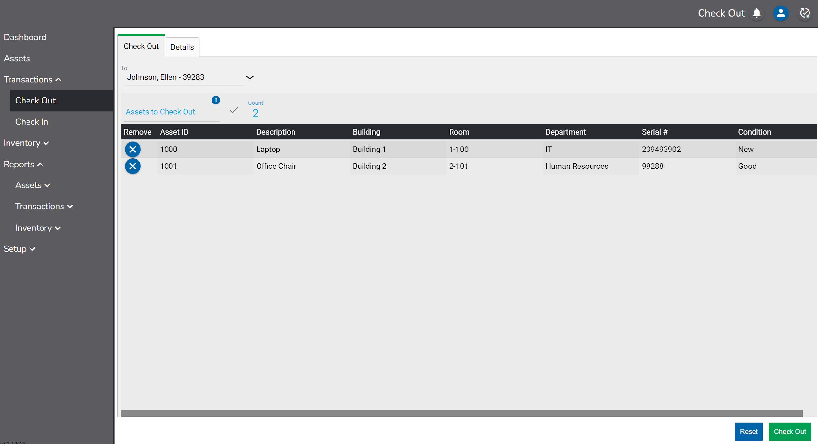

If desired, additional information about the transaction can be added in the Details tab. The detail fields include:

- Due Date – The date an asset is due to be checked back in.
- Reference Number – A number the user wants associated with the transaction.
- *Company – The Company to which the asset will be assigned.
- Building - The Building where the asset will be assigned.
- Room - The Room where the asset will be assigned.
- Project – The Project the transaction is associated with.
- Notes – Any notes for the transaction.

*If the system is built out with only one Company, company will be excluded from the options to select from in this section.

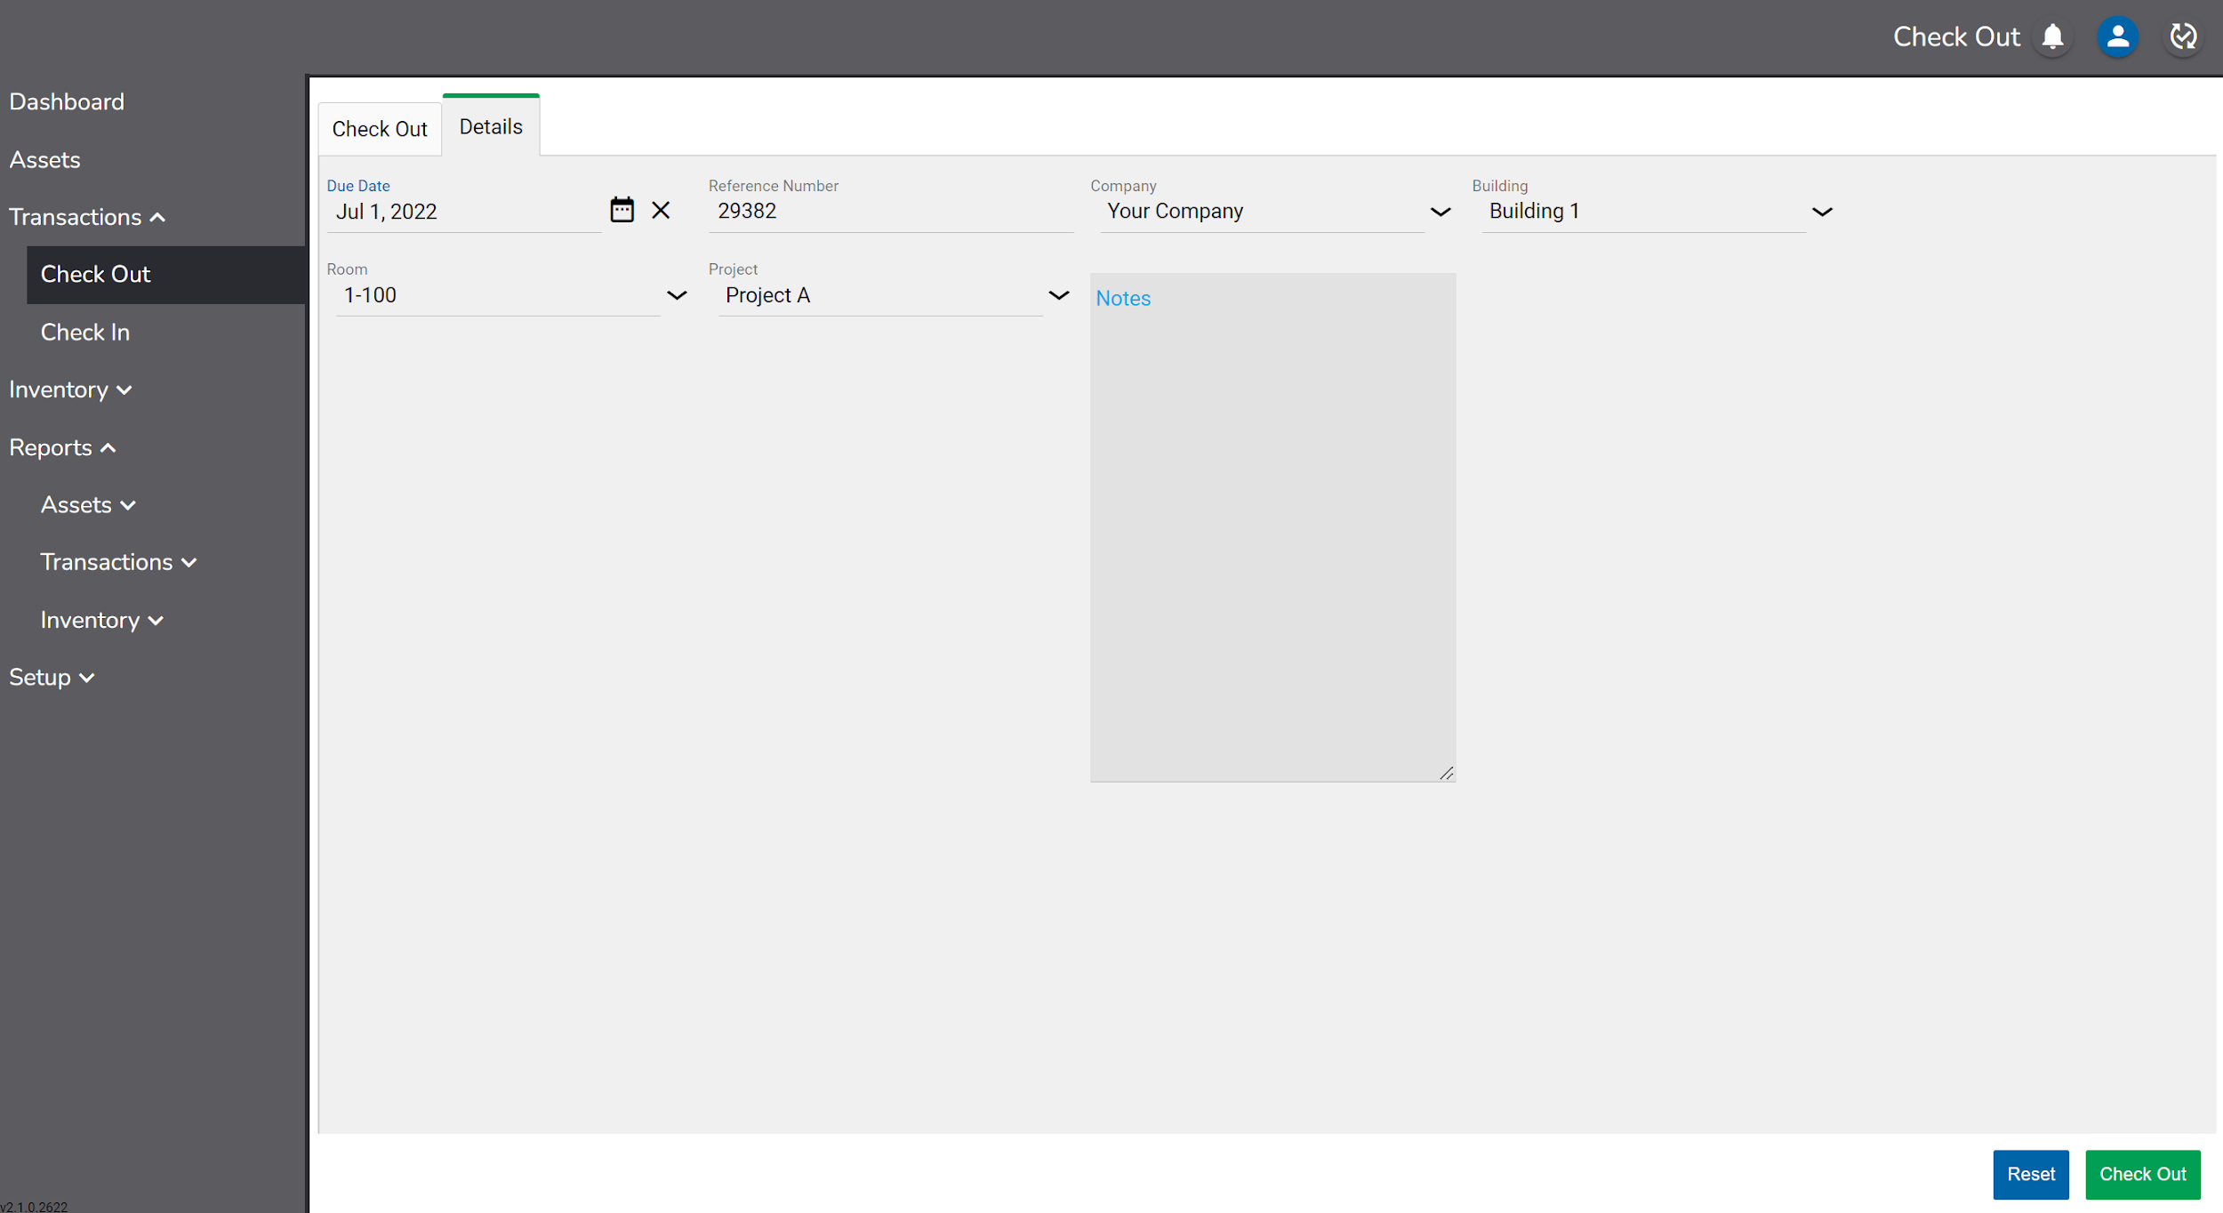

When done, click the Check Out button to complete the transaction. Information about the Person the asset is checked out to will display in the Checked Out section of the asset record.

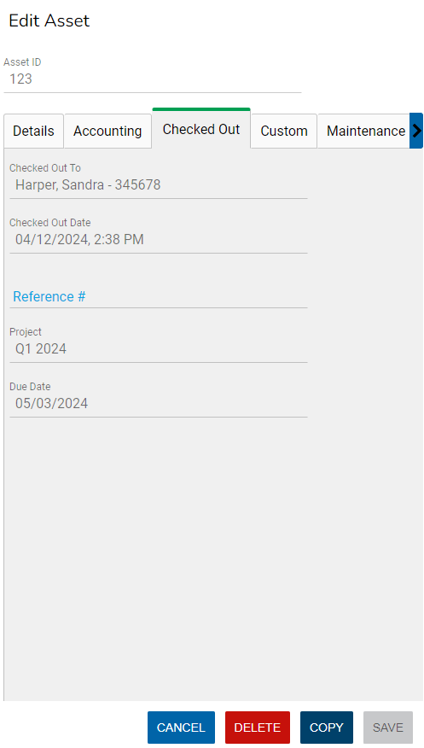

An asset can be checked out to another Person without first checking it back in.

Check In

To check in an item, go to the Check In tab under Transactions.

Select the Company, Building and Room where the assets will be checked in to. Once these values are selected the first time, they will be remembered in the same browser until changed.

Next, enter or scan the Asset ID of asset and click the check mark to add it to the check in grid. If scanning, program the scanner to perform a carriage return after each scan to add the asset to the grid without clicking the check.

Click the X next to the asset in the grid to remove it.

A total count of the assets in the transaction is displayed on the screen.

Continue to scan or input any additional assets for this transaction.

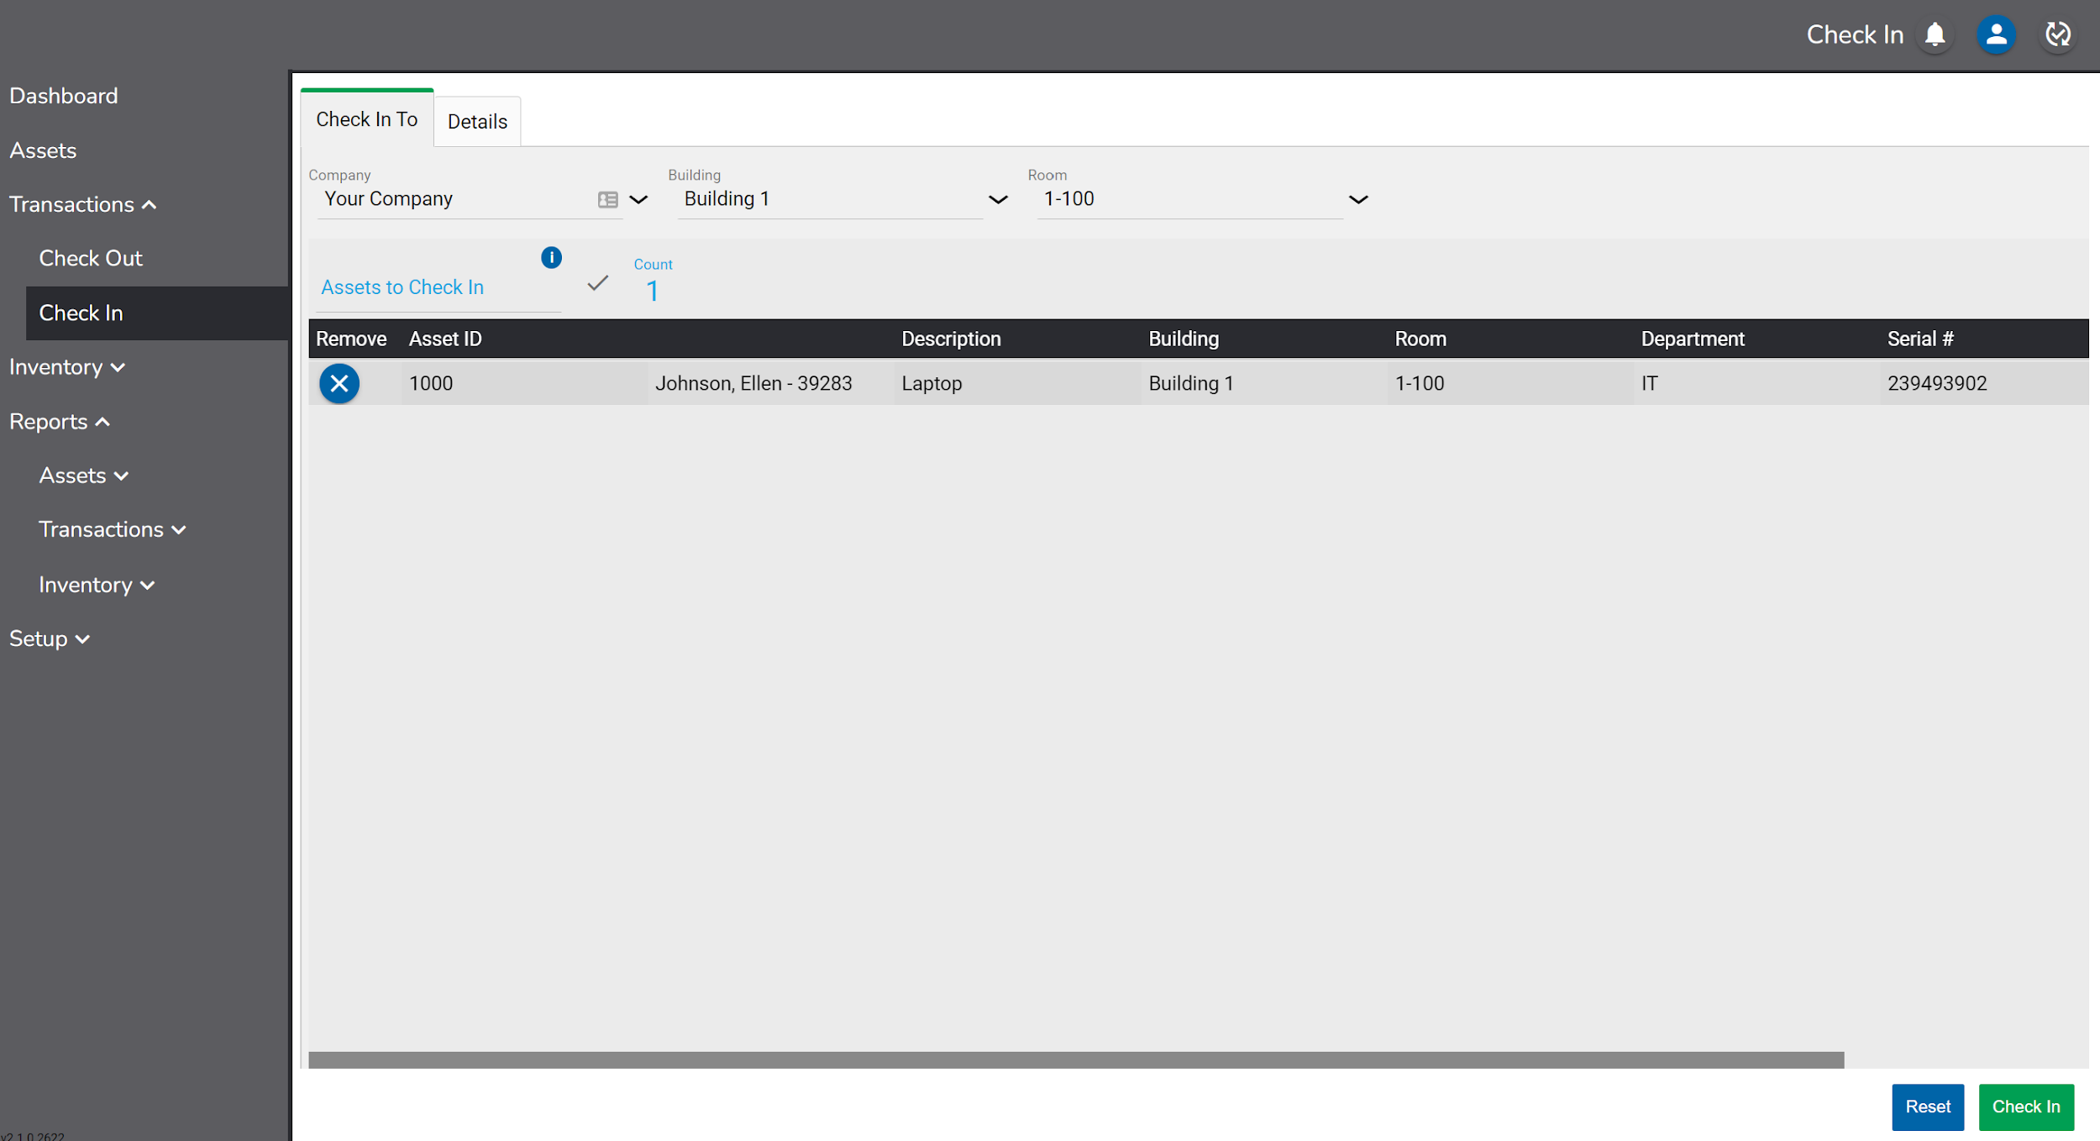

If the location entered for this transaction differs from the previous location of the asset(s), a message will display. Continuing will assign the asset to the new location.

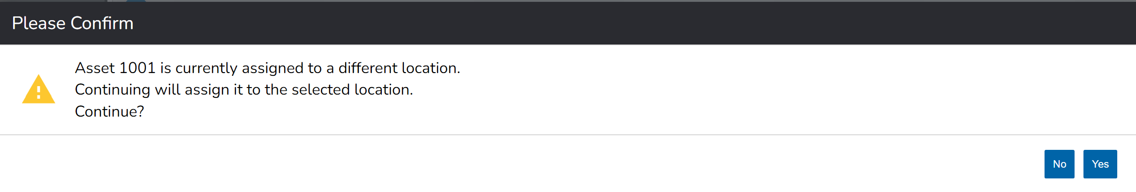

If desired, additional information about the transaction can be added in the Details tab. The detail fields include:

- Notes – Any notes for the transaction.

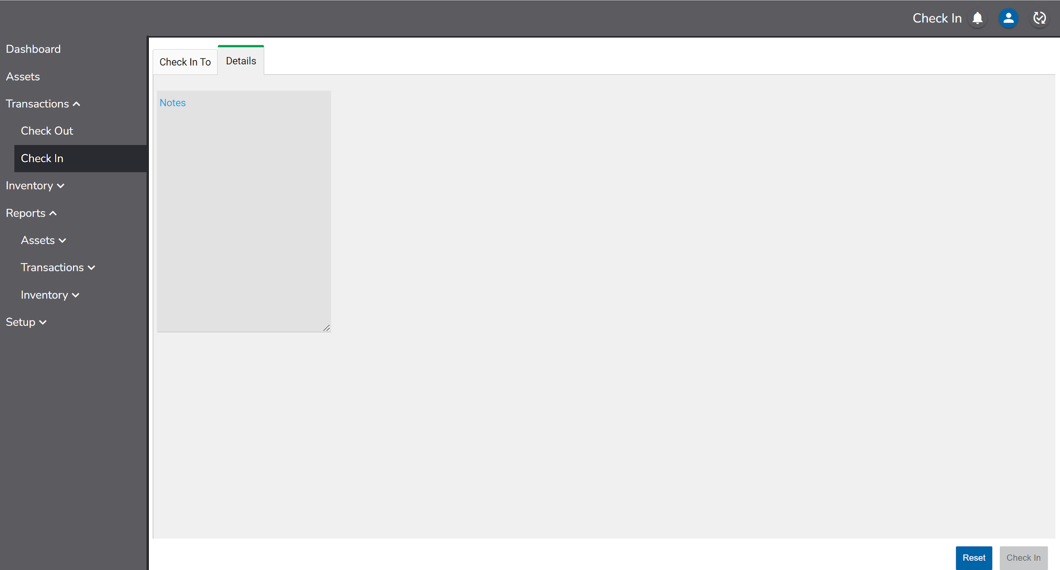

When done, click the Check In button to complete the transaction.

If an asset is checked in, it can be checked in again without having to be checked out.

Inventory

For compliance and budgeting purposes, organizations will periodically audit, or take a physical inventory, of their assets to increase visibility of lost items. During this time, users can capture other important information such as location, condition, specialized statuses etc. RedBeam will generate inventory reporting based on real-time findings.

RedBeam offers the ability to open multiple audit sessions at a time with the option to restrict the sessions to specified locations. This allows users the flexibility to open two sessions for two separate buildings, multiple sessions for different rooms, one session for all locations etc. Inventory sessions can include the same locations as other sessions opened at the same time.

Once an inventory session is closed, users will not be able to continue taking inventory, but the history of that session will be saved in RedBeam.

Manage

To open an inventory, navigate to the Manage tab. Click the button and enter an Inventory Name. Use the Company, Building and Room inclusion or exclusion criteria to assign locations to the inventory session if desired. Click Save to open the inventory.

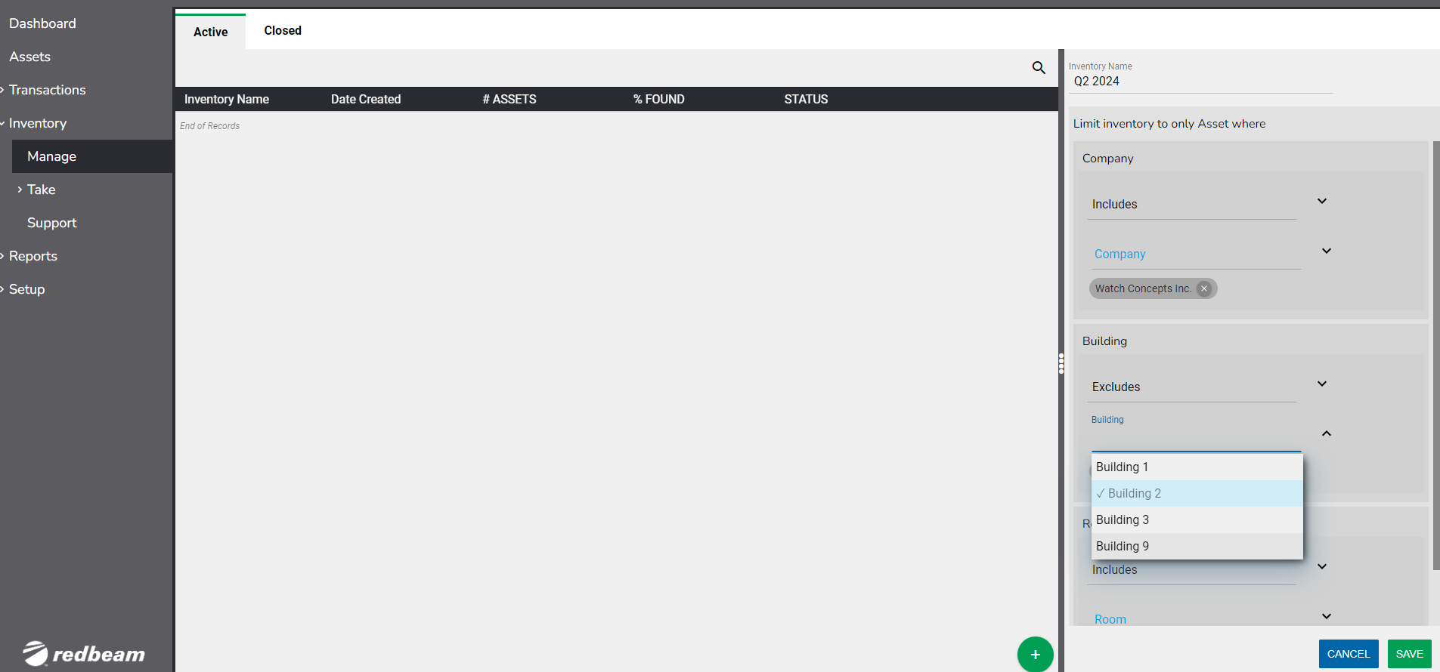

The newly created inventory will be displayed in the Active grid.

To view all inventory details, click on the inventory in the grid. Inventory details will display in the pane on the right of the screen.
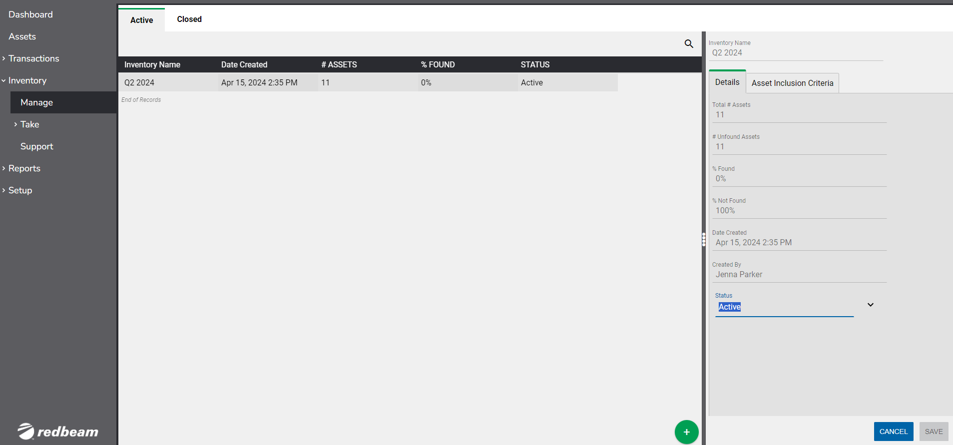

Details include:

- Inventory Name – This is the inventory name entered during the import process.
- Total # Assets – This is the number of active assets in the inventory.
- # Unfound Assets – This is the number of unfound assets in the inventory.
- % Found – This is the percentage of found assets in the inventory.
% Not Found - This is the percentage of unfound assets in the inventory.
- Date Created – This is the date and time the inventory was created.
- Created By - This is the user who created the inventory.
- Status – This indicates whether the inventory is Active or Closed.

To close the inventory, change the Status from Active to Closed and click the Save button. Once an inventory is closed it cannot be reopened, so only do this after having completed an inventory.

Click the Closed tab to view the details of all closed inventories.

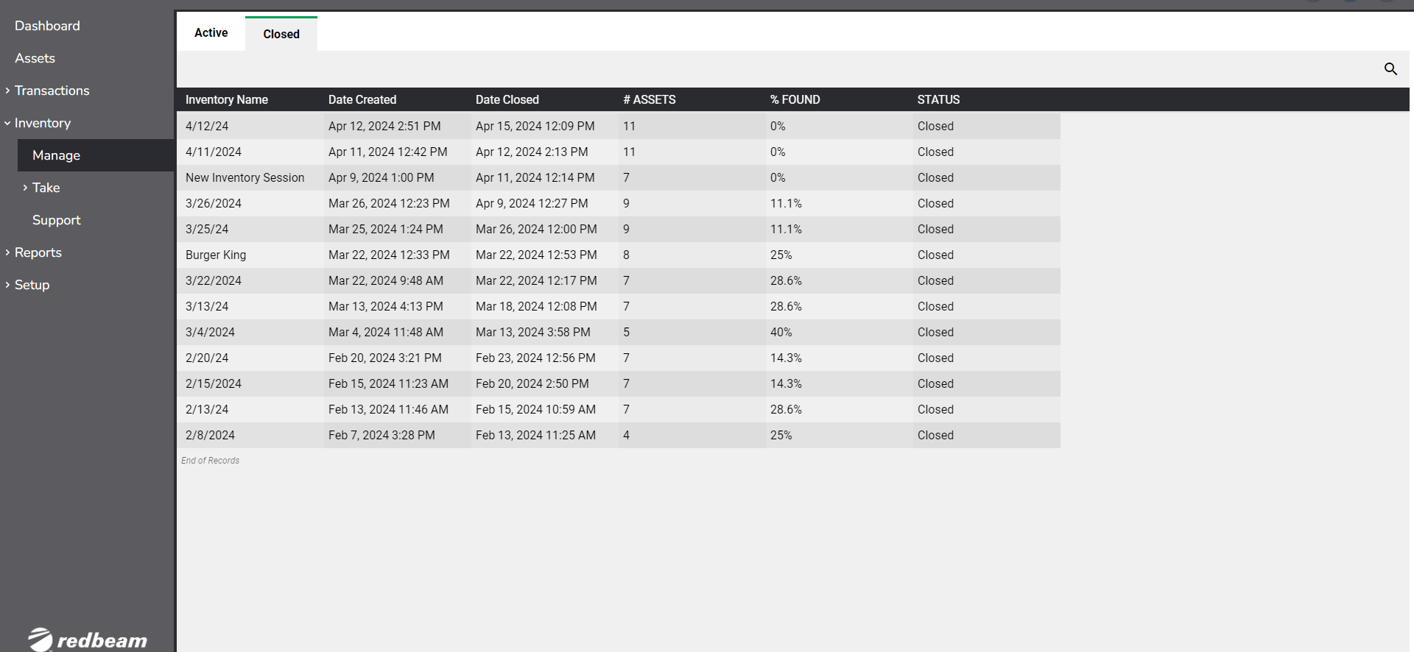

To view inventory reports, go to the Reports section of this document.

Take

When taking a physical inventory, users will go from room to room in a building and scan or enter each asset found. This is typically much easier and more efficient using a purpose-built mobile device with a barcode scanner.

It is recommended to use the mobile Take function described in the Mobile Functions section of this document for this process. However, users can take an inventory on a PC or laptop by navigating to the Take tab.

A list of all assets will display in the grid until location values are selected.

Select the Company, Building and Room where the assets are found. If only one Company exists, only the Building and Room fields will display.

Once the Room is selected, only the assets currently assigned to that Room in the database will display in the grid, with Unfound assets defaulted at the top of the list.

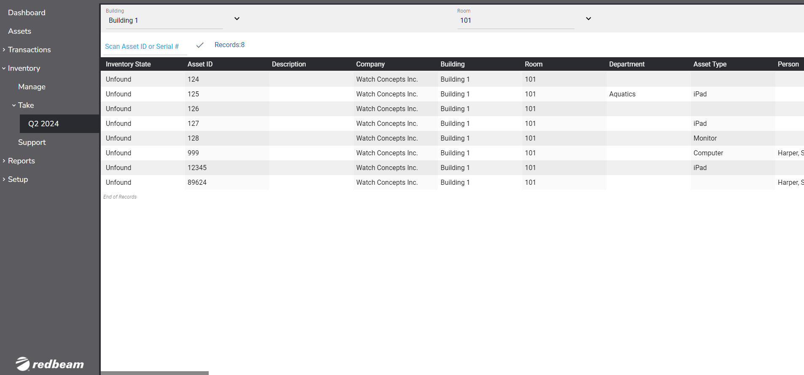

A user can type the Asset ID or Serial # of the asset or can use a barcode scanner to capture those values, which are case-sensitive.

Once entered or scanned, the asset details will display. A user can make any updates necessary to the Asset and then click Save to mark the asset as Found.

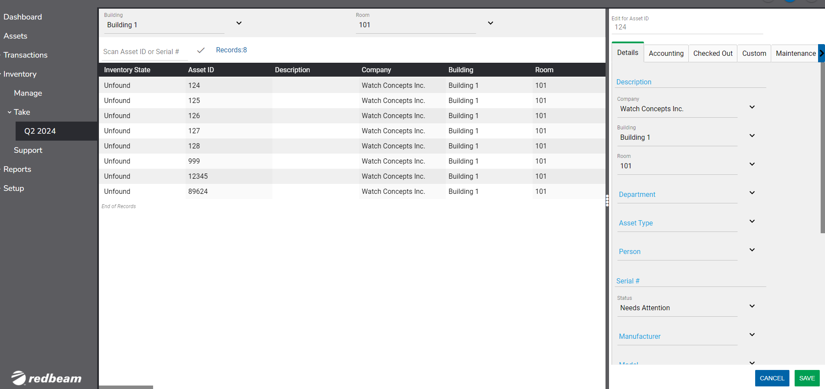

Continue to scan the next asset in the room and repeat the process until all assets found in that room are updated.

Once moved to the next room, change the room value to the new location and then scans the assets in the next room and so on.

If the asset was found in a different room than was previously assigned, a message will notify the user with the choice to update the Room value to the new room or to keep the previous Room value.

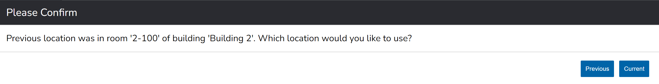
If the asset is new to the system, a message will notify the user and ask if he or she wants to add the asset to the database.

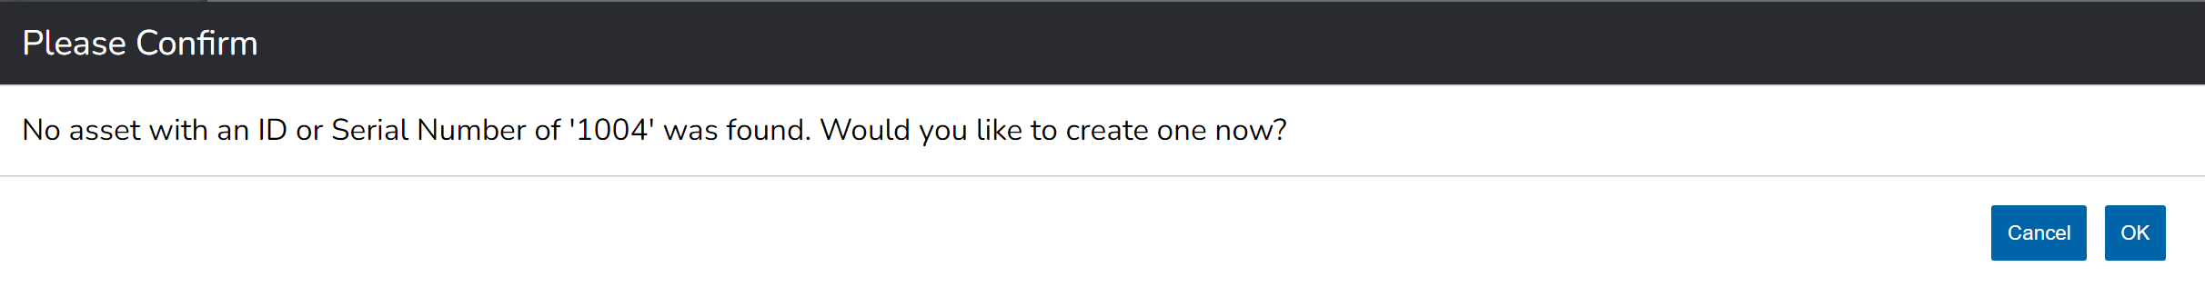
For users implementing an asset tracking system for the first time with RedBeam, taking an inventory may be a good way to input initial asset data into the system. Often, new users will print out labels or order pre-printed labels, tag the assets with the labels, scan the barcode, and enter the asset information. This process is then repeated until all assets are tagged and entered in the system.

Reports

All reports in RedBeam (apart from Closed Inventory Reports) allow users to filter, save filters, customize column order and visibility and export reports.

If users repetitively select the same filtering criteria, Users may save personal filters with the 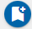 icon. Admin users may save shared filters for all users in the account with the 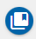icon.

To save a personal or shared filter, select the filtering criteria on the Filter By pane, click the desired icon, and name the saved filter.

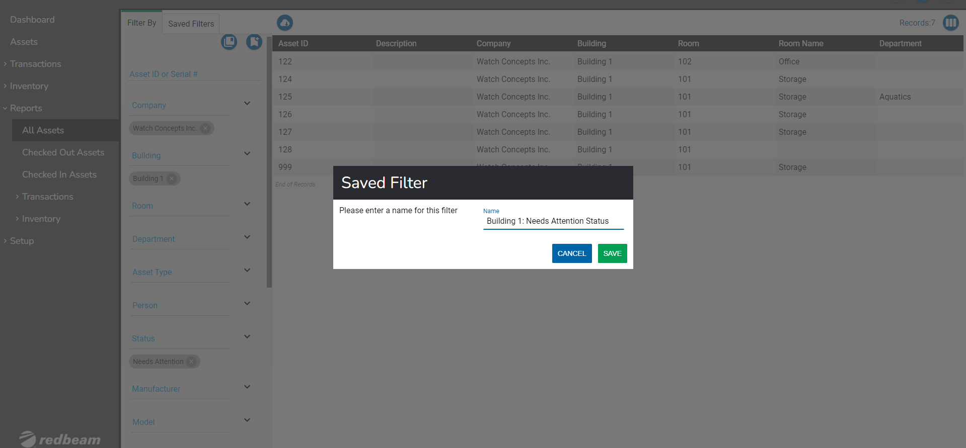

Click the Saved Filters pane to access all personal and shared saved filters. Click on the saved filter to activate the saved filter criteria.

Delete a saved filter by selecting it and clicking the 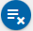icon.

Users can edit the asset grid view with the icon, allowing users to hide column visibility with the icon, and adjust column order by dragging the field names up and down.

Editing column order and visibility is per-browser, so one user’s view will not affect that of another user.
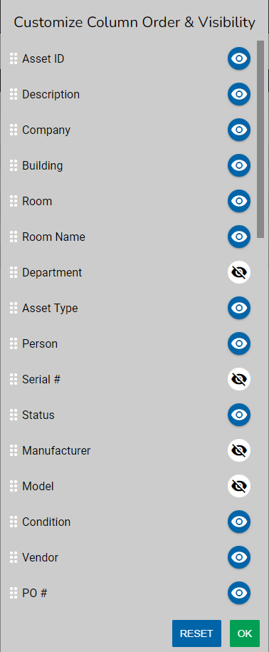

Asset data can be exported using the icon.

Exported files will reflect the column order and column visibility as altered by the icon.

Users can export files in the following formats.

Choose the desired file format to export the data.

All Assets

The All Assets report allows users to filter and export data from the entire database of the system.

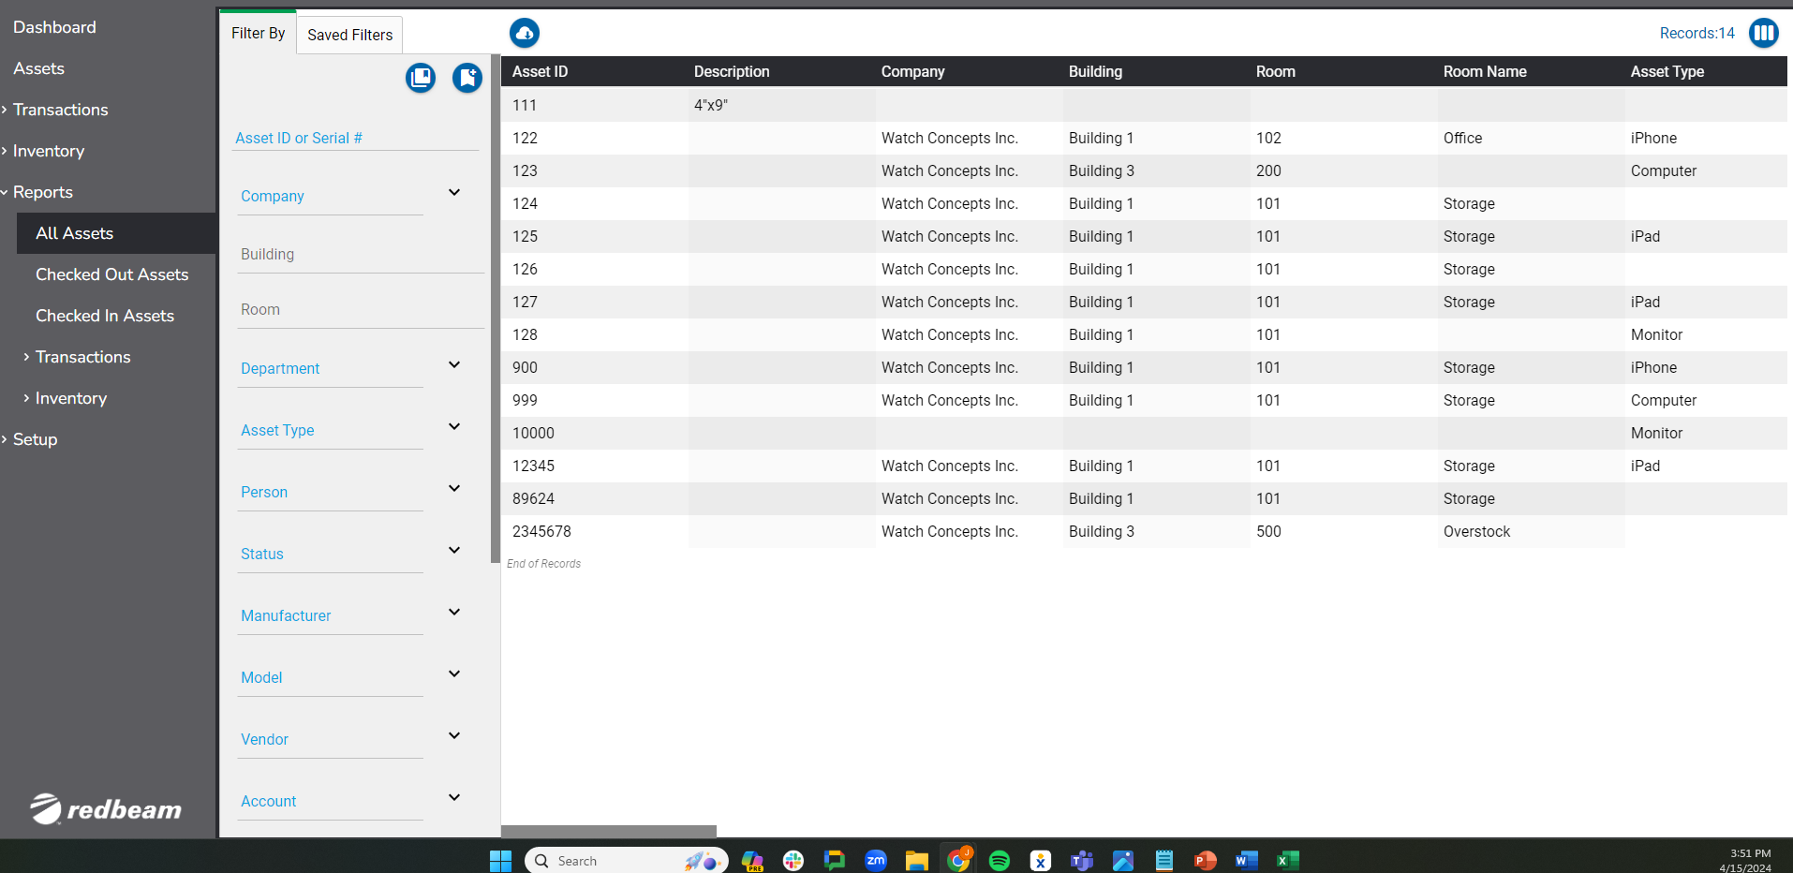

Filters include:

- Asset ID or Serial #
- Company
- Building
- Room
- Department
- Asset Type
- Person
- Status
- Manufacturer
- Model
- Vendor
- Account
- Condition
- Drop Down 1
- Drop Down 2
- Drop Down 3
- Drop Down 4
- Drop Down 5
- *Active

The Active toggle has three modes, allowing users to view just the Inactive assets, just the Active assets, or all assets regardless of active status with the middle mode.

Checked Out Assets

The Checked Out Assets report contains all currently checked out assets.

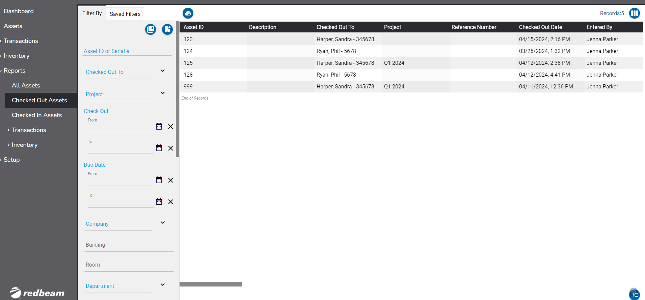

In addition to the filtering options found in the All Assets report, users can filter by:

- Checked Out To
- Project
- Check Out Date (From date/time and To date/time)
- Due Date (From date/time and To date/time)

This report also includes:

- Reference Number
- Entered By

Checked In Assets

The Checked In Assets report contains all currently checked In assets and includes the same filtering options as found in the All Assets report.

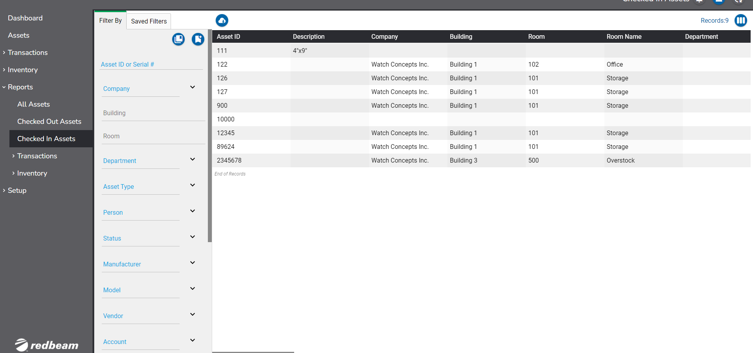

Transaction Reports

The Transaction report tab allows users to view the All Transactions report, Check Out History report and Check In History report.

The All Transactions report contains a full history of all check-ins and all check-outs that have occurred in the account.

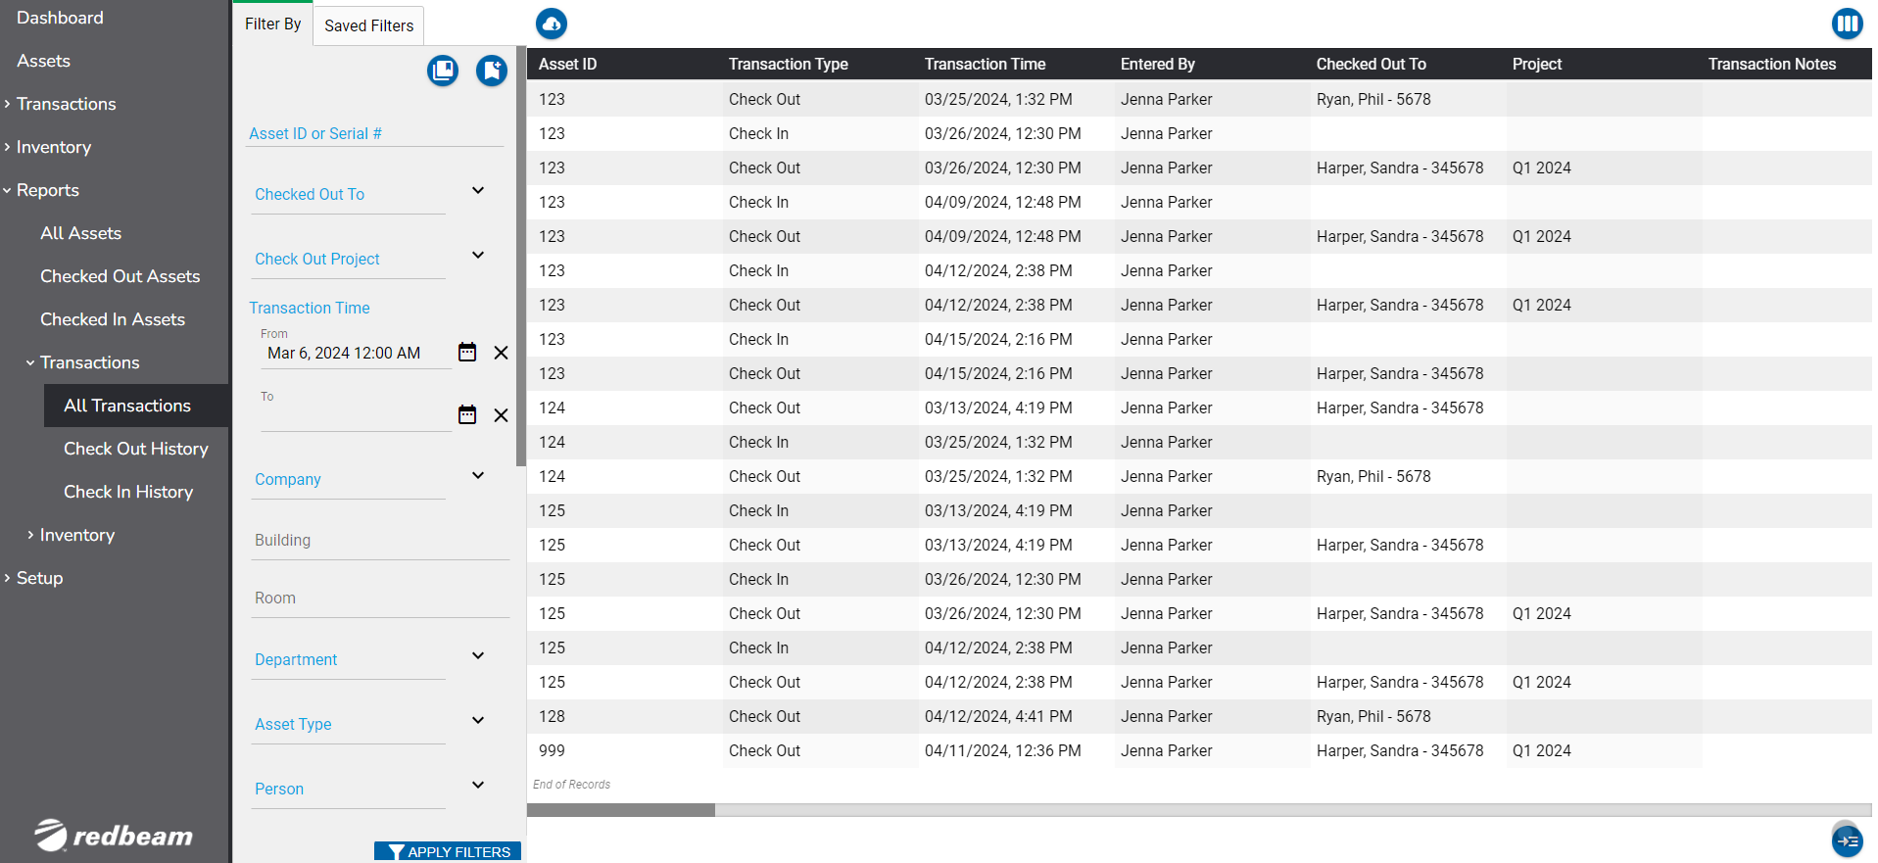

In addition to the filtering options found in the All Assets report, users can filter by:

- Checked Out To
- Checked Out Project
- Transaction Time (From date/time and To date/time)

The Check Out History report contains all check out transactions.

The Checked In report contains all check-in transactions.

Inventory Reports

From the Inventory report tab, users can choose to view Open Inventory reports or Closed inventory reports.

For an Open inventory, users can select from the following types of inventory reports:

- All Assets –A report on all assets in the inventory
- Found – A report on all found assets.
- Unfound – A report on all unfound assets.
- New Room – A report on all assets with updated locations during the inventory.
- New Serial – A report on all assets with an updated serial number during the inventory.
- New Status – A report on all assets with an updated status during the inventory.
- New Asset – A report on all newly added assets during the inventory.

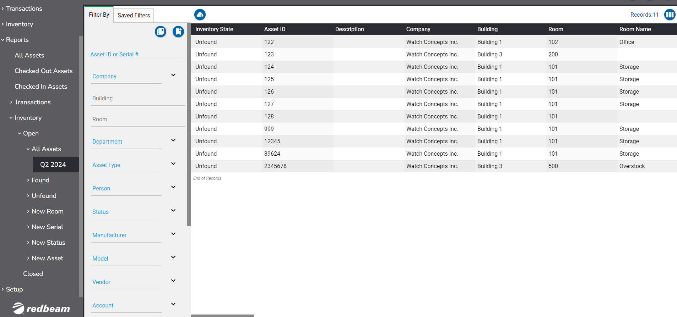

Once an inventory is Closed, the inventory data can no longer be filtered in the system, but the complete inventory data can be viewed in the grid or exported.

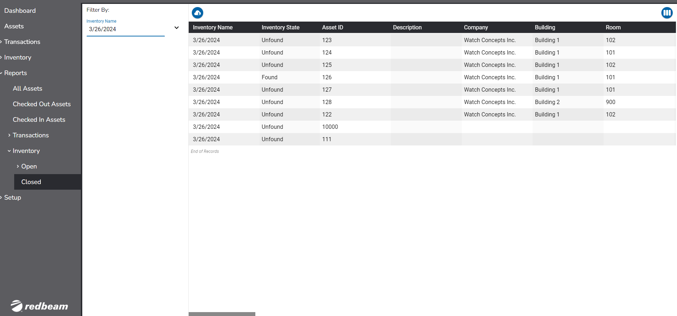

Setup

The Setup tab allows users to create the dropdown options for asset metadata dropdown fields.

Users may create metadata dropdown options manually with the button, may batch create by importing using the icon, or may use APIs for more advanced integration. See the API section of this document for more details.

Users may export the list of dropdown options from each section with the icon.

Admin users can delete one or multiple metadata dropdown options with the 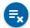icon.

To edit or delete one dropdown option, click on it in the grid and make the desired changes.

Locations

The location of an asset is the physical place where an asset can be assigned. RedBeam has a three-tier nested hierarchy system of locations, Company, Building and Room where a Room must belong to a Building which must belong to a Company.

Companies

Companies are the highest tier in the location hierarchy. Company details may include:

- Company Name (required and immutable)
- Address 1
- Address 2
- City
- Zip Code
- Country
- State
- Phone
- Fax

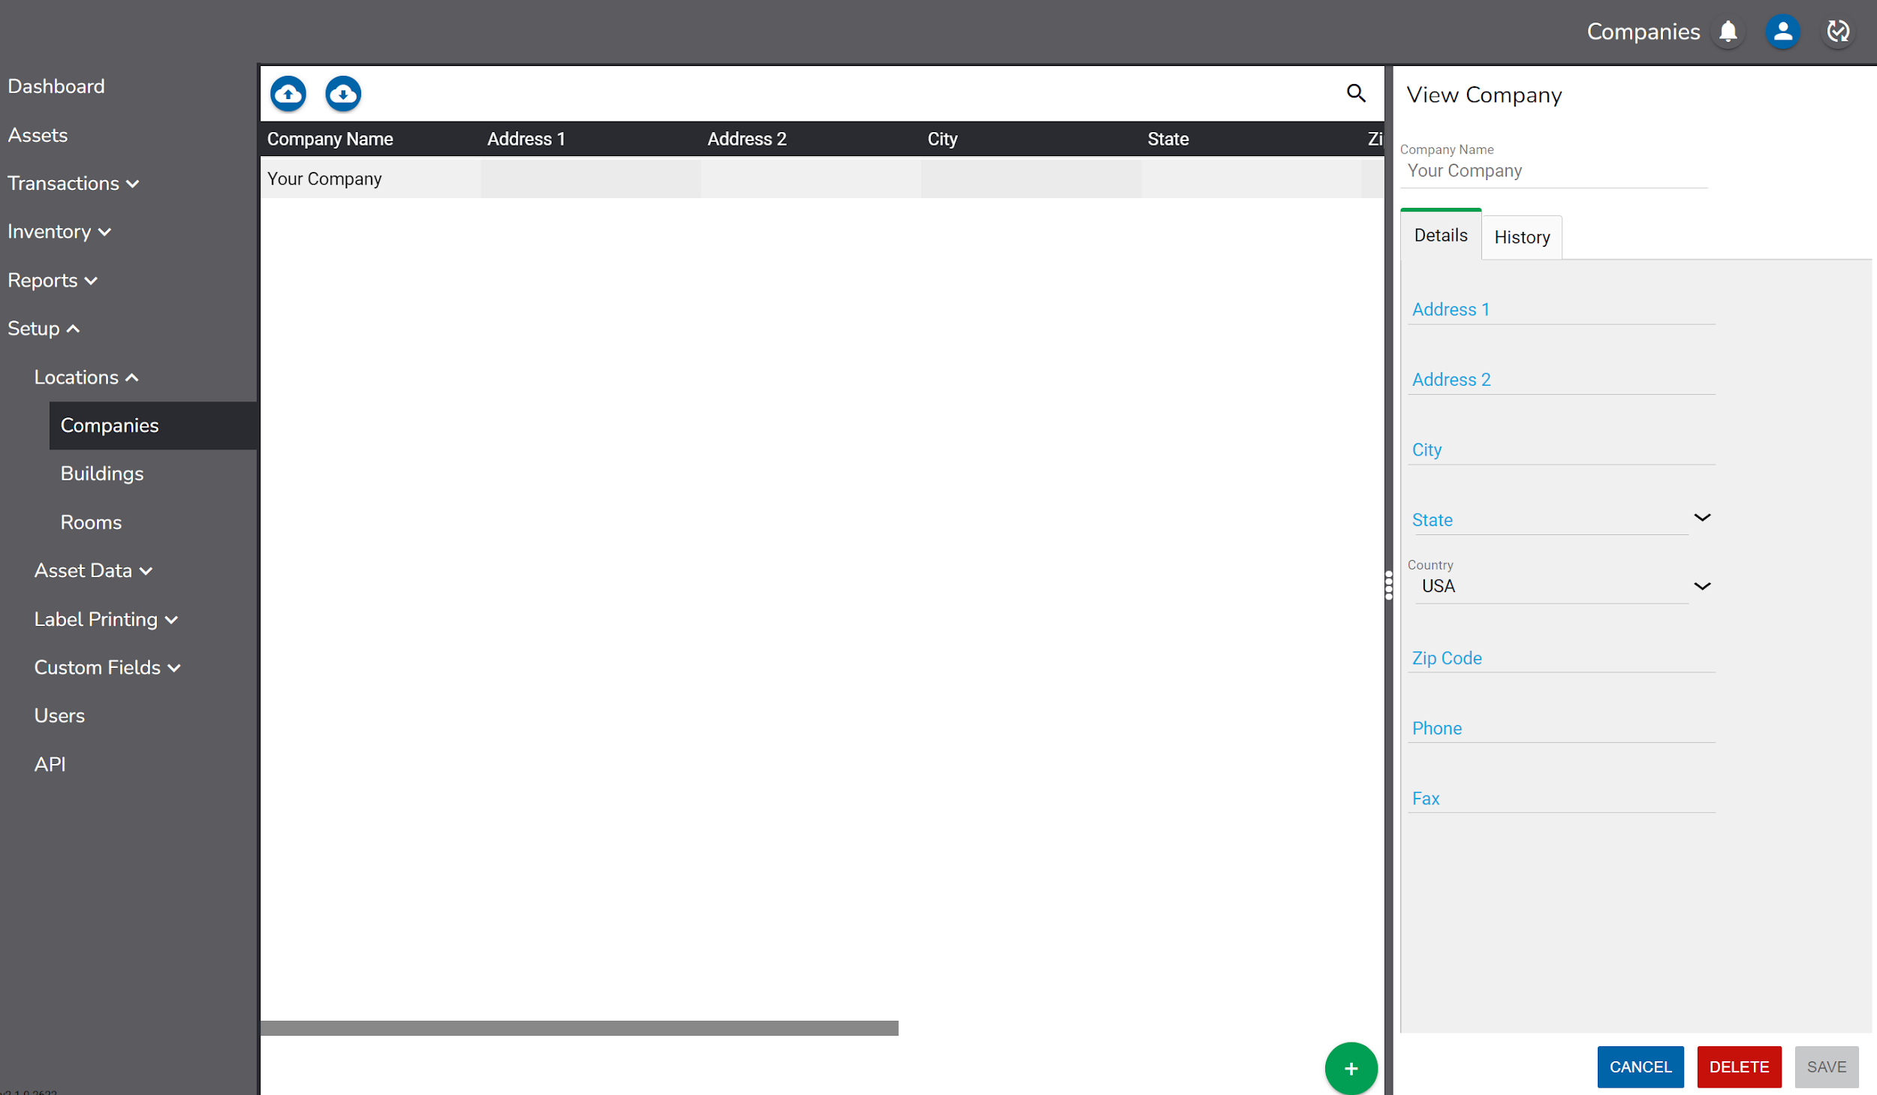

Buildings

Buildings are assigned to companies and are the second tier in the location hierarchy. Building details may include:

- Building Name (required and immutable)
- Company
- Address 1
- Address 2
- City
- State
- Country
- Zip Code
- Phone
- Fax

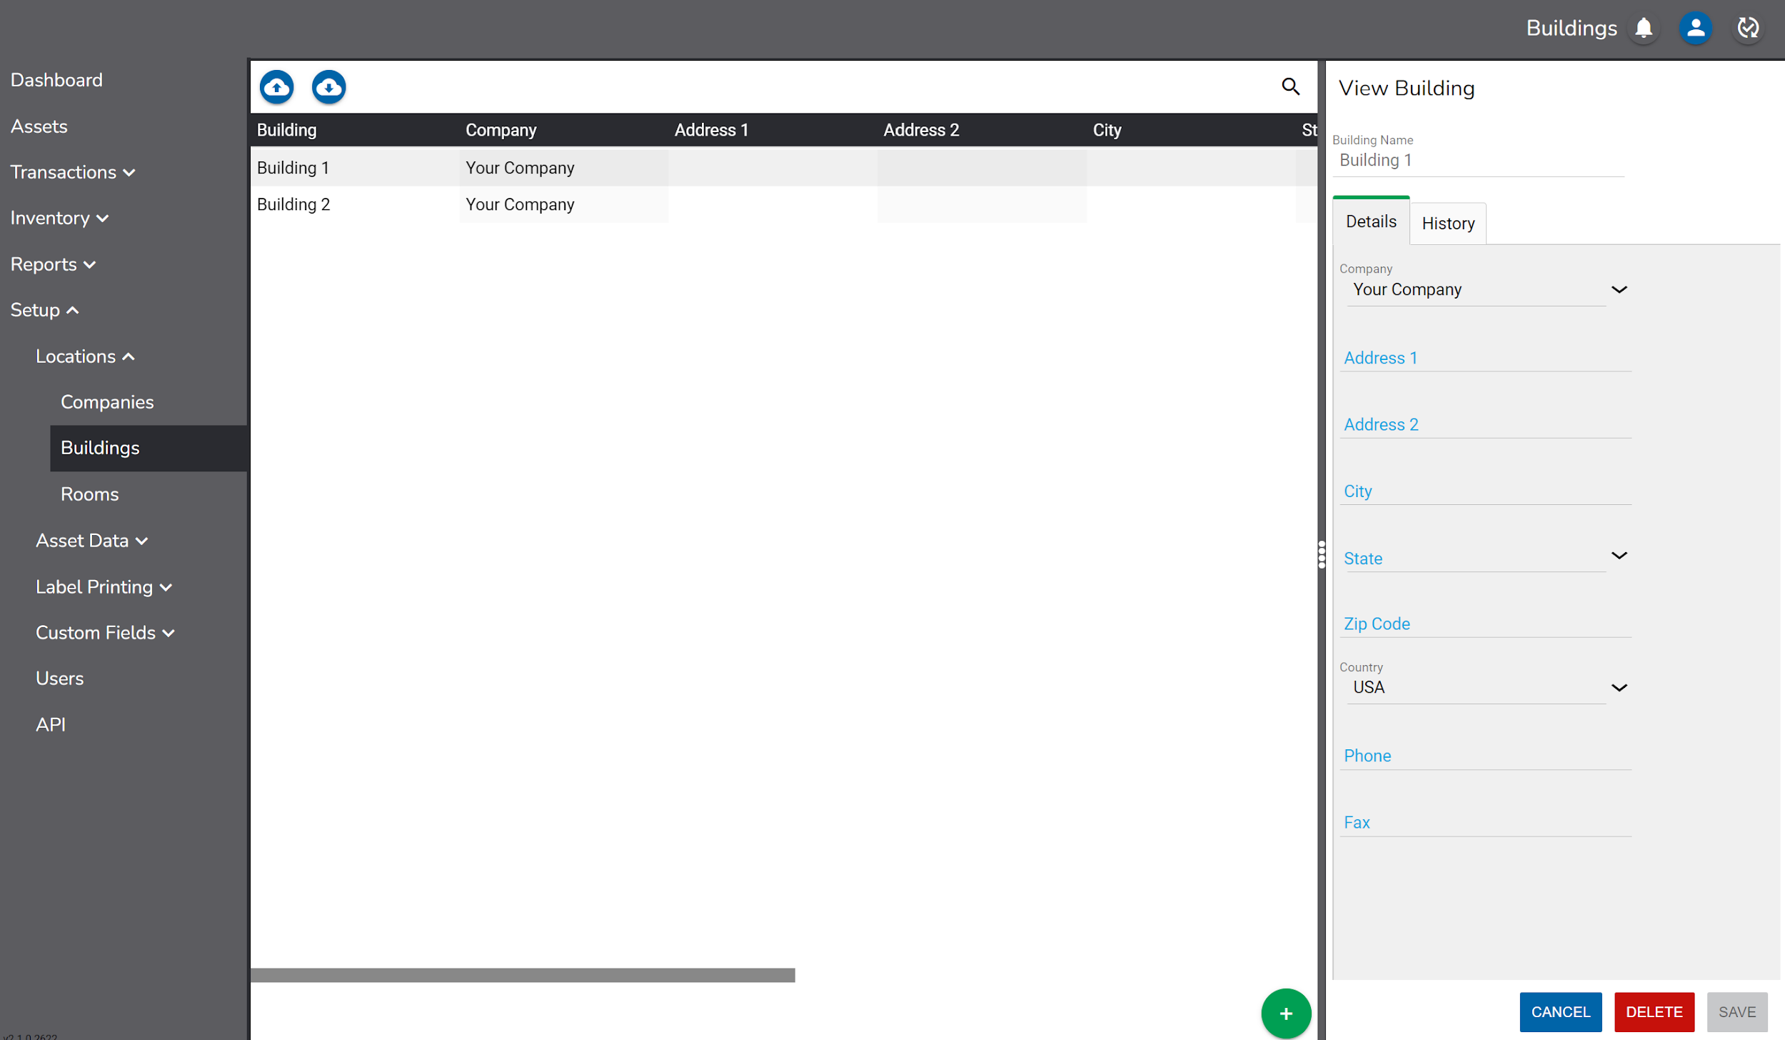

Rooms

Rooms are assigned to buildings and are the third and lowest tier in the location hierarchy. Assets must be assigned at the room level for the purposes of taking a physical inventory and for checking in items.

Room details may include:

- Room ID (required and immutable)
- Room Name
- Building
- Phone

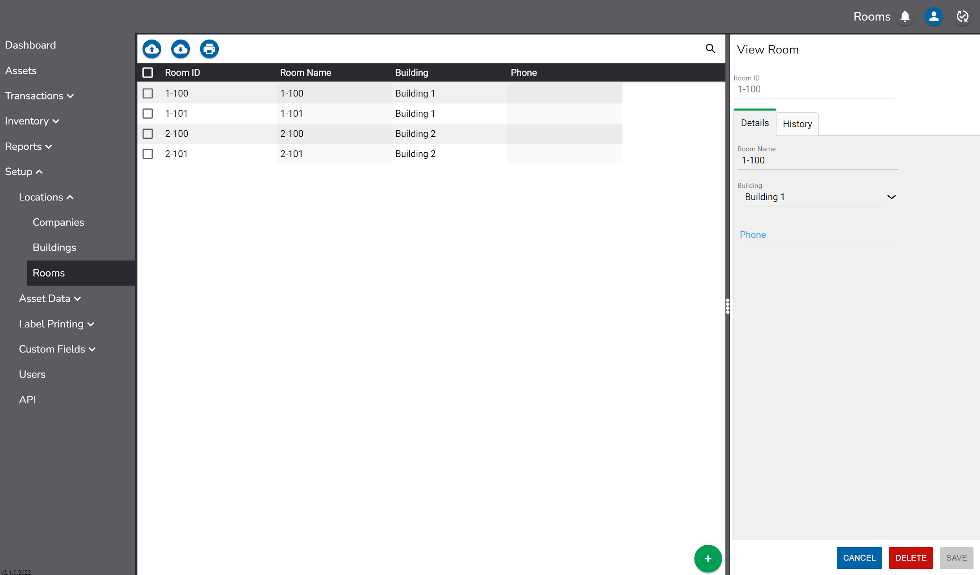

If using a supported barcode label printer, Room ID labels can be printed from the Rooms screen.

To print labels, check the boxes next to the desired rooms.

Then click the icon and select the desired Printer and Label Template.

A preview of the labels to be printed will display in addition to a count of the total number of labels to be printed.

Click Print to print the labels.

Asset Data

Users can assign asset metadata dropdown fields in RedBeam as Departments, People, Projects, Asset Types, Manufacturers, Models, Vendors, Accounts, Conditions, and Statuses and five custom dropdown fields.

Departments

Unlike Company, Building and Room which are physical locations where assets may be found, Departments are non-location-based groupings of assets that designate which division in an organization is responsible for the asset. Assets in the same location may be assigned to different departments.

Department details may include:

- Department Name
- Address 1
- Address 2
- City
- State
- Country
- Zip Code
- Phone
- Fax

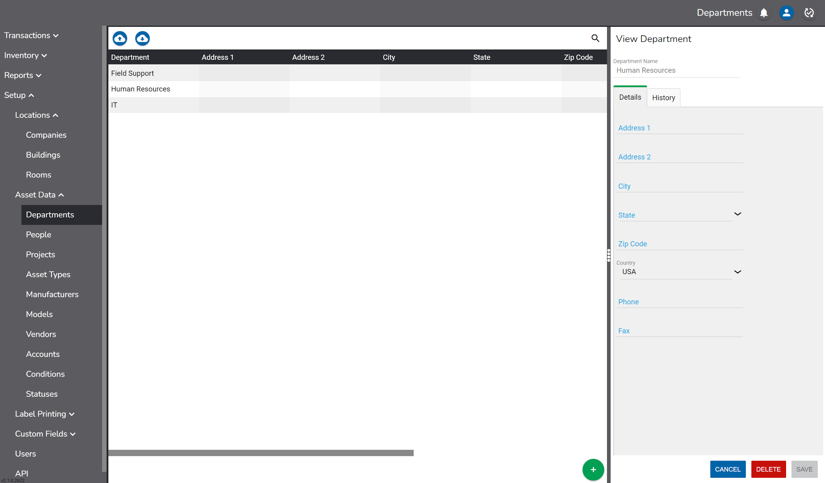

People

People are individuals to whom assets may be assigned or checked out to. People details may include:

- Name – This view-only field is what will display in the Person drop-down throughout the application user interface. It is created when the record is first saved and is a combination of: Last Name, First Name, Middle Name, Person ID.
- First Name
- Middle Name
- Last Name
- Email
- Job Title
- Person ID
- Address 1
- Address 2
- City
- State
- Country
- Zip Code
- Phone
- Mobile
- Fax

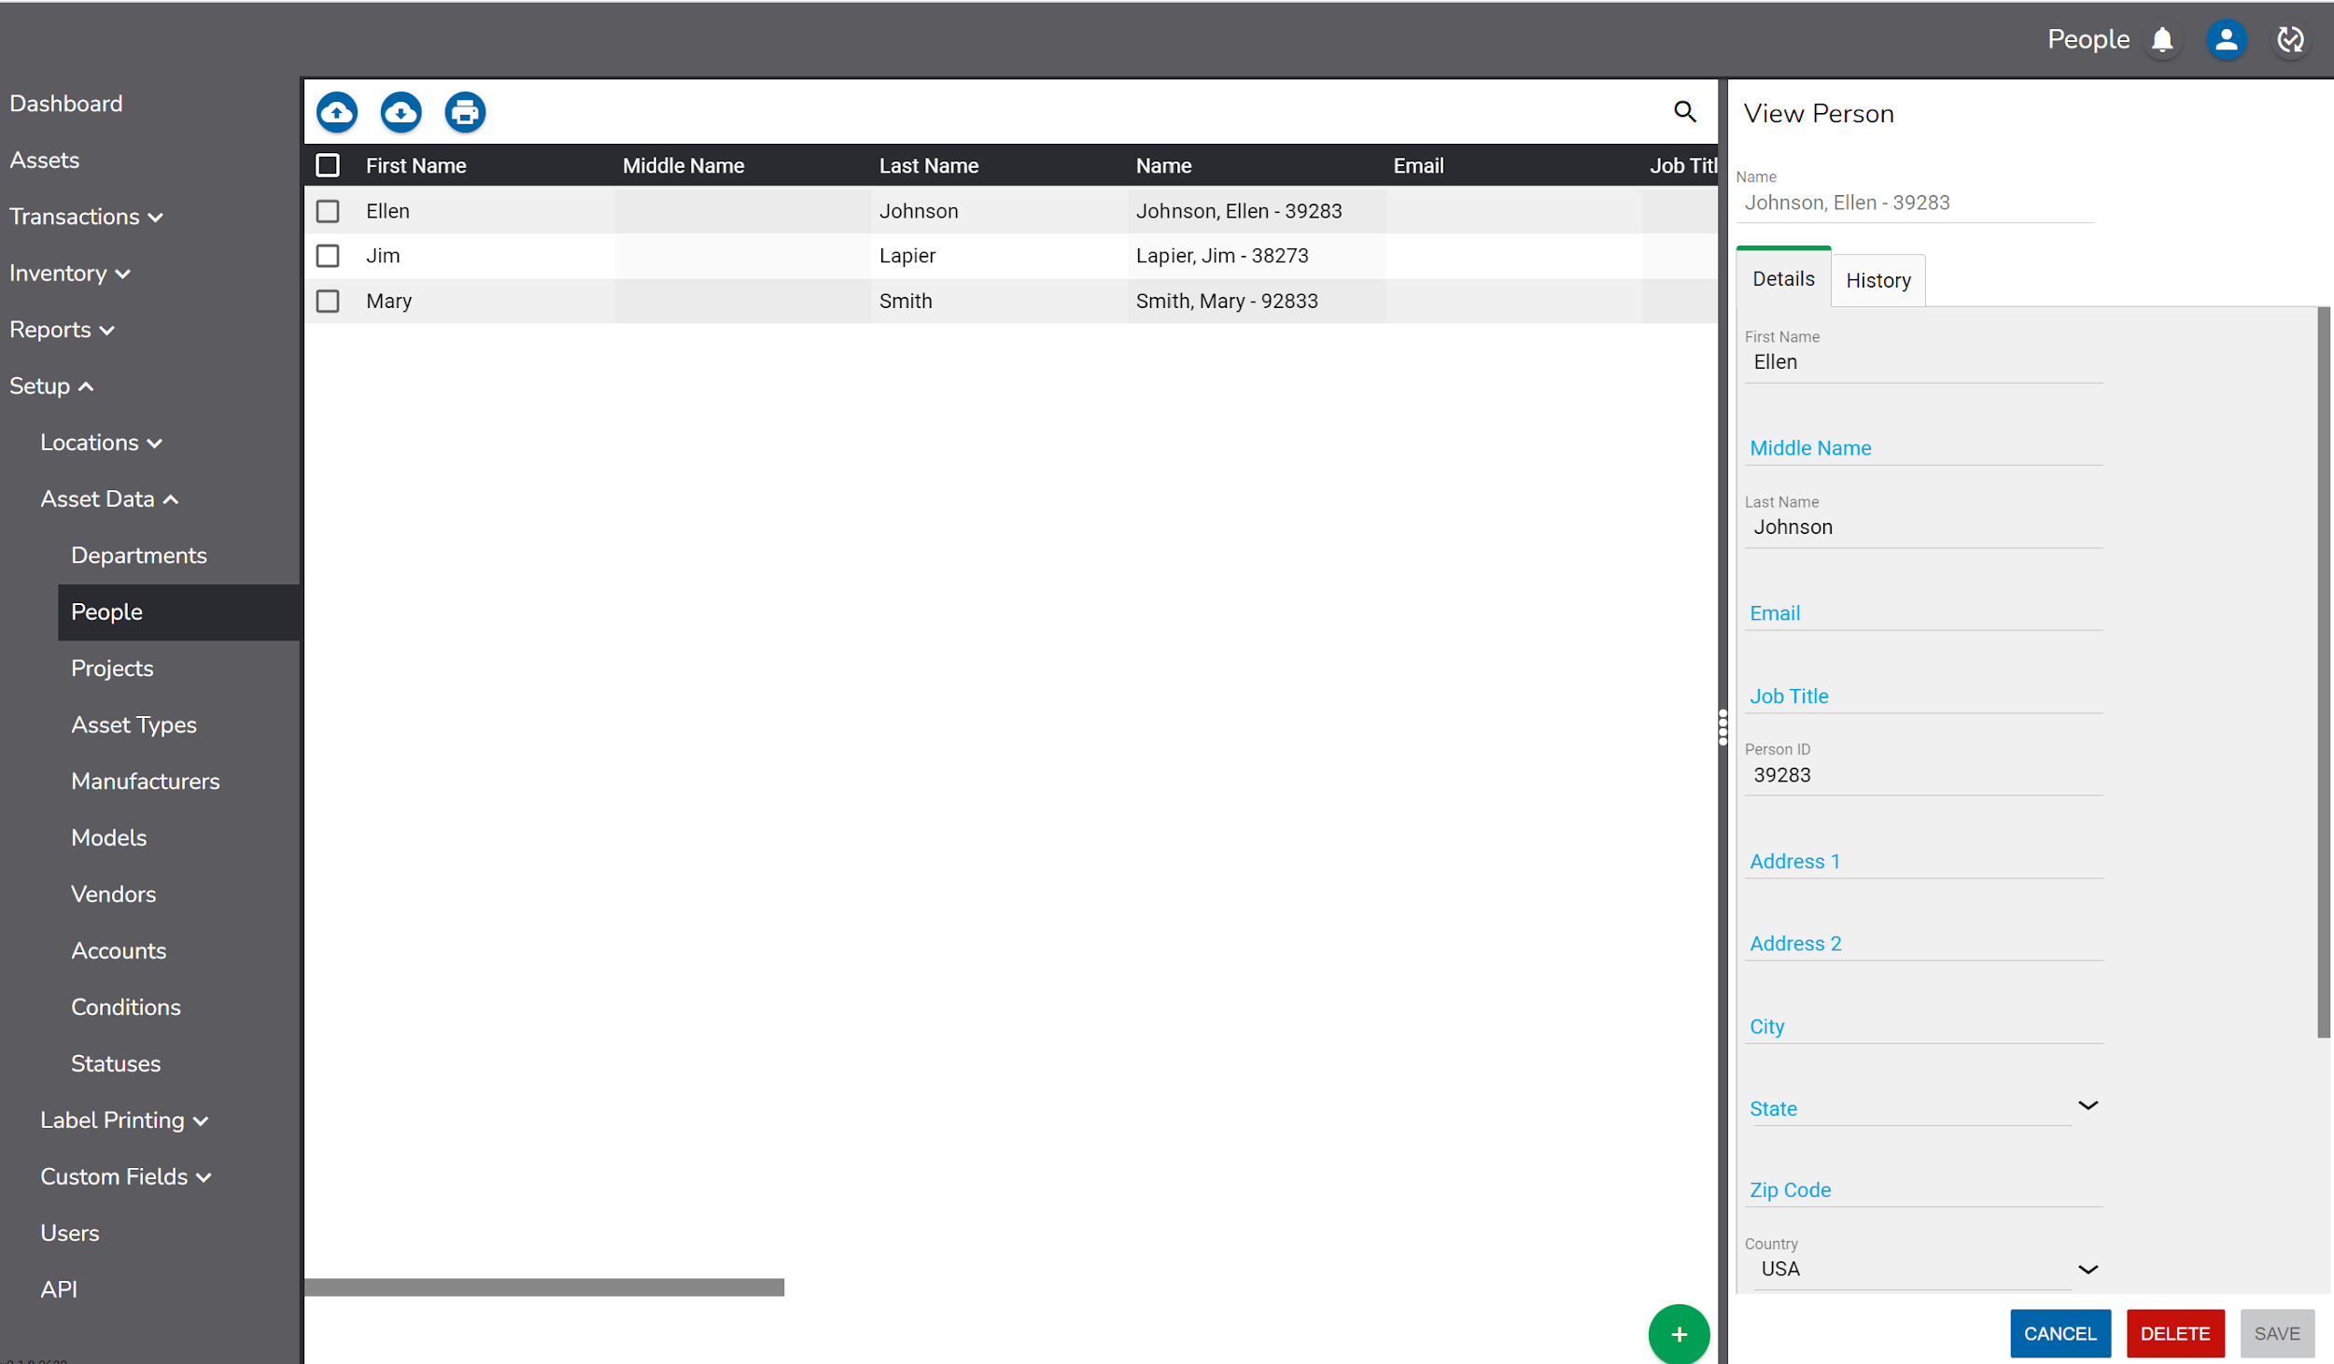

If using a supported barcode label printer, Person ID labels can be printed from the People screen.

To print labels, check the boxes next to the desired people.

Then click the icon and select the desired Printer and Label Template.

A preview of the labels to be printed will display in addition to a count of the total number of labels to be printed.

Click Print to print the labels.

Projects

Projects can be assigned to assets on the Details page during the Check Out process.

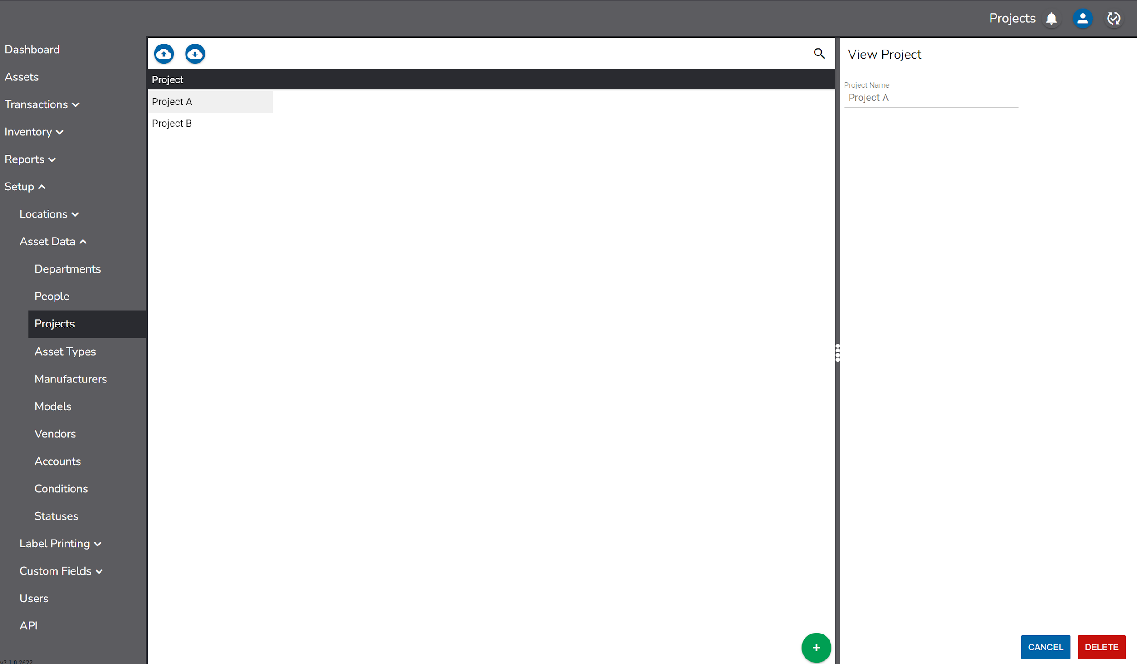

Asset Types

Asset Types are categories that generally describe an asset.

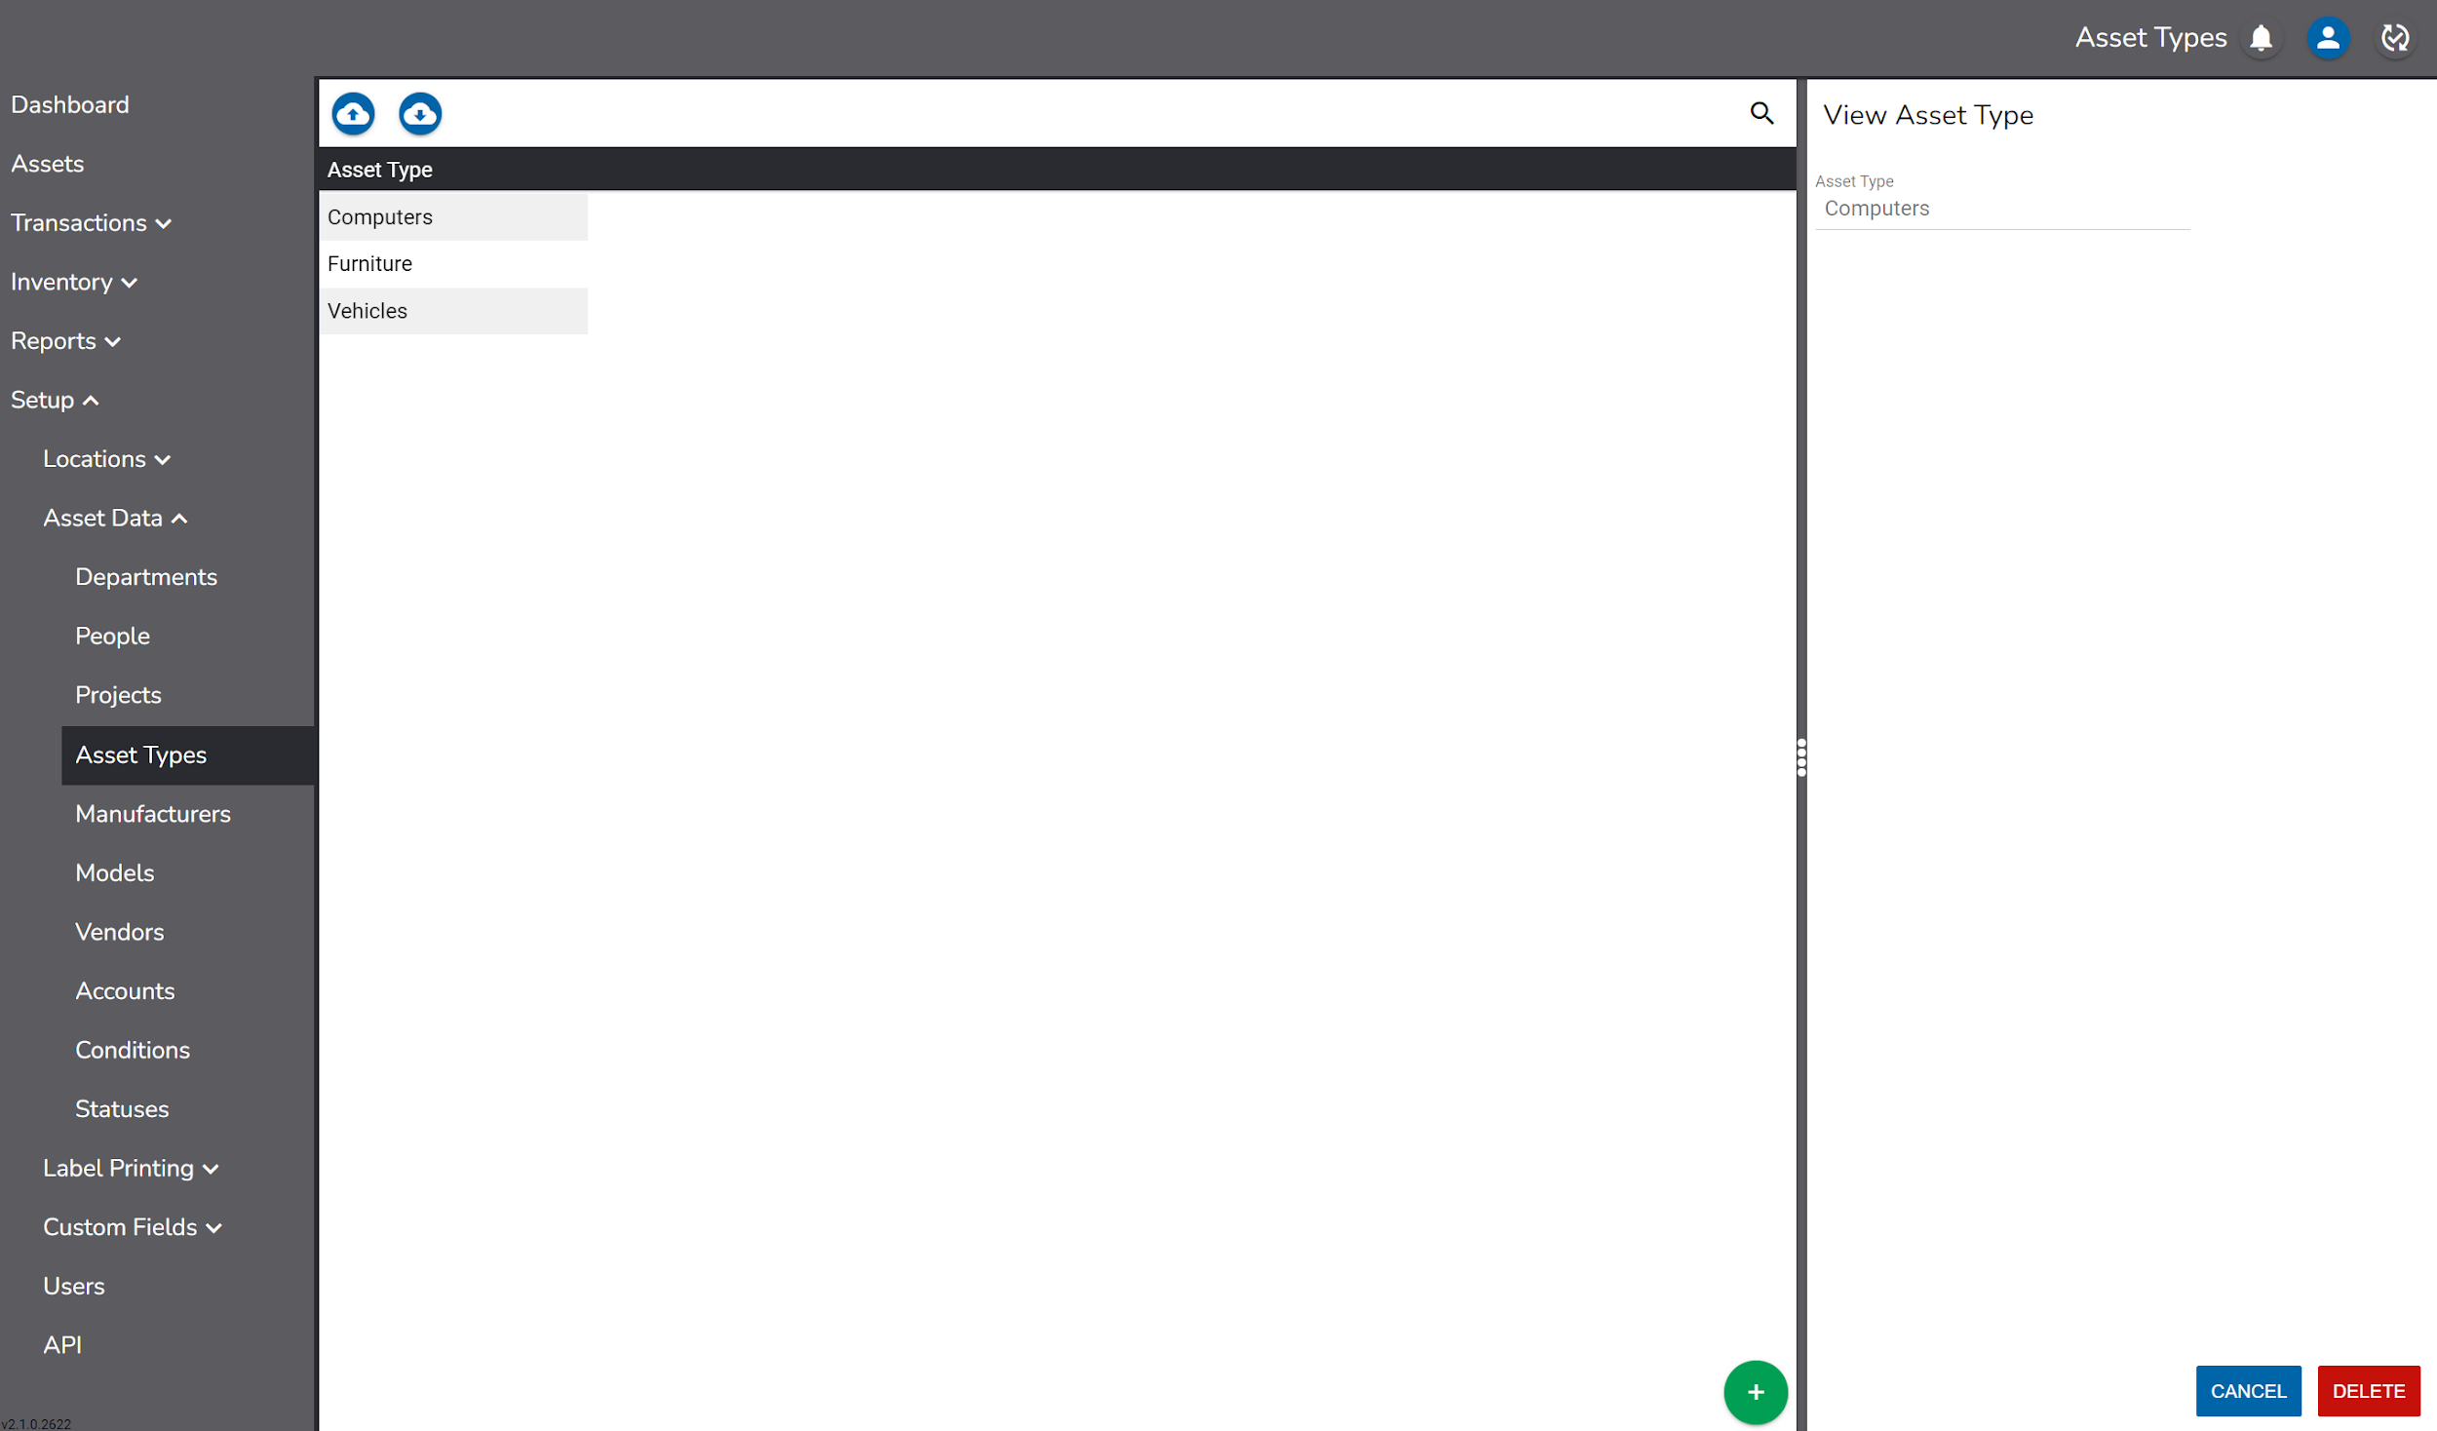

Manufacturers

Manufacturers are companies who produce or manufacture assets. Manufacturer details include:

- Manufacturer
- Address 1
- Address 2
- City
- State
- Country
- Zip Code
- Phone
- Fax

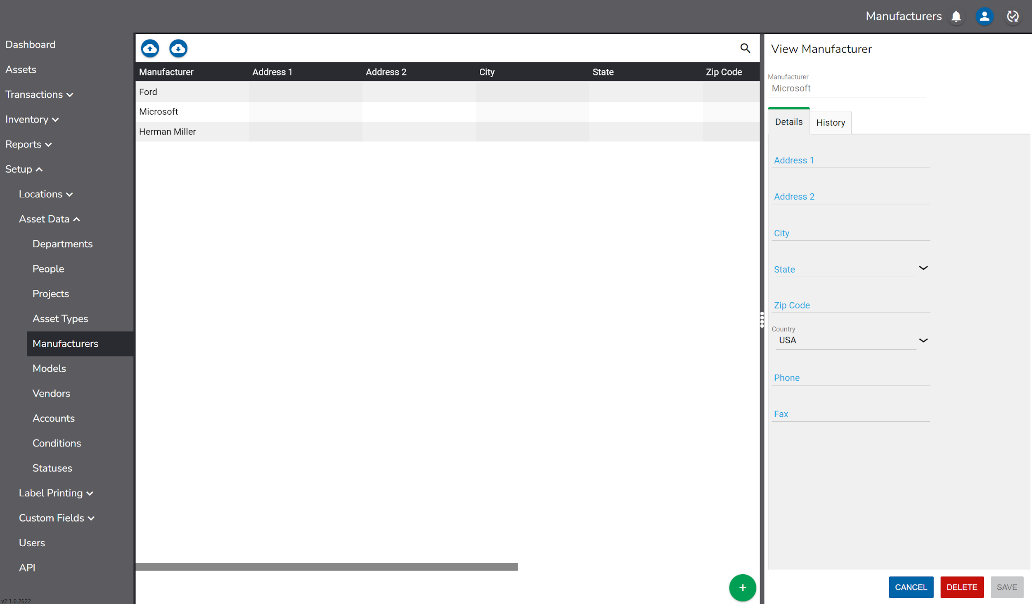

Models

A Model is a name given by a manufacturer to a type of product to help identify it.

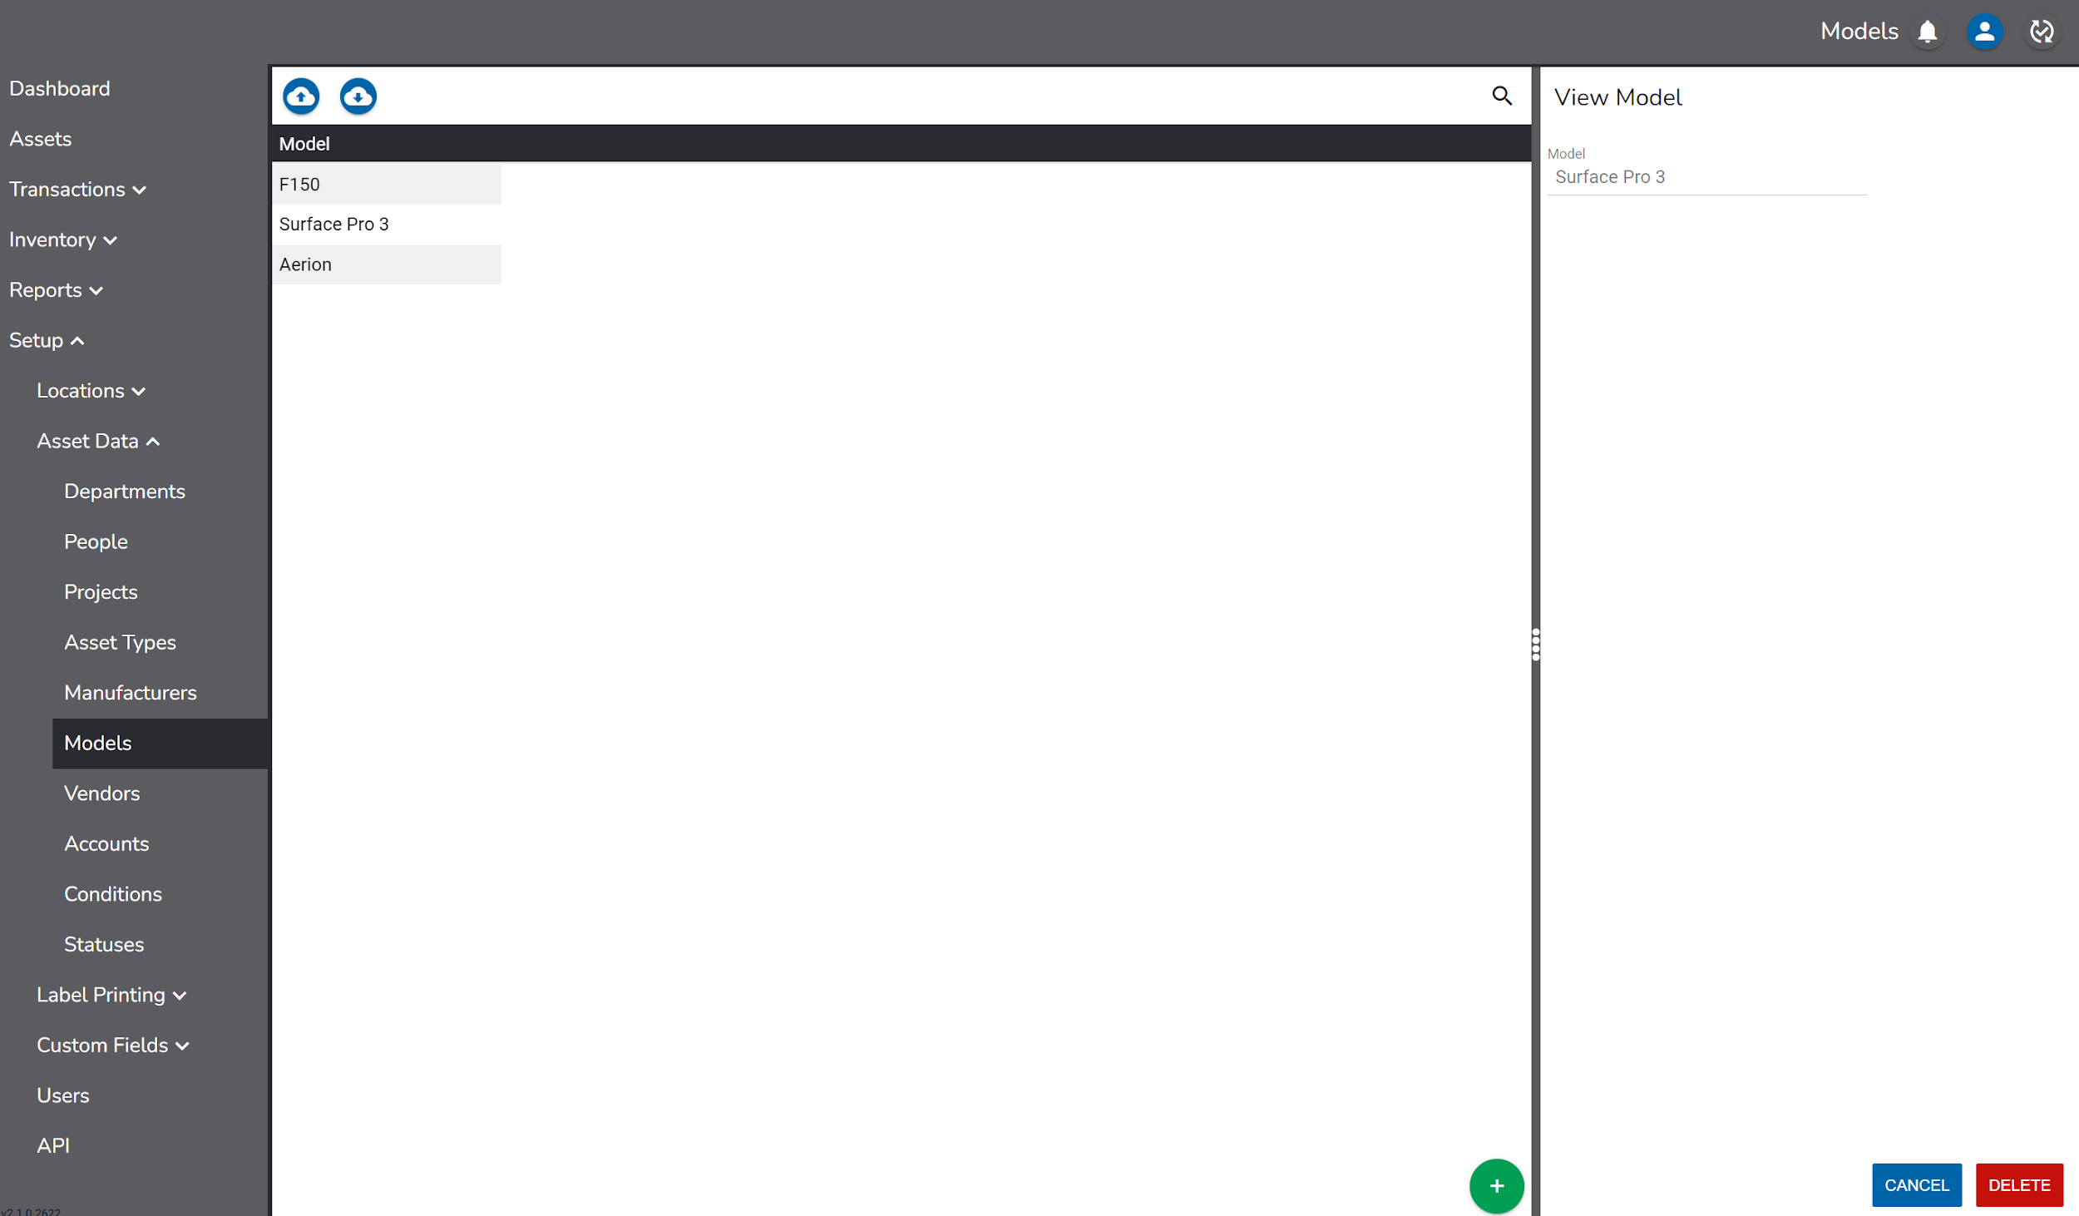

Vendors

Vendors are companies from whom assets are purchased. Vendor details include:

- Vendor
- Address 1
- Address 2
- City
- State
- Country
- Zip Code
- Phone
- Fax

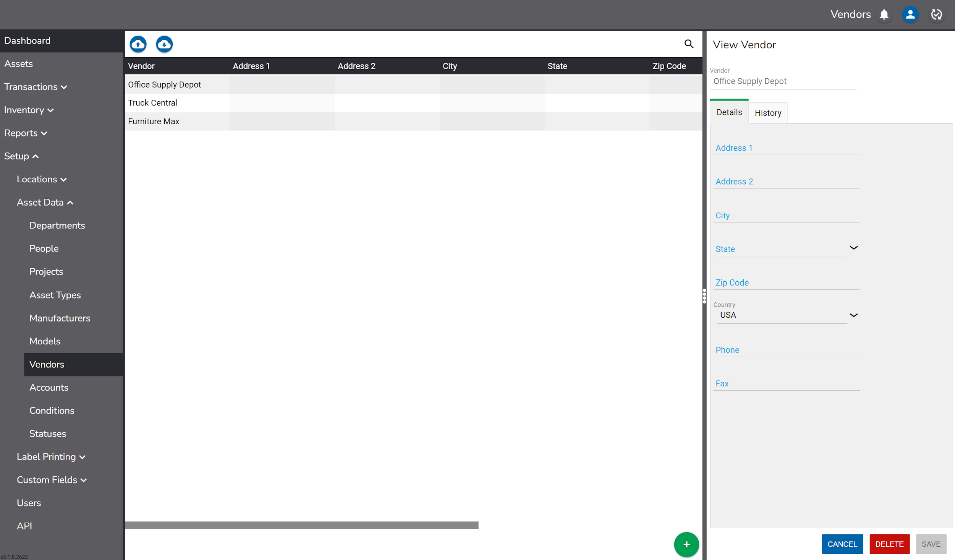

Accounts

Accounts can be used to record financial groupings such as G/L accounts, cost centers or grant numbers.

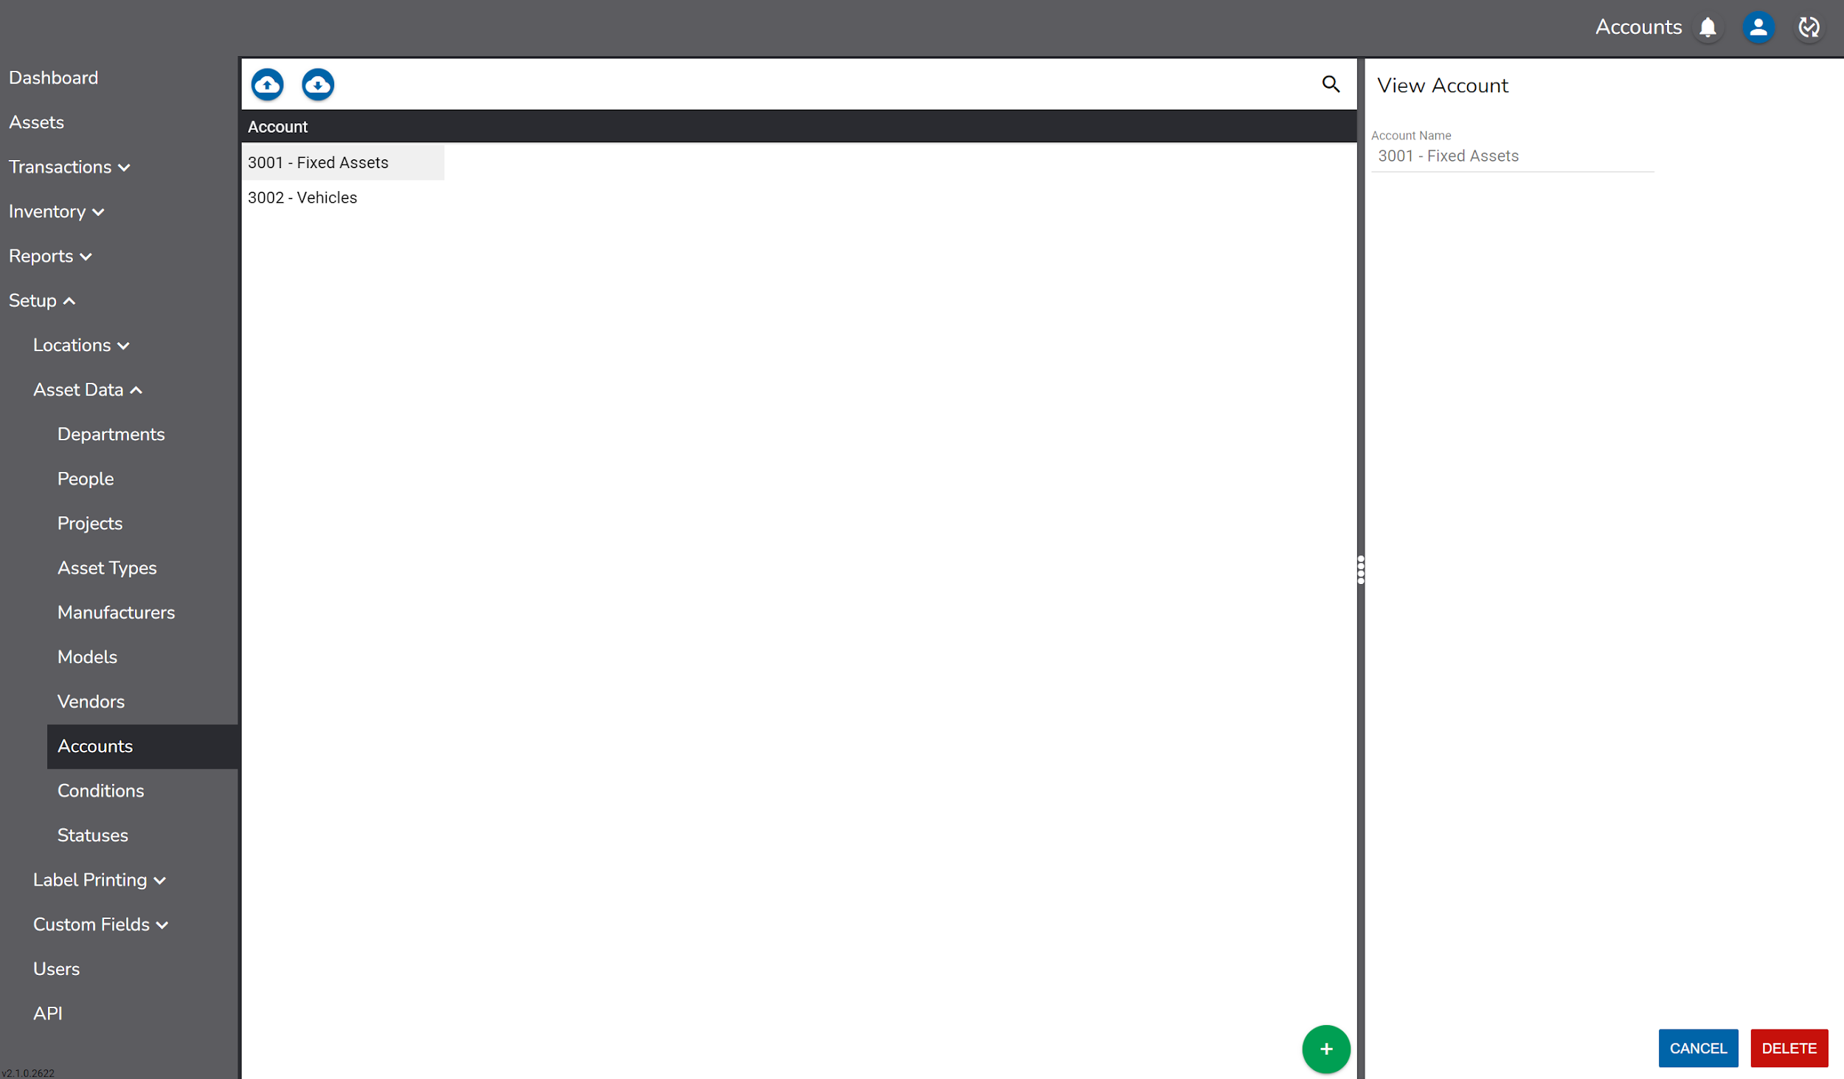

Conditions

The Condition of an asset is a subjective measure of the health or useful life of an asset.

Typical asset conditions include “New”, “Good”, “Fair” or “Poor”, but could be step up as any value that reflects how an asset’s condition is measured.

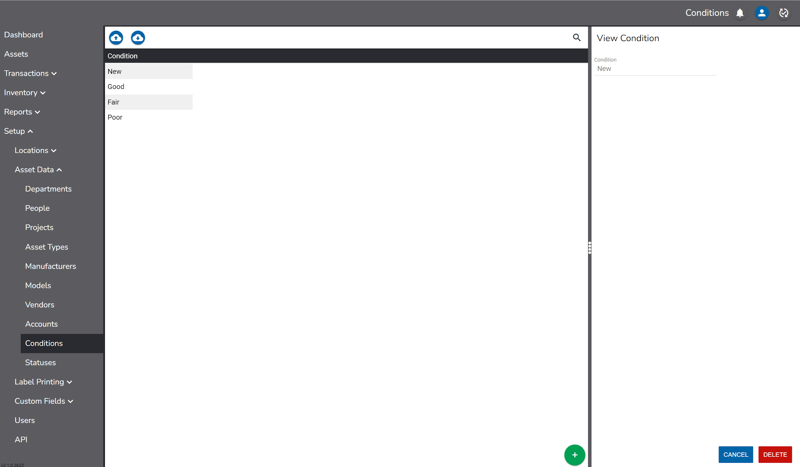

Statuses

The Status of an item indicates how or if it is being used. Common statuses include “Active”, “Inactive”, “Out for Repair” or “Retired”.

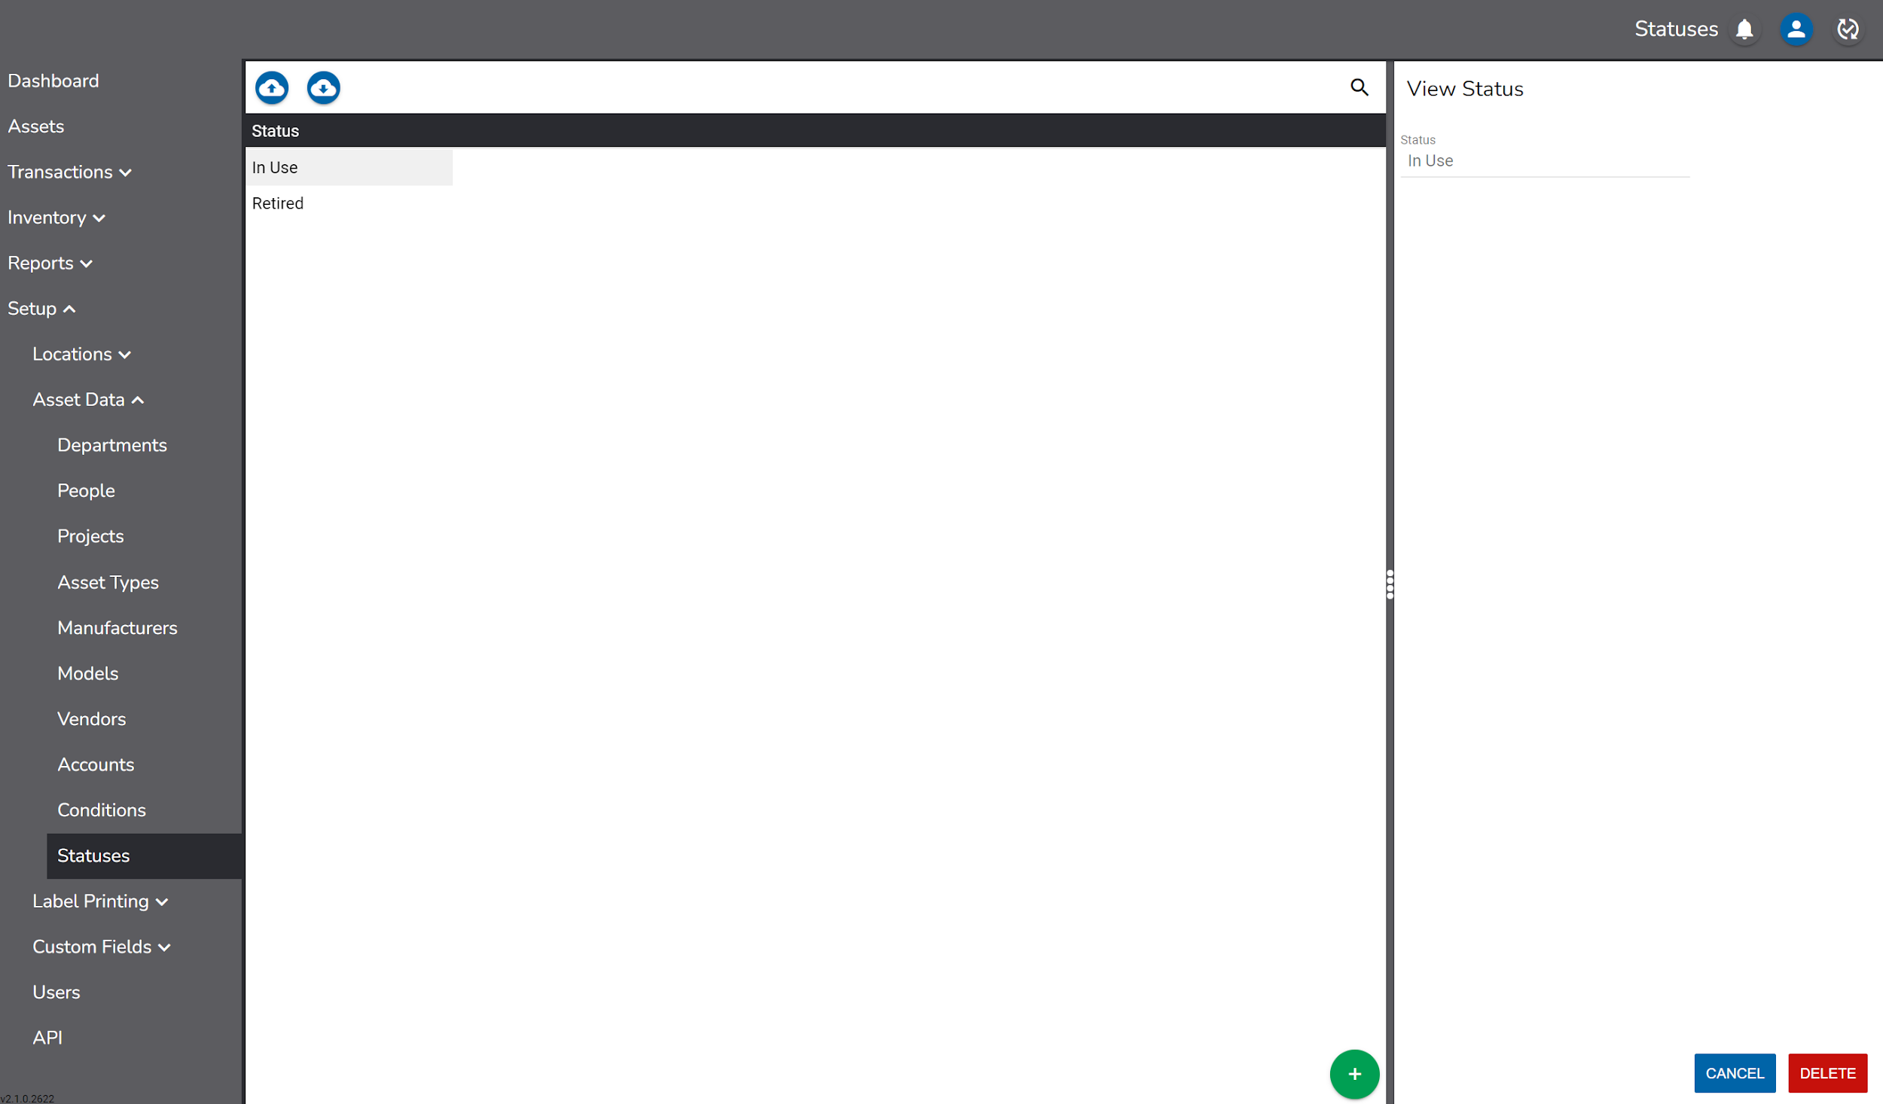

Custom Fields

In addition to the user definable free text, date, and toggle fields in the Custom tab on the asset record, five custom drop downs are also available. Values for these drop downs are entered under Custom Fields.

To change the name of custom fields, see the Caption Override section of this document.

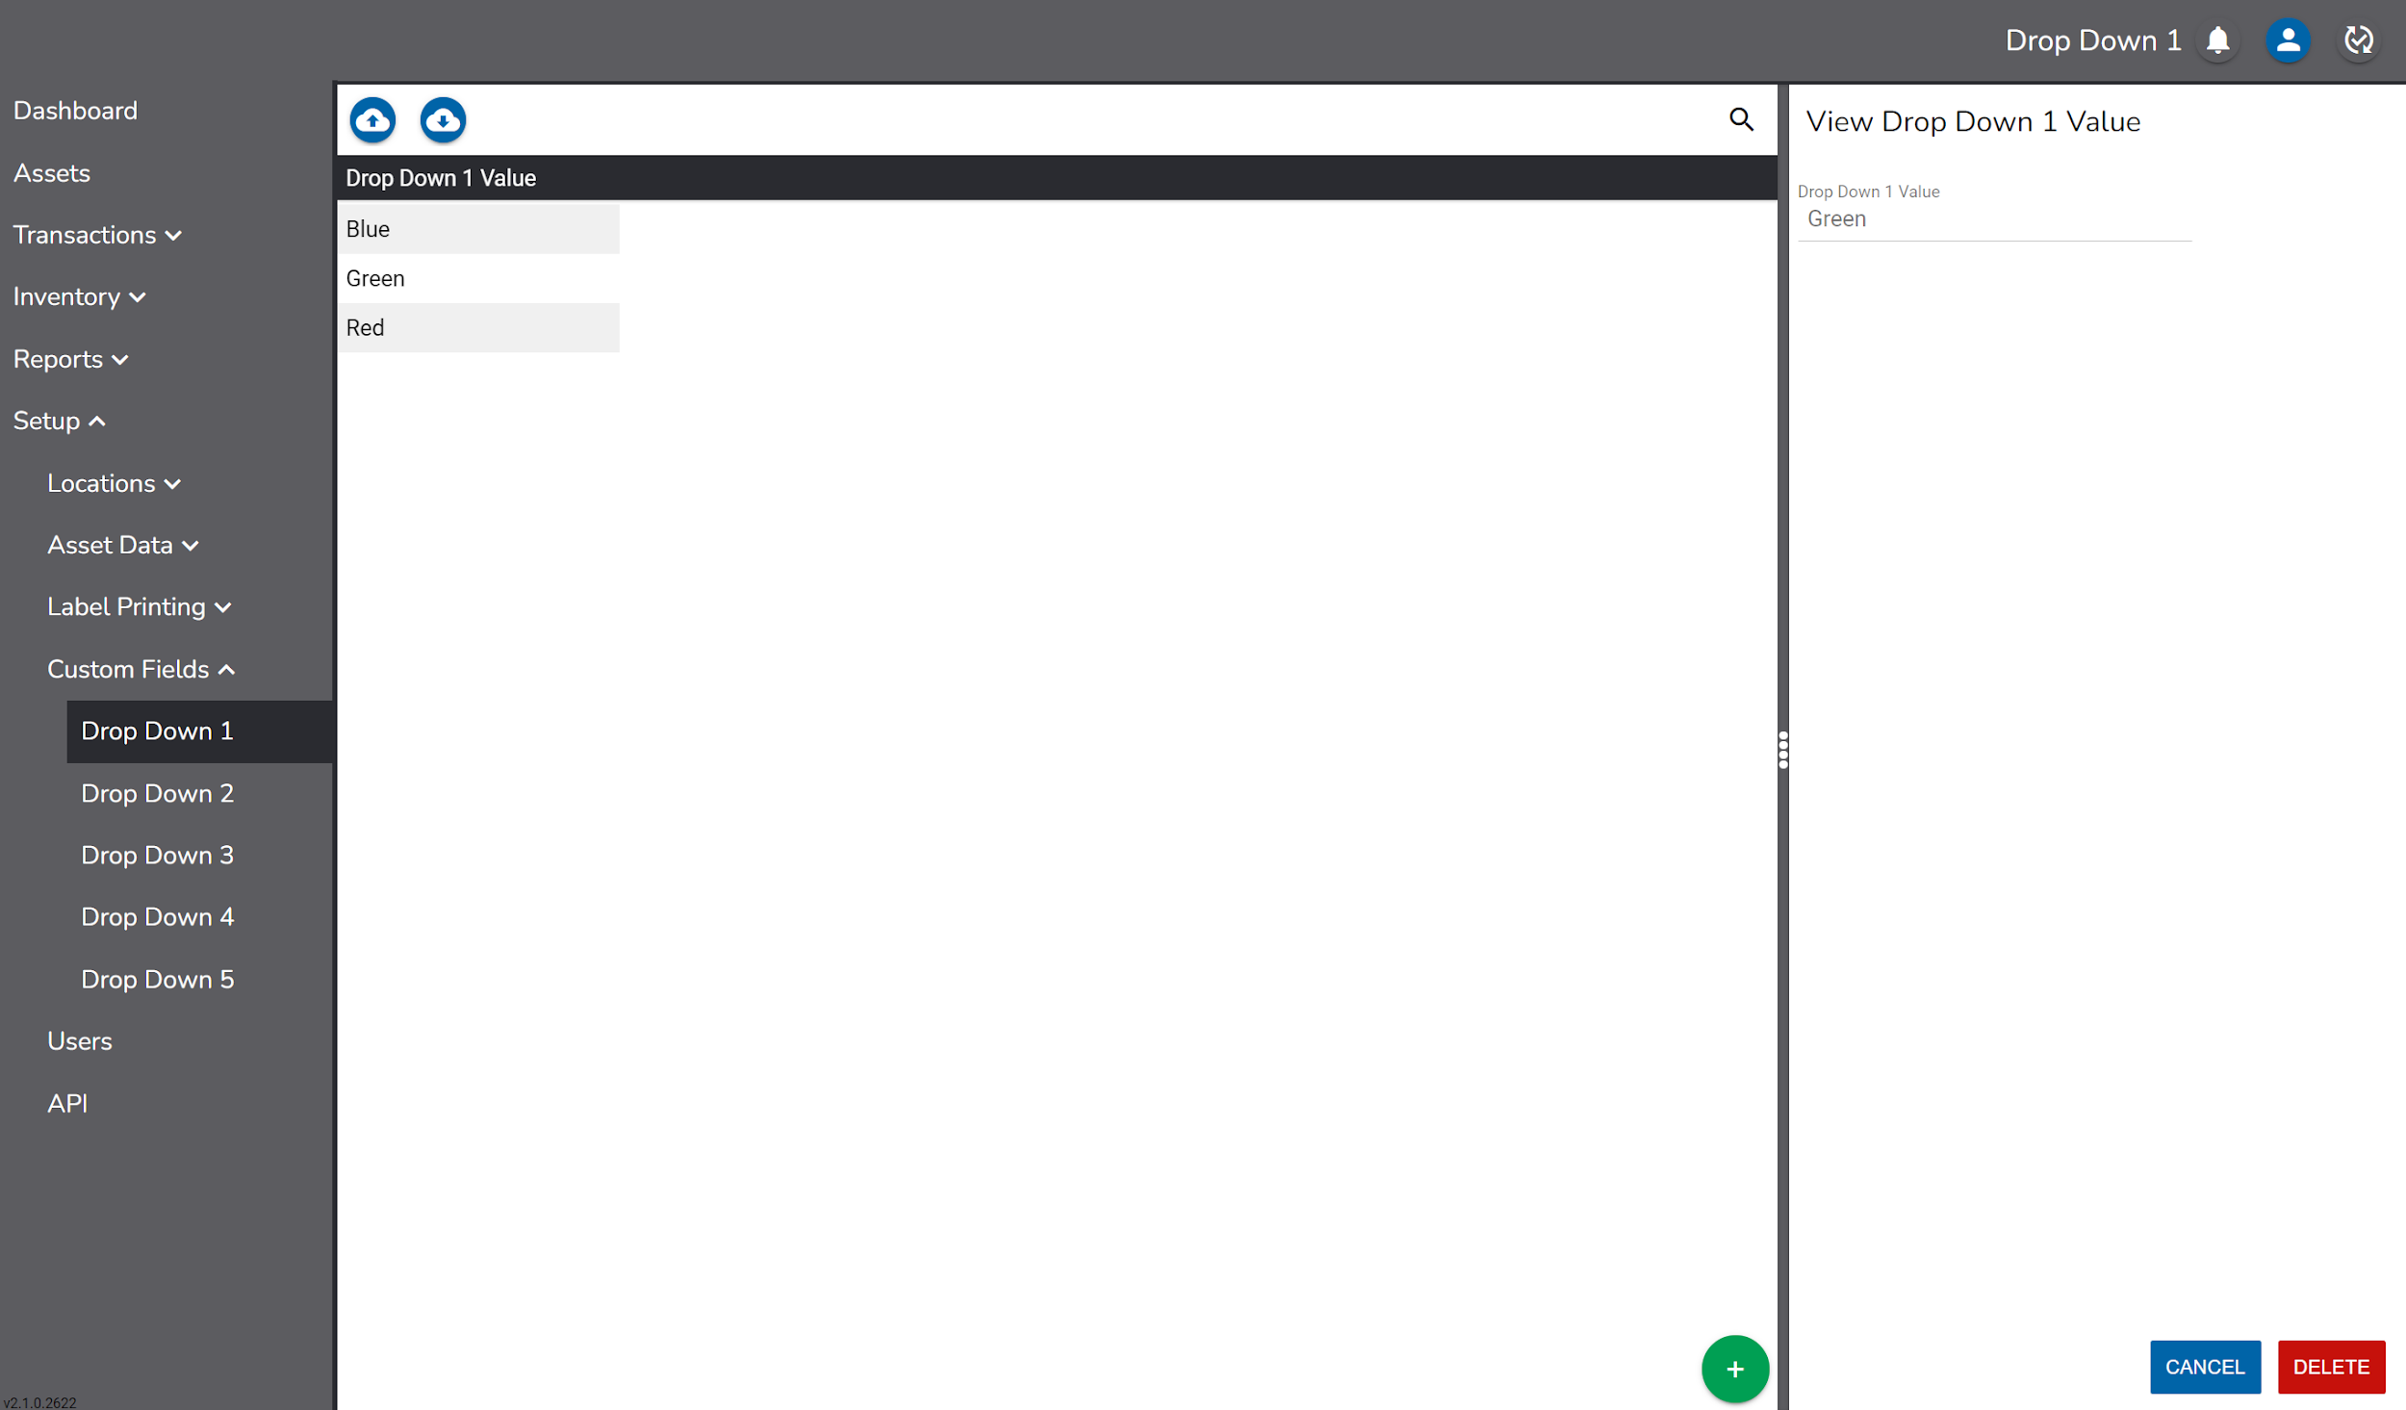

Label Printing

Label Printing allows users set up a compatible label printer, create label templates and print sequential labels.

Printer Setup Instructions

Before labels can be printed from RedBeam, the printer must be connected to a network and the IP address will need to be configured within RedBeam.
1. Once you have tags loaded into your printer, connect a network cable to the rear of the printer.
2. Connect the other end of the network cable into an available port on your network.
3. Plug your power adapter into the rear of the tag printer and plug the power cable into an available AC outlet.
4. Power the tag printer on by pressing and holding the power button for about 5 seconds and then release the power button.
5. Once the tag printer has finished powering on, press and hold the Feed and Cancel buttons for two seconds and then release. This will print out a configuration page as shown below. Please note that by default, a new tag printer will obtain an IP address via DHCP.
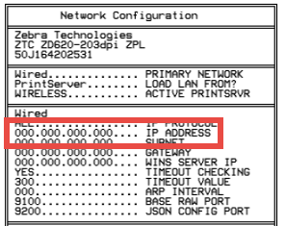
6. Download the Zebra print utility here.
7. Right click on that downloaded file name zebra-browser-print-windows-v131445(.exe) and select Properties > Compatibility > Change high DPI settings.
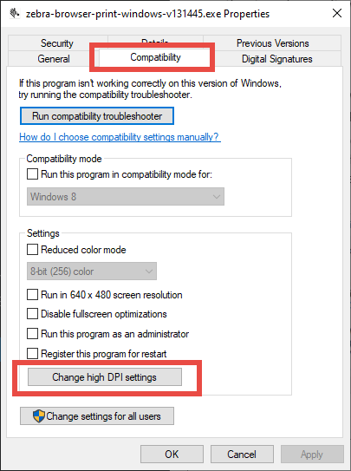
8. Check both boxes and select System from the dropdown. Then click Ok, and Ok again.
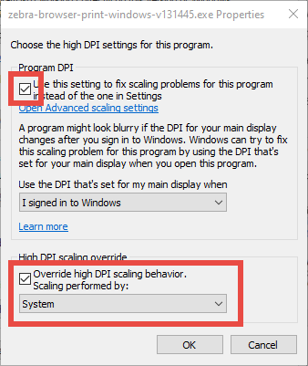

9. Double click the file zebra-browser-print-windows-v131445(.exe) to start the installation and click Next until you get to install. Then click Install. Make sure to keep the box checked for Launch Zebra Browser Print before clicking Finish.
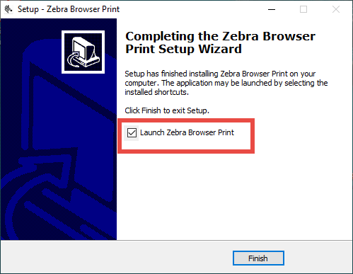
10. You will receive a message that security needs to be accepted. Click OK.
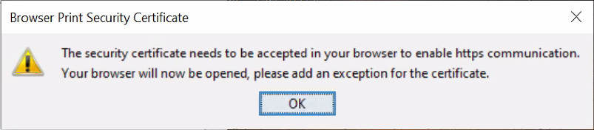
11. Then you will see a webpage showing your connection isn't private. Click Advanced and click Continue to localhost.
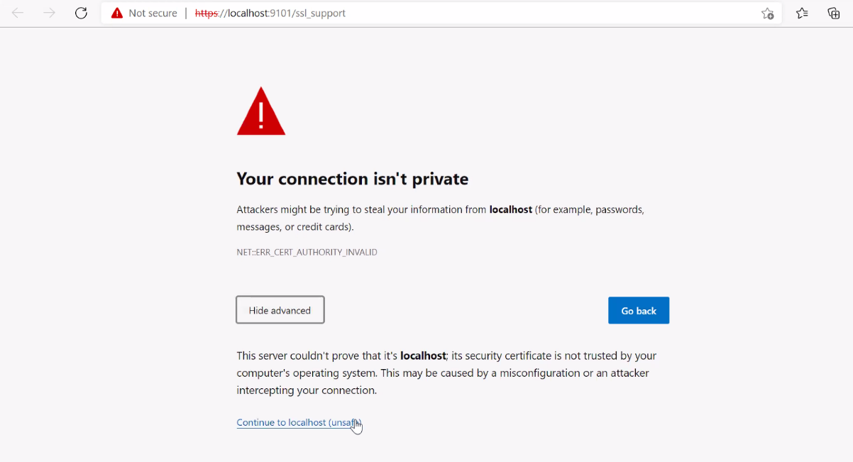
12. Select Yes to give your computer access to the Zebra printer.
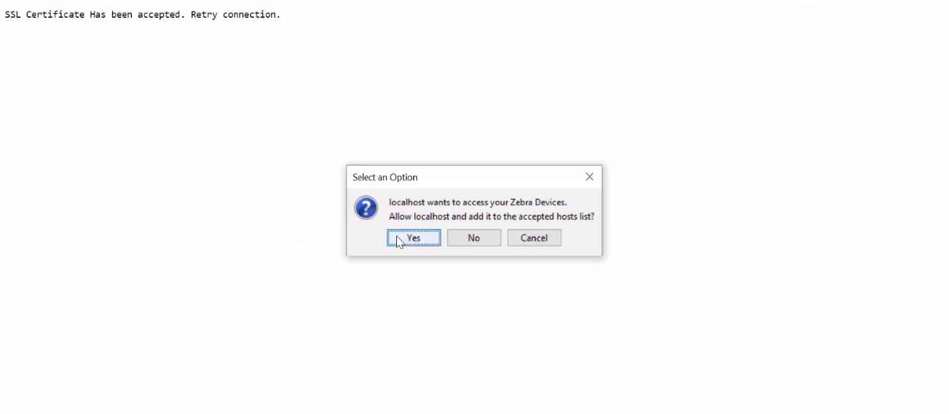
13. Open your task tray at the bottom right and select Browser Print.
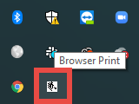
14. Under Added Devices, select Manage.
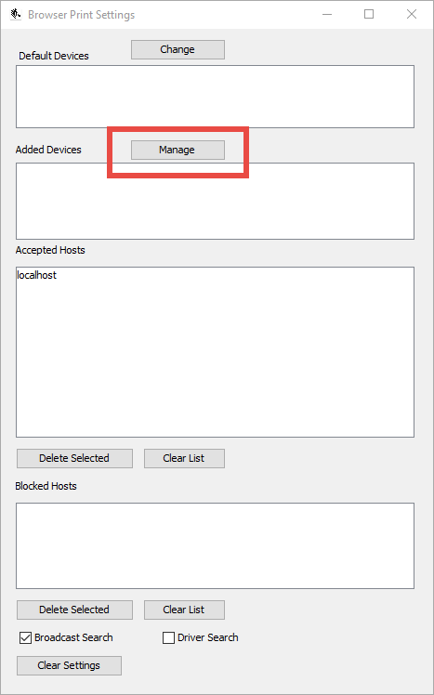
12. Enter any printer name as you would like it to appear. Then enter the printer's IP address (from step 5) for Device Address and click Add.
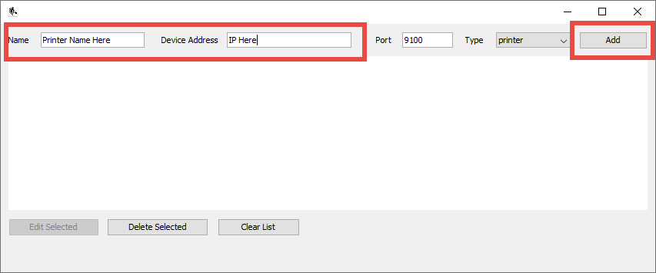
13. Login to your RedBeam account and go to the Assets page.
14. Check the box for any asset and click the Printer icon.
15. Select the printer from the dropdown.
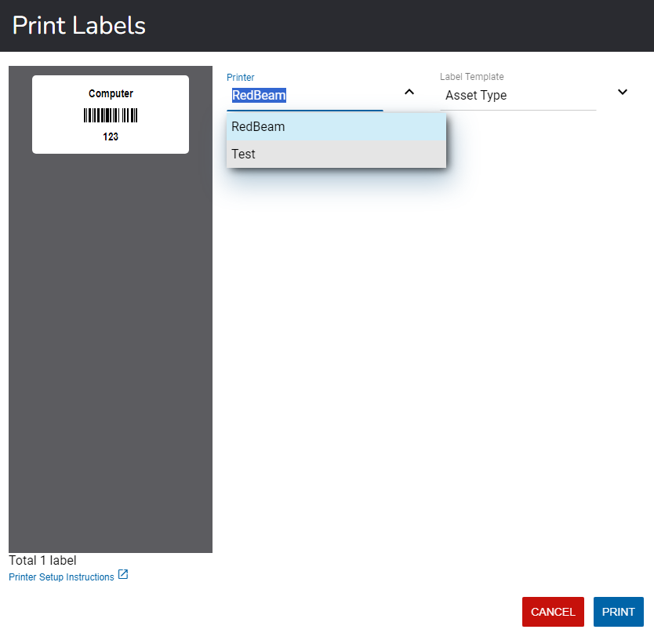
16. Click Yes to allow RedBeam access to your Zebra printer.
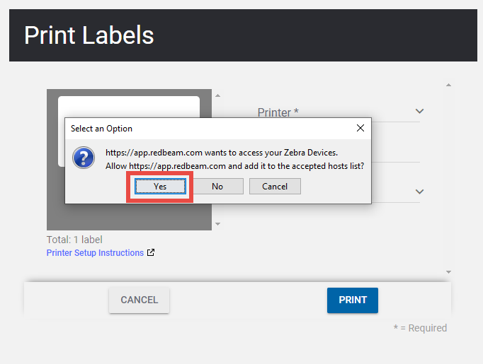
Your printer is now configured to print barcode labels from RedBeam.

Label Templates

To create a Label Templates, click the button and enter a Template Name that is representative of the type of label being created (i.e. My Company Asset Label).

To add content to the label, click the button in the Label Content section and choose from Fixed Text, From Field or Barcode.

Choosing Fixed Text allows the user to enter a line of text that will always appear on the label.

Choosing From Field allows the user to choose a data field that will be populated on the label based on information in the Asset, Room or Person record selected to print.

Choosing Barcode allows the user to populate the label with a barcode and its corresponding human readable value.

Click Save to save the label format.

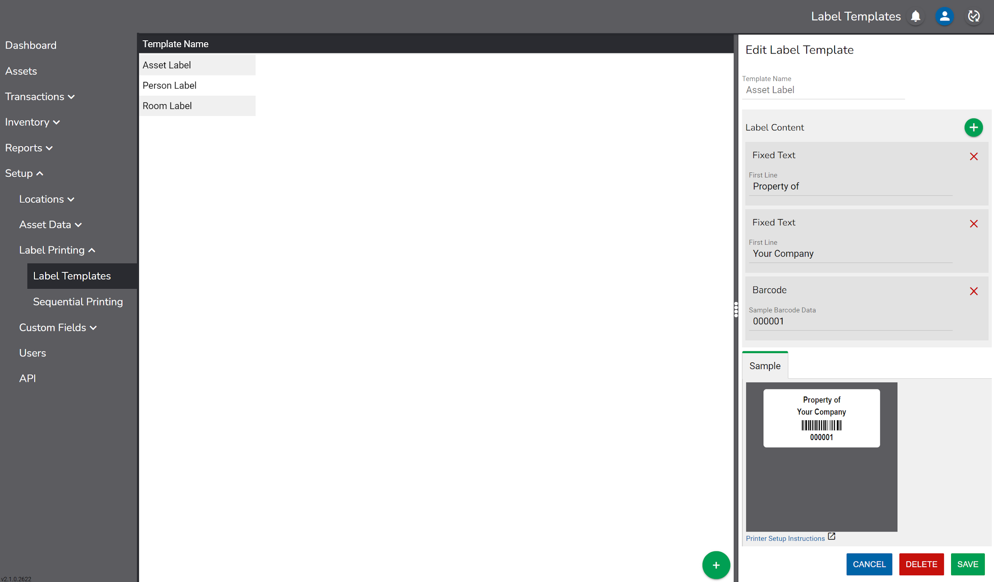

Sequential Printing

It is common for users implementing an asset tracking system for the first time to start from scratch without barcodes or Asset ID’s.

If this is the case, it is to print a series of sequential labels. Users can then go from asset to asset, apply the next label in the series, scan the barcode and enter information about that asset into RedBeam.

To print sequential labels from the Sequential Printing screen, enter the starting number (i.e. 100) in the Start field and the ending number (i.e. 199) in the End field. Then select a Printer and a Label Template. A preview of the labels will display. Click Print to print the labels.

There are several other options to choose from when printing sequentially.

To add a prefix to all the labels being printed (i.e. ABC), enter the prefix in the Prefix field. Labels starting at 100 will print as ABC100, ABC101 and so on.

The increment can be changed to something other than 1 by changing the value in the Update field. When this value is 1, labels starting at 100 will increment one at a time (i.e. 100, 101, etc.). If this value is changed to 2, as an example, the labels will increment 2 at a time (i.e. 100, 102, etc.).

To keep asset labels all the same number of digits, enter the number of digits desired in the Pad to Maximum Length of field. If this value is 4, as an example, labels starting at 100 will print as 0100, 0101, etc.

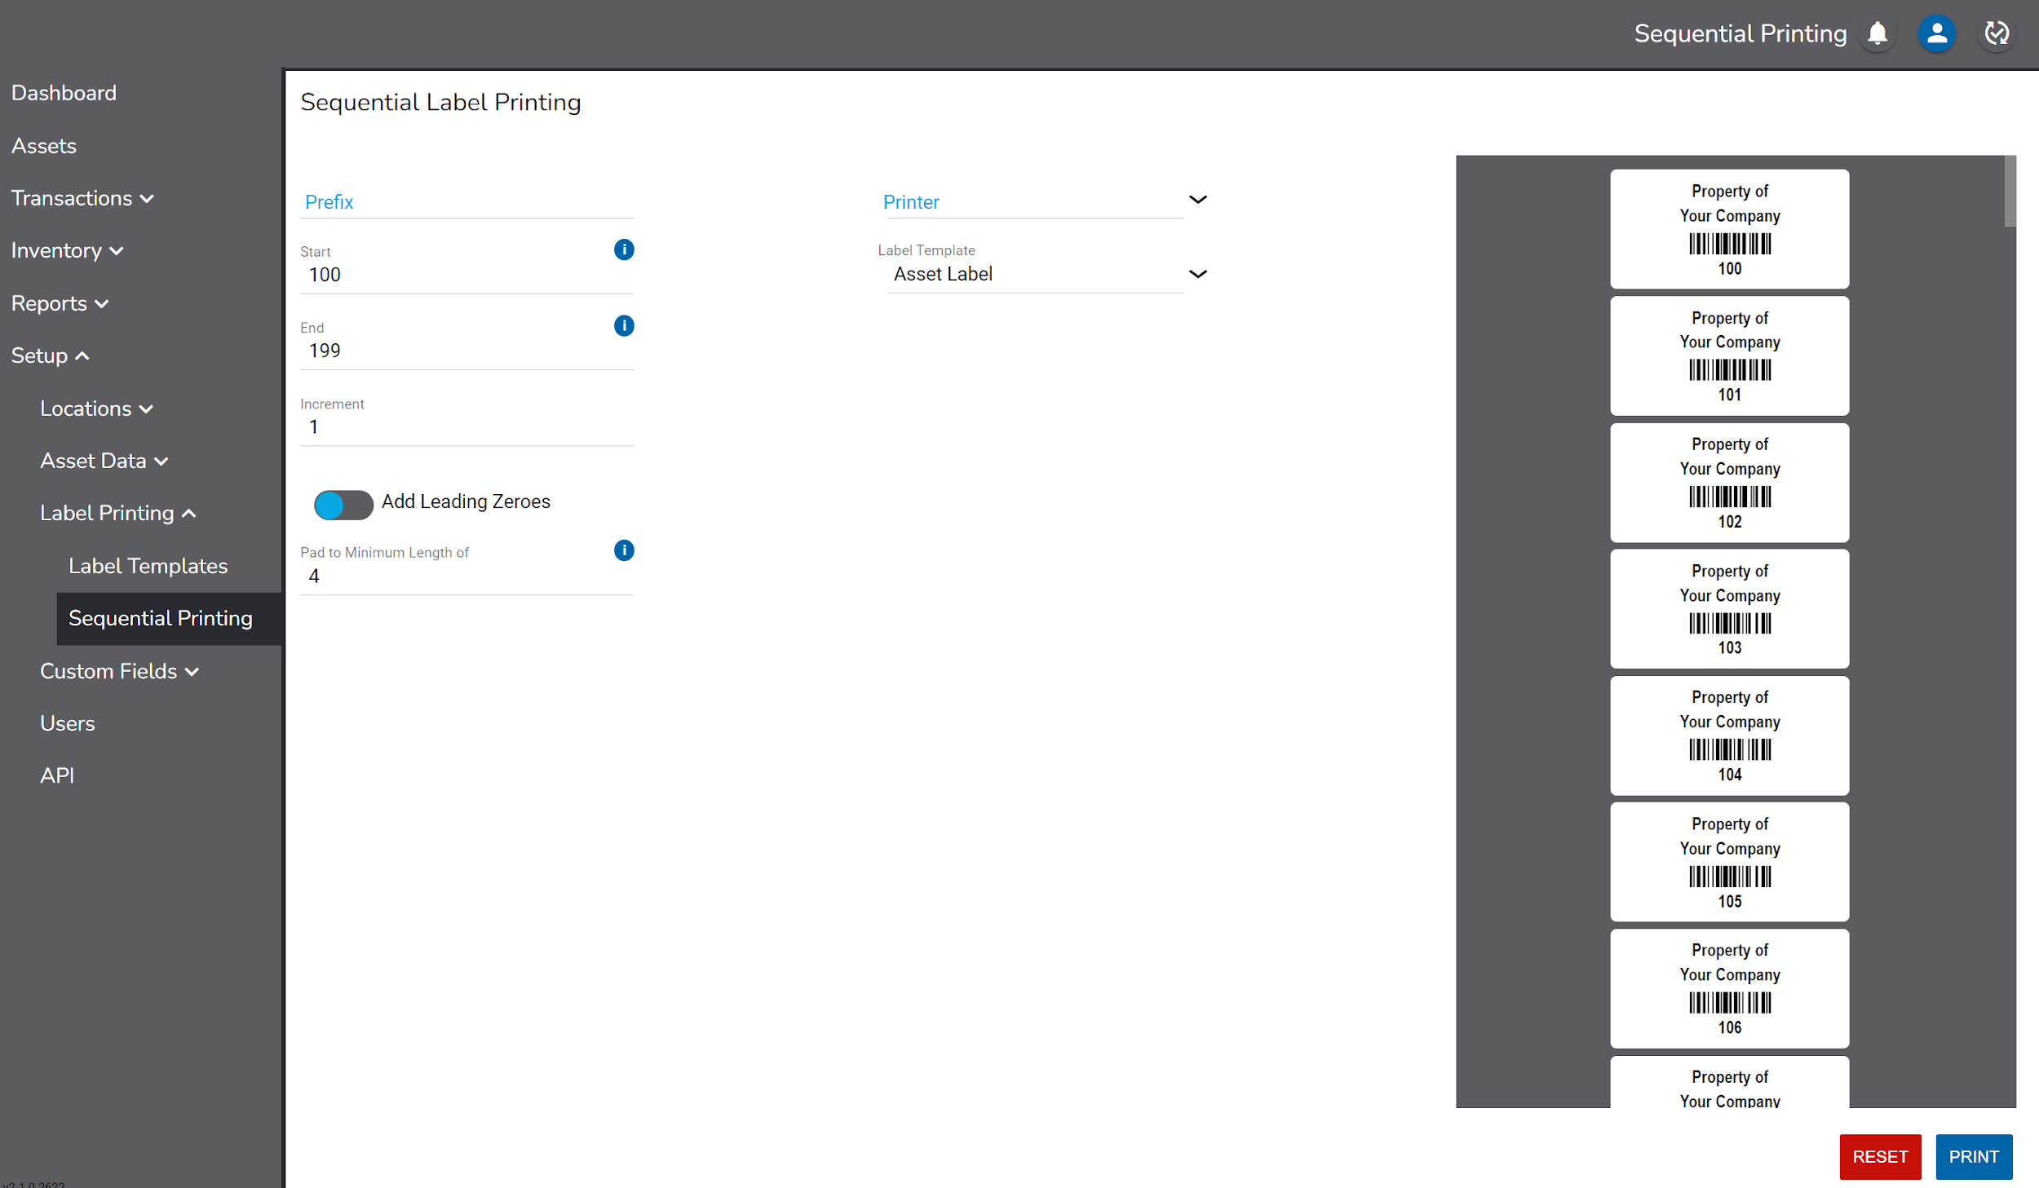

Caption Override

Caption Override allows Admin users to configure the titles of the custom fields.

Type the desired title in the desired position and click Save.

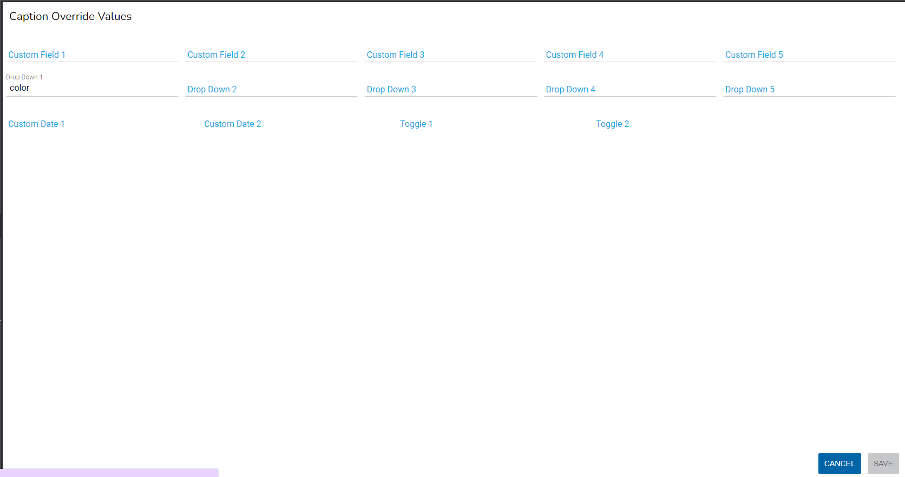

Users
Users may be added to the system up to the number of licenses purchased.

To create a User, click the button and enter:

- First Name
- Last Name
- Email
- Role

Users assigned the “Administrator” role have full access to the system features.

Users assigned the “User” role will have not have access to Manage inventories, Users or APIs.

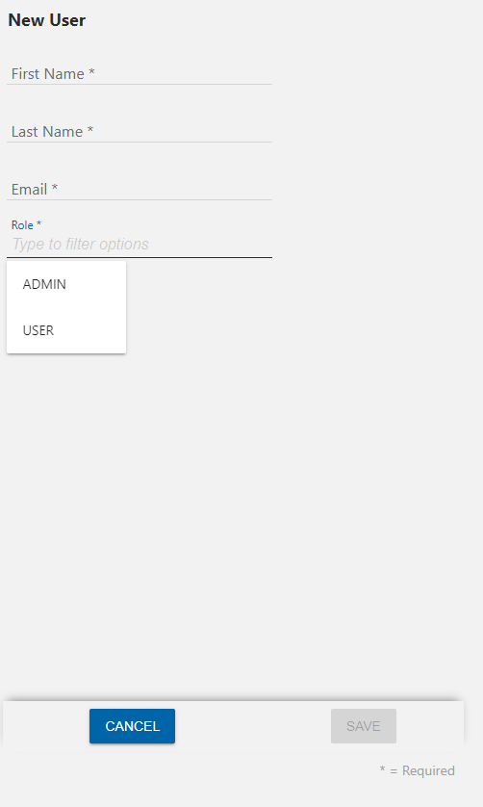

Click Save to create the User. Once saved, the new user will receive an email with a link that will allow them to create their password and log in to the system.

To edit or delete a User, select the User by clicking on it in the grid and make the desired changes.

Deleting a user will prevent the deleted user from accessing the system and free up a user license.

API

RedBeam provides RESTful API’s that can be used to integrate with other systems.

API’s can be accessed under the API tab.

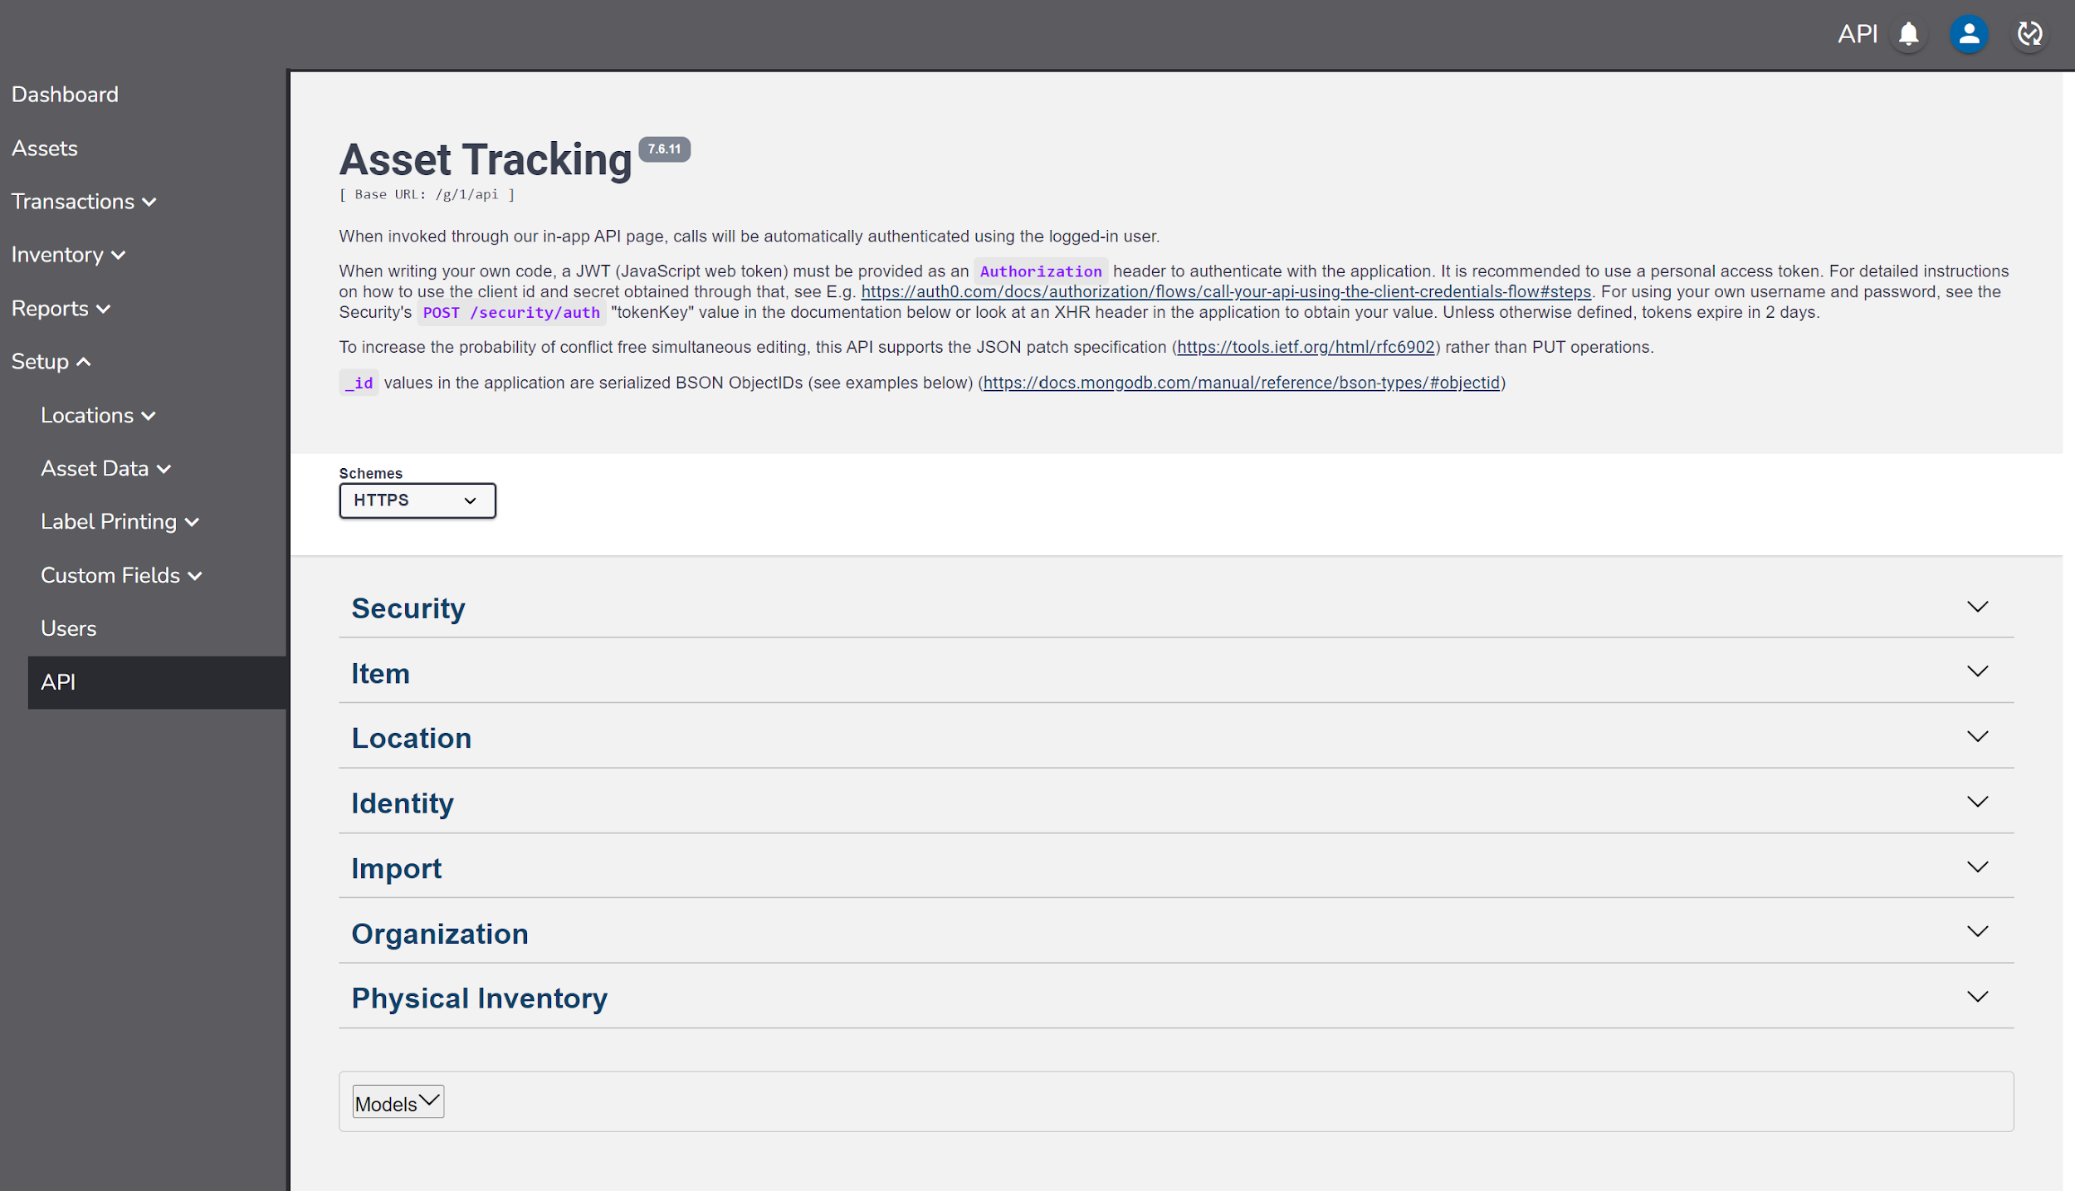

Mobile Functions

Users can access the application on a mobile device through a compatible web browser by going to redbeam.com and clicking Login or by going directly to app.redbeam.com.

On the Login screen, users can enter their login credentials. If forgotten, users can reset their passwords form this screen.

The mobile Menu displays the mobile functions including Update, Transactions, and Inventory.

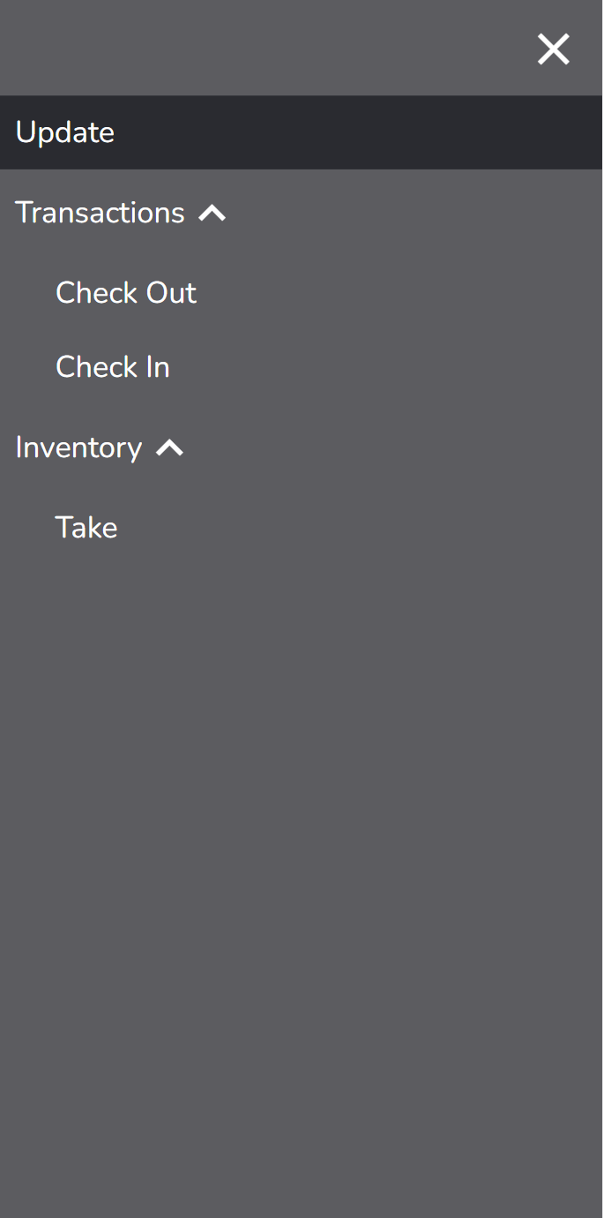

Update

The Update function is used to create, edit, view, or delete assets.

To create an asset, scan or enter a new Asset ID. To edit an existing asset, scan or enter an existing Asset ID. If using a mobile device with a camera, the camera can also scan a barcode by clicking on the 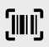 icon.

For convenience, the system will suggest one number higher than the highest Asset ID in the system for a new asset. This can be overwritten. The only required field to create an asset is the Asset ID field.

When done entering asset information, click the Save button to create the asset.

A copy of an existing asset can be made by clicking the Copy button.

To delete the asset, click the Delete button. A warning message will display prior to deletion.

To edit an existing asset, click the asset record in the grid. Assets in the grid can be searched using the icon.

Details

Enter asset information under the Details tab including:

- Asset ID – This is the number used to uniquely identify the asset. For barcode scanning to work properly, this complete number (including any leading zeros) should be encoded in printed barcodes used to tag the assets.
- Description – This is a description of the asset.
- Company – This is the company to which the asset is assigned.
- Building – This is the building in which the asset is located.
- Room – This is the room in which the asset is located. Selecting a room is required when taking an inventory.
- Department – This is the department to which the asset belongs.
- Asset Type – This is the asset category that generally describes the asset.
- Person – This is the person to whom the asset is assigned.
- Serial # – This is the serial number of the asset. If an asset barcode is damaged or not visible, the user can scan or enter the serial number while updating or taking an inventory of the asset.
- Status – This is the status of the asset.
- Manufacturer – This is the manufacturer of the asset.
- Model – This is the model number of the asset.
- Condition – This is the condition of the asset.
- Notes – This is a free text field for additional information about the asset.
- Active – This is a Yes/No field. Assets marked as inactive, will not show in an Inventory or in Check In or Check Out transactions.

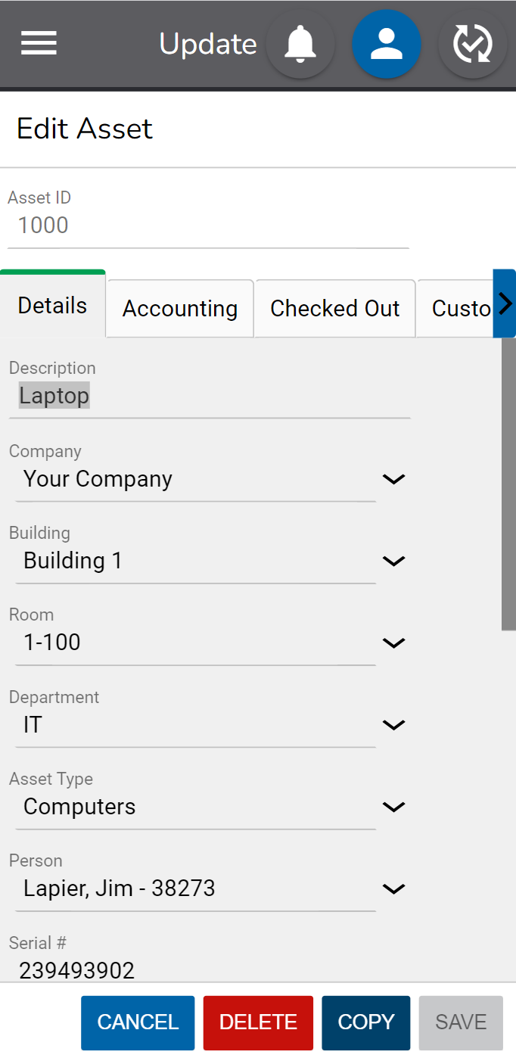

Accounting

Enter asset information under the Accounting tab including:

- PO # – This is the number of the purchase order on which the asset was purchased.
- Vendor – This is the vendor from whom the asset what purchased.
- Account – This is the financial reference account under which the asset was purchased.
- Acquisition Date – This is the date on which the asset was purchased.
- Cost – This is the price paid for the asset.
- Recovery Period in Year – This is the period during which an asset is depreciated.
- Scrap Value – This is the value an asset can be sold for once it is fully depreciated.
- Depreciated Value – This is a calculated value that represents the cost minus the scrap value minus the amount deprecated.
- Amount Depreciated – This is a calculated value that represents the amount of the asset’s value that has been depreciated. One month of the asset’s value is depreciated at the end of the first full month since the asset was acquired and subsequently at the end of each month after that until the asset is fully depreciated. The scrap value is subtracted from the cost prior to calculating depreciation.
- Warranty # – This the number associated with the asset’s warranty.
- Warranty Start Date – This the date that the asset’s warranty begins.
- Warranty End Date – This the date that the asset’s warranty ends.
- Lease # – This the number associated with the asset’s lease.
- Lease Start Date – This the date that the asset’s lease begins.
- Lease End Date – This the date that the asset’s lease ends.

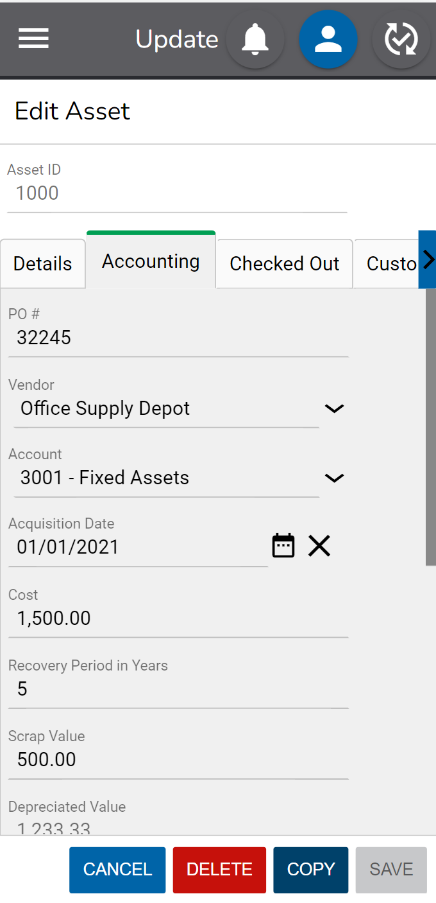

Checked Out

The Checked Out tab shows information about the asset if it is actively checked out. Check out information includes:

- Checked Out To – This is the Person the asset is checked out to.
- Checked Out Date – This is the data and time the asset was checked out.
- Reference # - This is the Reference # entered in the Check Out transaction.
- Project – This is the Project entered in the Check Out transaction.
- Due Date - This is the Due Date entered in the Check Out transaction.

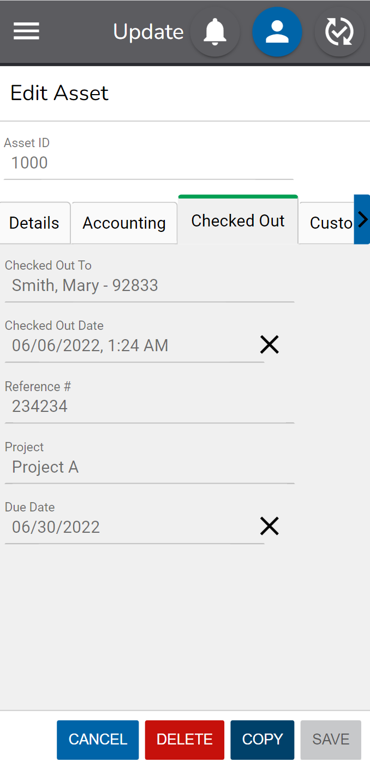

Custom

The Custom tab has additional free text, drop down, date and toggle fields if needed.

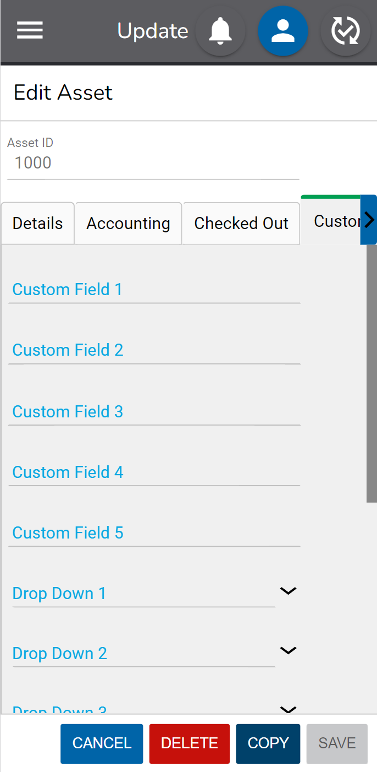

History

A full history of changes to an asset are displayed in the History tab.

Transactions

The Transactions tab allows the user to check items in and out to People. This person the asset is checked out to can be different than the person the asset is assigned to in the Details section of the asset record.

Check Out

To check an item out to a Person, go to the Check Out function under Transactions.

Select the Person the assets will be checked out to in the To field. If using a mobile barcode scanner, a Person ID barcode can also be scanned.

Next, enter the Asset ID of the first asset to be checked out and click the check mark to add it to the check out grid. If using a mobile barcode scanner or camera, scan the barcode of the first asset. If the mobile scanner is programmed to perform a carriage return after each scan, the asset will automatically be added to the grid. If using a mobile device with a camera, the camera can also scan a barcode by clicking on the icon.

Continue to scan any additional assets for this transaction.

Click the X next to the asset in the grid to remove it.

A total count of the assets in the transaction is displayed on the screen.

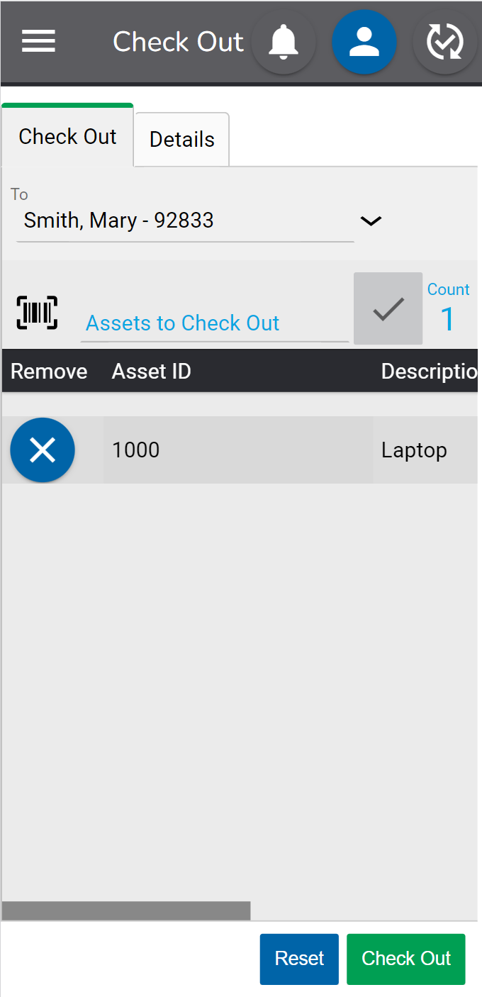

If desired, additional information about the transaction can be added in the Details tab. The detail fields include:

- Due Date – The date an asset is due to be checked back in.
- Reference Number – A number the user wants associated with the transaction.
- Company – The Company to which the asset should be moved during the transaction.
- Building - The Building to which the asset should be moved during the transaction.
- Room - The Room to which the asset should be moved during the transaction.
- Project – The Project the transaction is associated with.
- Notes – Any notes for the transaction.

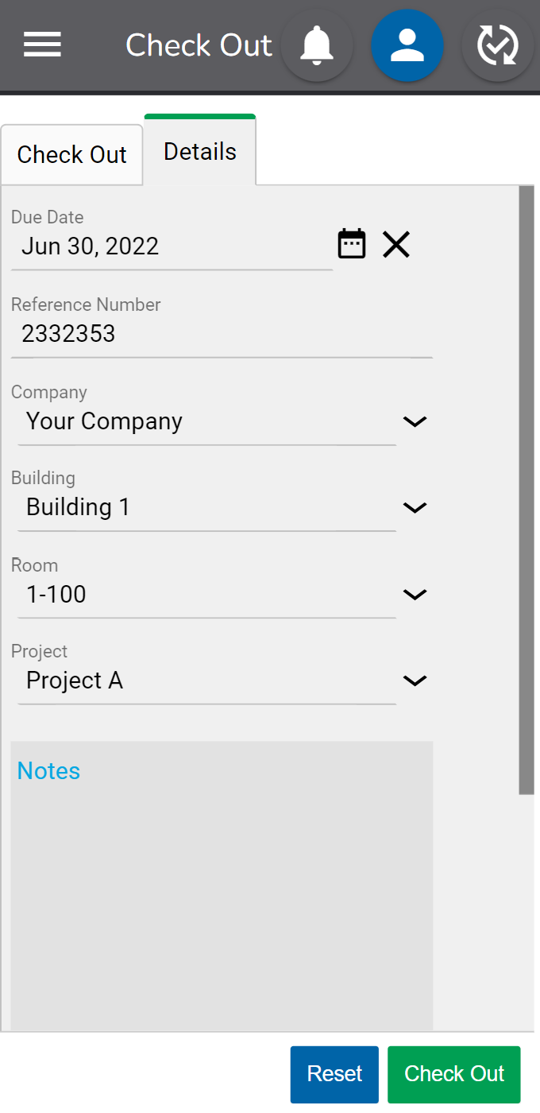

When done, click the Check Out button to complete the transaction. Information about the Person the asset is checked out to will display in the Checked Out section of the asset record.

If an asset is checked out, it can be checked out to another Person without it first having to be checked back in.

Check In

To check in an item, go to the Check In tab under Transactions.

Select the Company, Building and Room the assets will be checked in to. Once these values are selected the first time, they will be remembered in the same browser until changed.

Next, enter the Asset ID of the first asset to be checked in and click the check mark to add it to the check in grid. If using a mobile barcode scanner or camera, scan the barcode of the first asset. If the mobile scanner is programmed to perform a carriage return after each scan, the asset will automatically be added to the grid. If using a mobile device with a camera, the camera can also scan a barcode by clicking on the icon.

Continue to scan any additional assets for this transaction.

Click the X next to the asset in the grid to remove it.

A total count of the assets in the transaction is displayed on the screen.

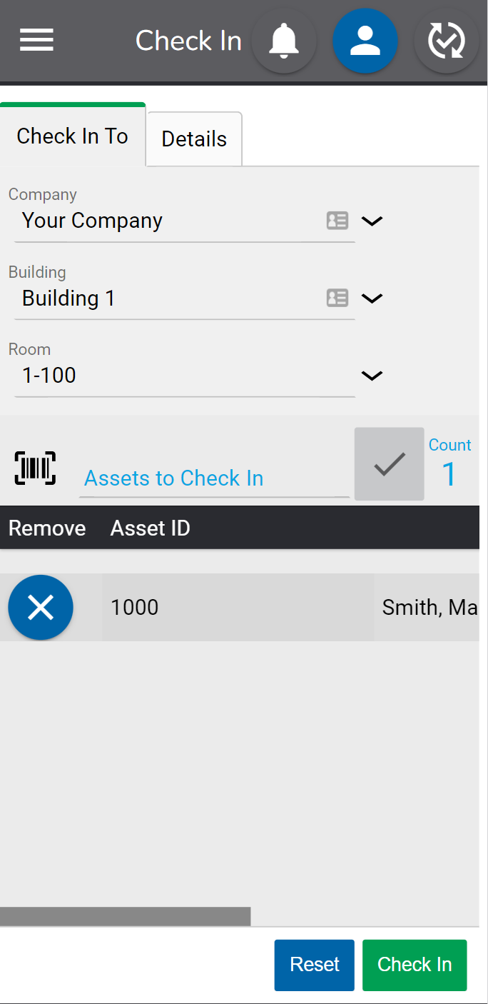

If an asset is entered or scanned into a location other than the one it was previously found in, a message will pop up indicating this. Continuing will assign the asset to the new location.

If desired, additional information about the transaction can be added in the Details tab. The detail fields include:

- Notes – Any notes for the transaction.

When done, click the Check In button to complete the transaction.

If an asset is checked in, it can be checked in again without having to be checked out.

Inventory

To use the Inventory functions on the mobile device, an inventory must first be opened in the full application on a PC or laptop under Manage inventory. Once an inventory is open, mobile users can use the Take function to record assets as found.

Take

When taking a physical inventory, users will go from room to room in a building and scan or enter each asset found. This is much easier and more efficient using a purpose-built mobile device with a built-in barcode scanner.

RedBeam recommends using the mobile Take function for this process. However, users can take an inventory on a PC or laptop by navigating to the Take tab.

A list of all assets will display in the grid until location values are selected.

Select the Company, Building and Room where the assets to be scanned or entered are found. If only one Company exists, only the Building and Room fields will display.

Once the Room is selected, only the assets in that Room will be displayed with Unfound assets defaulted to the top of the list. This gives the user an idea of the assets they should look for during the inventory.

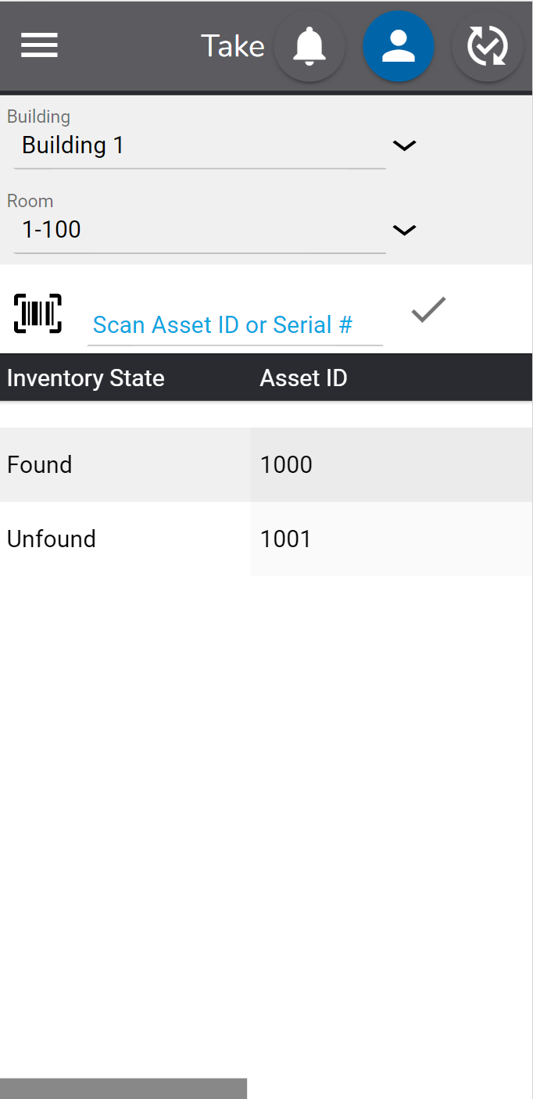

A user can type or use the mobile barcode scanner to scan the Asset ID or Serial #. If using a mobile device with a camera, the camera can also scan a barcode by clicking on the icon. Please note that the Asset ID and Serial # are case sensitive.

Once entered or scanned, the asset details will display. A user can make any other changes needed to the Asset (i.e. assignment to a new Person or Department) and then click Save to mark the asset as Found.

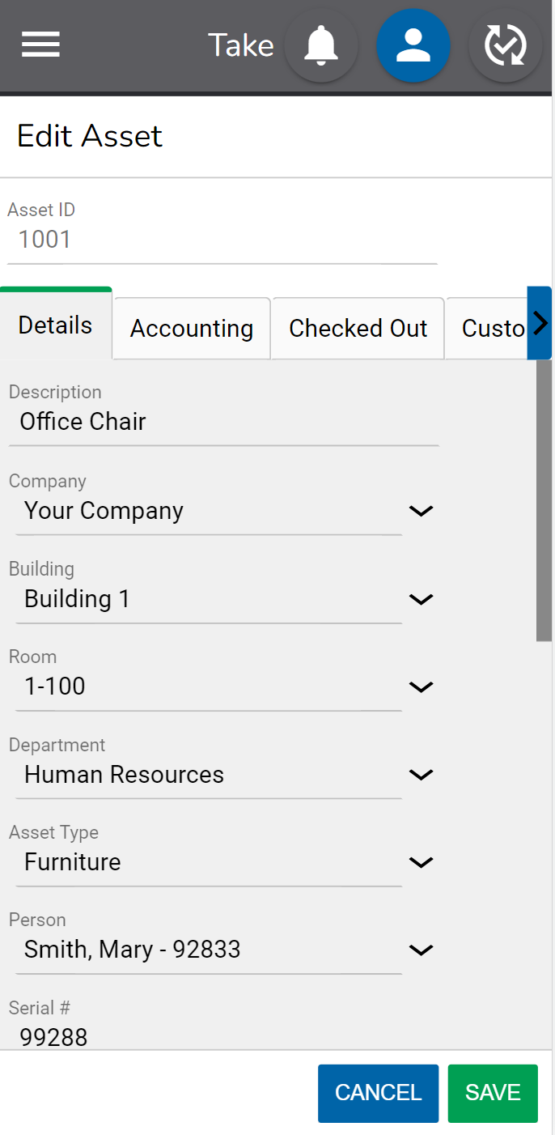

They can then scan the next asset in the room and repeat the process until all assets found in that room are updated.

After moving to the next room, the user changes the room value to the new location and then scans the assets in the next room and so on.

If the asset was found in a different room than the system expected, a message will notify the user and give them a choice to update the Room value to the new room or to keep the previous Room value.

If the asset is new to the system, a message will notify the user and ask if they want to add the asset. They can enter the new Asset ID and other relevant data and click Save to both create the asset and mark it as found.

For many users implementing an asset tracking system for the first time, this is a good way to get initial asset data into the system. Often, new users will order pre-printed, sequential barcode labels, peel off the first label, tag the first asset, scan the barcode, and enter the asset information. This process is then repeated until all assets are tagged and entered in the system.

Mobile RFID Functions

In order to use the mobile RFID functions, the RedBeam RFID mobile application must first be installed on a compatible mobile device. This application installation is different from how a user would access RedBeam as stated in the previous sections of this user manual.

To access RedBeam with the mobile RFID functions, a user will need the latest version of the RedBeam native application which they should receive as a QR code from the customer support team. The QR code is linked to the specific download needed to install the application.

Next, RFID scanning must be enabled on the device in correspondence with the application. To ensure this, navigate to the “Settings” on the device, and click on “Key Programmer.” Make sure that the “rear button” option is set to “Button_16.”

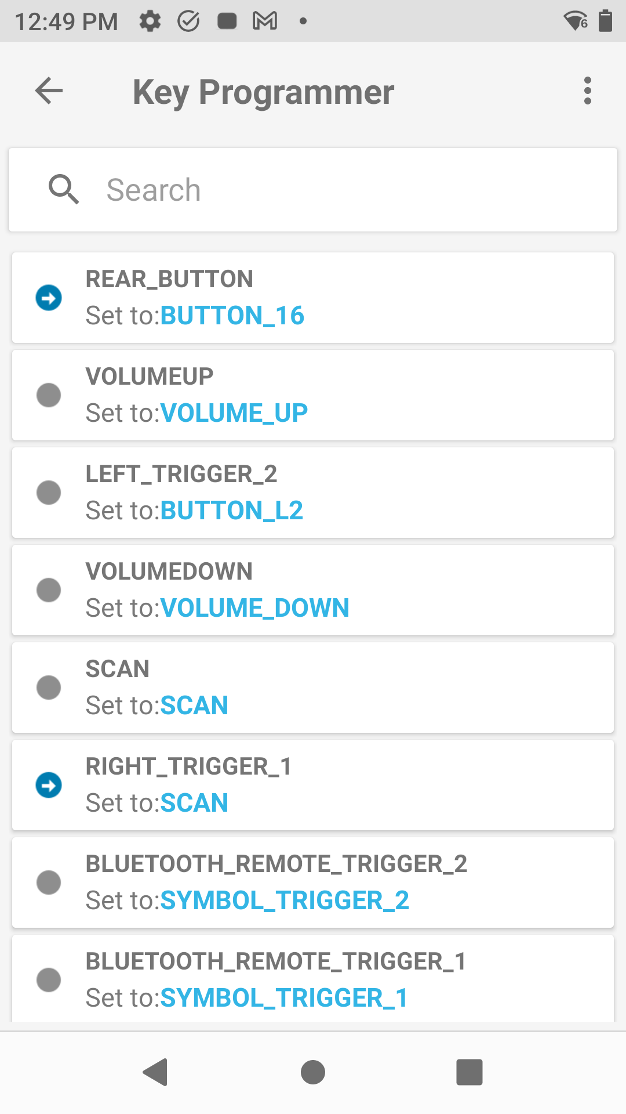

For users in the United States, RFID frequency should be configured correctly. For those in other countries, make sure that the RedBeam application is closed and navigate to an application on the device called 123RFID. Go to Settings, Regulatory and then select your region so that the device knows which frequencies it can transmit on. After configuring this appropriately, ensure that you close the 123RFID application as only one application can communicate with the RFID engine at a time.

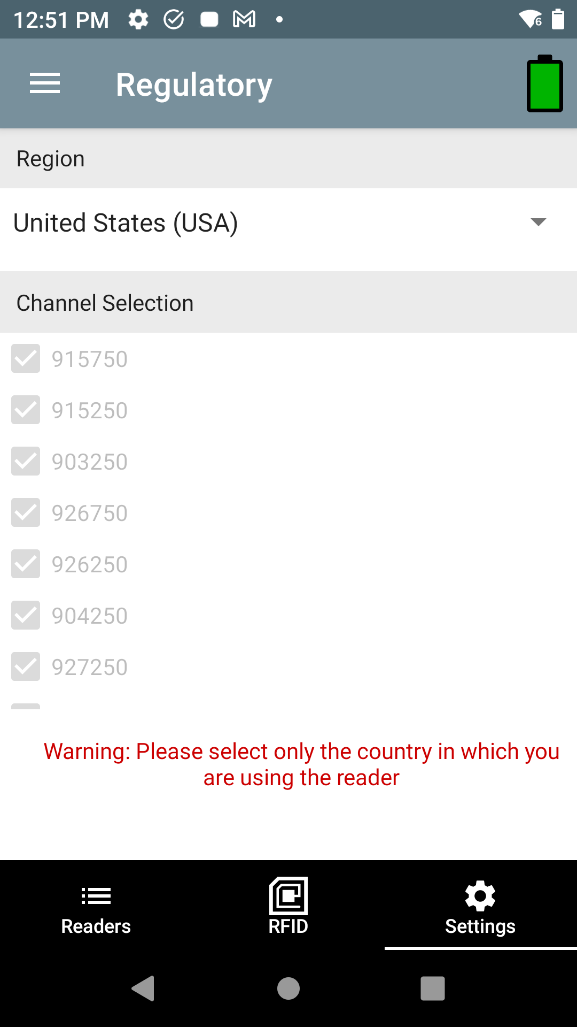

Open the RedBeam application and see the Login screen where users can enter their login credentials.

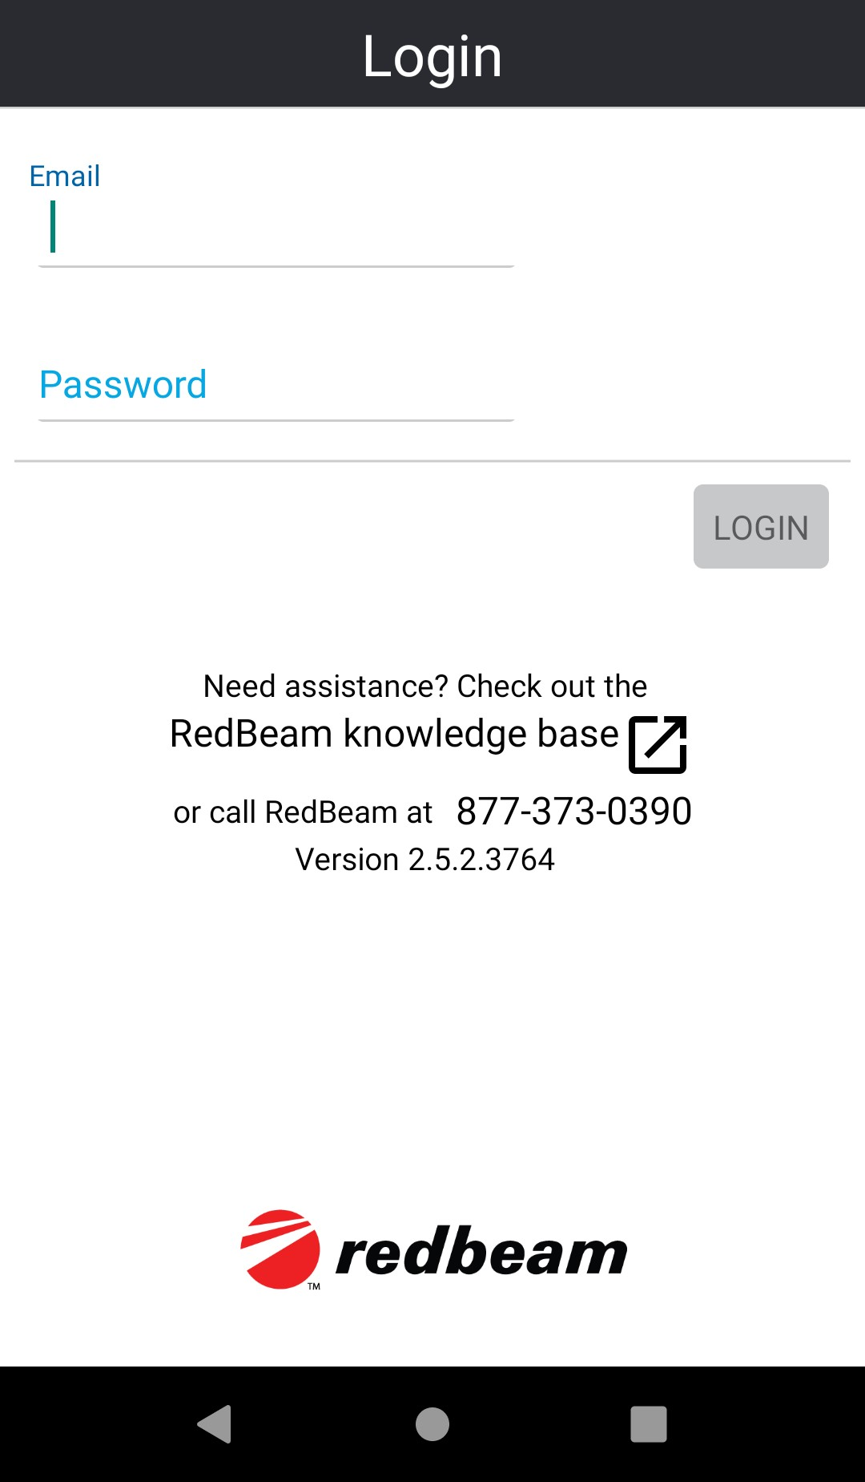

The mobile Menu displays the mobile functions including Update, Inventory, and Assign RFID.
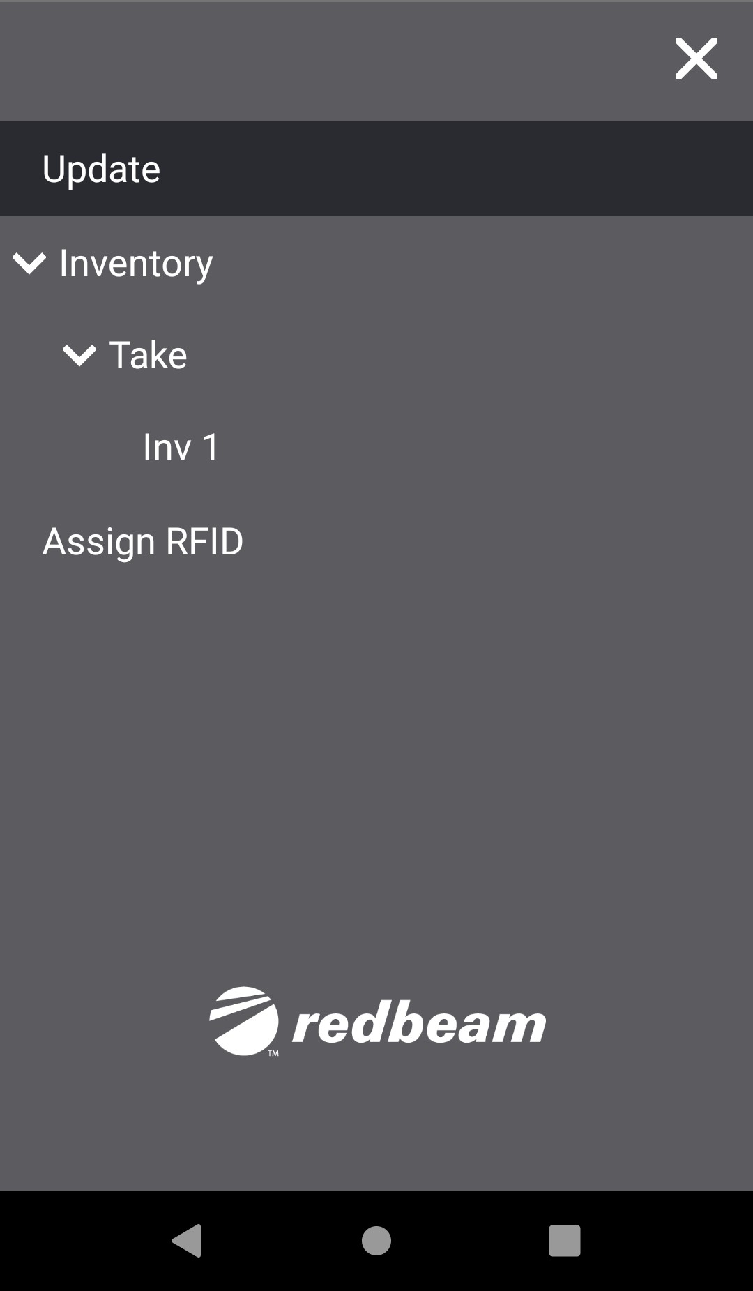

Prior to using RedBeam to take audit inventory of assets, users will need to log assets into the system.

For a barcoding solution, users can scan barcoded assets into the system through the Update page, upload them in the desktop view, or create them manually in the desktop view.

For the RedBeam RFID configuration, users will need to log assets by their Asset ID as well as their RFID Tag ID. The Asset ID is the unique number associated with a barcode. The Tag ID is the serial number within the RFID tag that was created at the time that the tag was produced by its manufacturer. This Tag ID is inherently unique amongst each RFID tag.

Whereas some systems use a process called encoding in order to assign RFID tags to assets, RedBeam utilizes the pre-configured Tag ID that is already built into each RFID tag. In order to tie RFID tags to assets, RedBeam allows users to “Assign” Tag IDs to Asset IDs.

If a user’s assets are already tagged with both barcodes and RFID tags prior to using RedBeam, contact the RedBeam team to run a Tag ID migration.
If a user is tagging assets for the first time, navigate to the Assign RFID tab. This will be the first step in setting up your system to prepare for using RFID technology to take your audit inventory and make changes to your assets.

Assign RFID

The Assign RFID function is used to assign an RFID tag to an asset with its Asset ID.

Adjust the strength of the power slider to minimize or maximize the read of the RFID scan depending on the distance between the device and the tag. To assign one RFID tag to one Asset ID, a user will need the power slider set relatively low, and will need to create distance between the other RFID tags and the one intended to be assigned.

The next step in assigning a tag to an asset is to type or barcode scan the Asset ID of the asset in the Asset ID field. To scan a barcode, squeeze either the left and/or right buttons on the sides of the mobile computer. After entering the Asset ID, click 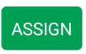.

If successful, the user will be presented with a ‘Tag Association Successful!’ message. Now, the asset is uniquely identified with an Asset ID and the RFID Tag which is tied to that Asset ID.

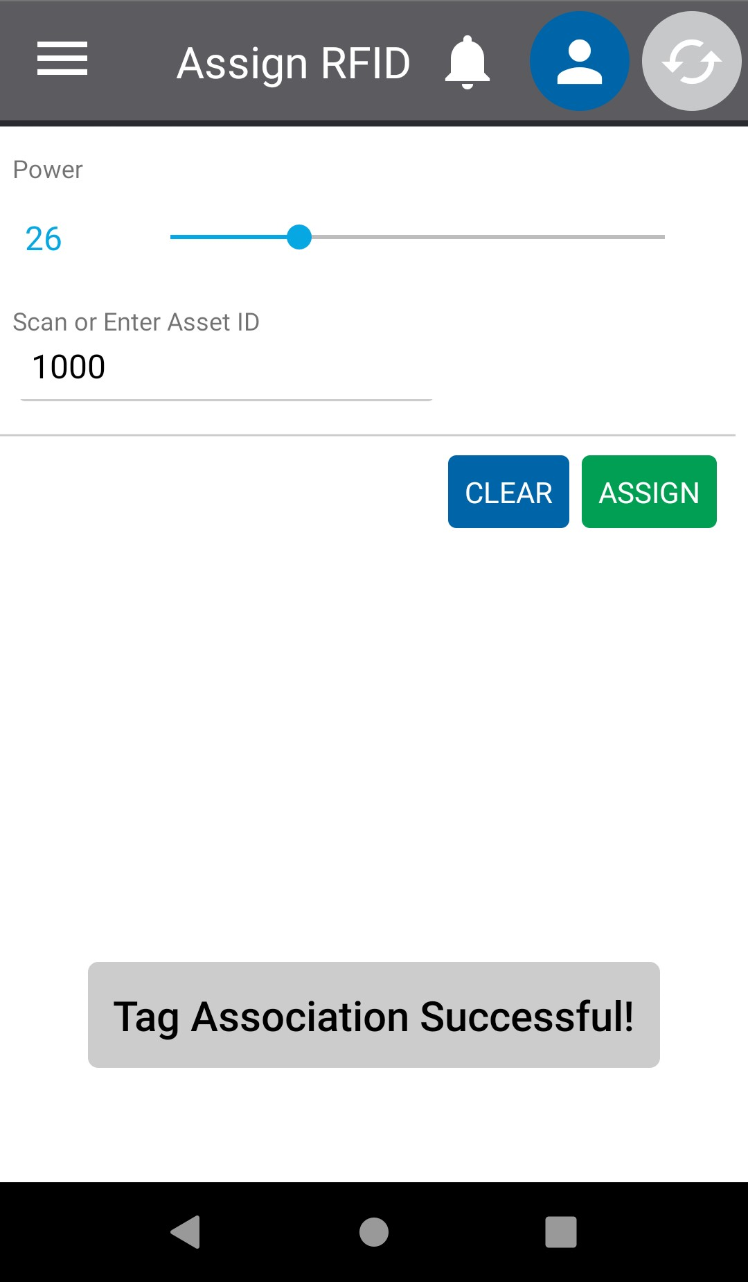

Once all of the assets are associated with a unique RFID tag, a user can begin to use the RFID technology to take inventory or detect assets in order to create them in the system, edit them, view them or delete them.

Update

To create, edit, view or delete assets, navigate to the Update page.

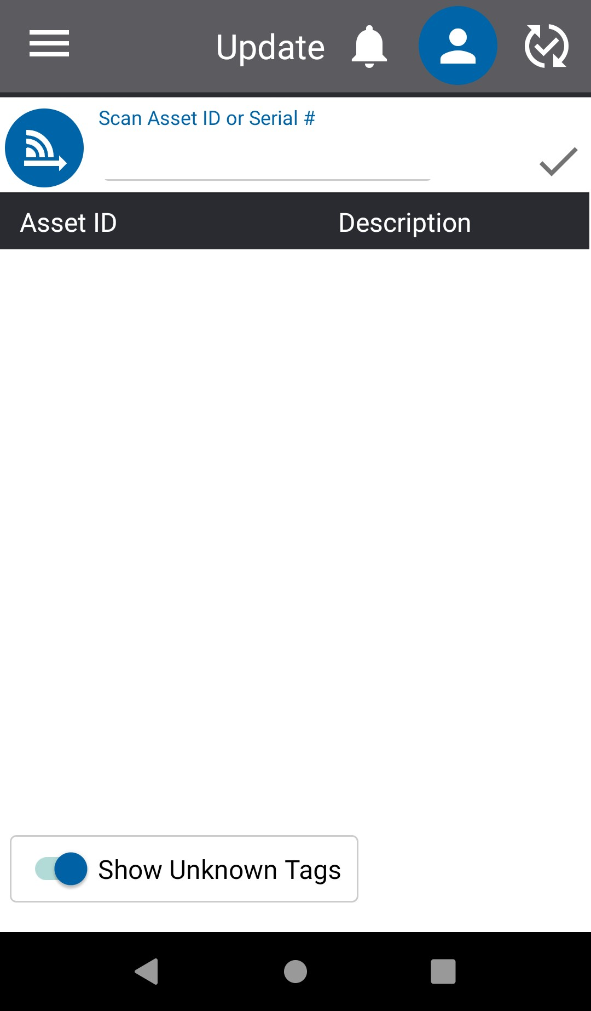

To detect multiple assets at once using RFID, users should first adjust the RFID power slider by clicking on the blue icon with the connection and arrow symbol. Adjust the strength of the power slider to minimize or maximize the read of the RFID scan depending on the distance between the device and the tag(s).

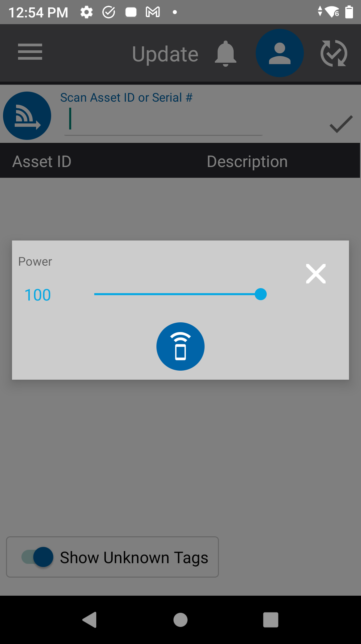

A user can read only assigned tags or allow the RFID reader to show unassigned tags by toggling the “Show Unknown Tags” button at the bottom of the screen.

When a user is ready to activate the RFID scan, press the trigger button on the handle of the RFID sled. Adjust the power slider as necessary in order to scan the desired tags.

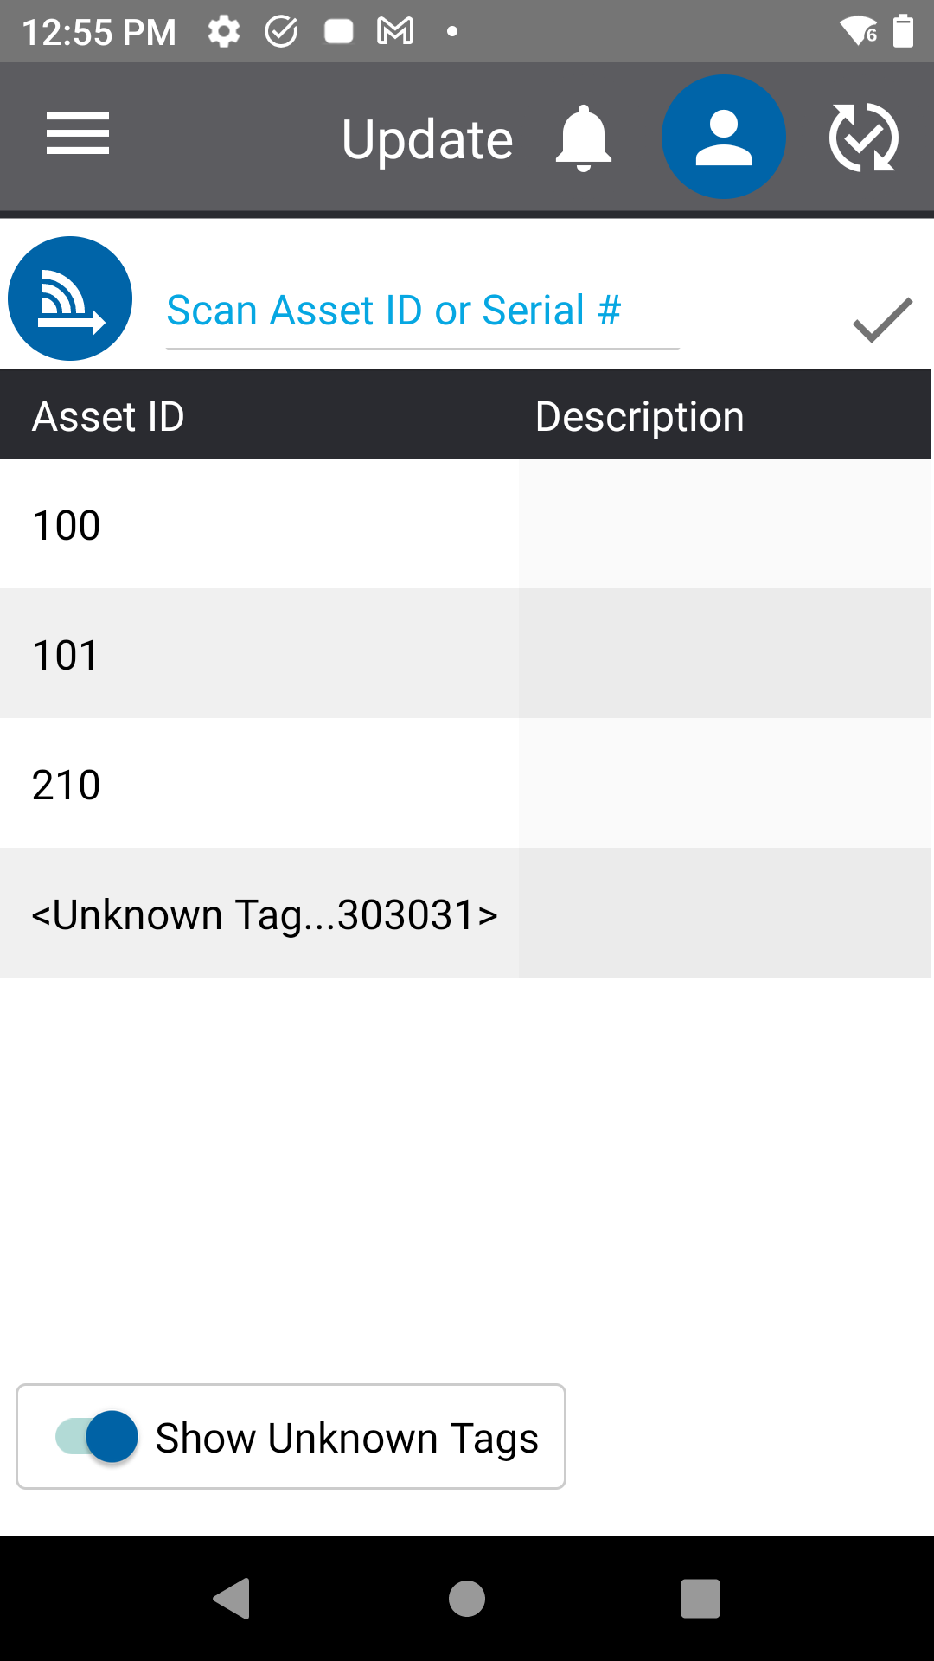

The distance at which the RFID scan can be read is dependent on the types of tags, the environment, and how the assets are stored in correspondence to tag position.

RFID tags cannot be read if blocked by metal or water. People, as we are mostly made of water, can hinder the read if blocking the tags.

For advice on tag types and asset storage in accordance with how a user desires tags to be read, contact the RedBeam team with pictures of the environment and the assets.

Once the trigger is pressed, the Asset IDs and/or Unknown Tags will appear in the grid. Click on an asset to make changes to its metadata and click the Save button once done, make a copy of the asset by clicking the Copy button, or delete the asset by clicking the Delete button.

A warning message will display prior to deletion.

To create an asset, scan or enter a new Asset ID to pull up the Asset Details, Accounting and Custom tabs. Make all desired changes.

If the new asset or an existing asset is not associated with an RFID tag yet, when a user views the Asset Details, Accounting and Custom tabs, the user will see a toggle button called Assign Tag beside the Cancel and Save buttons at the bottom of the screen.

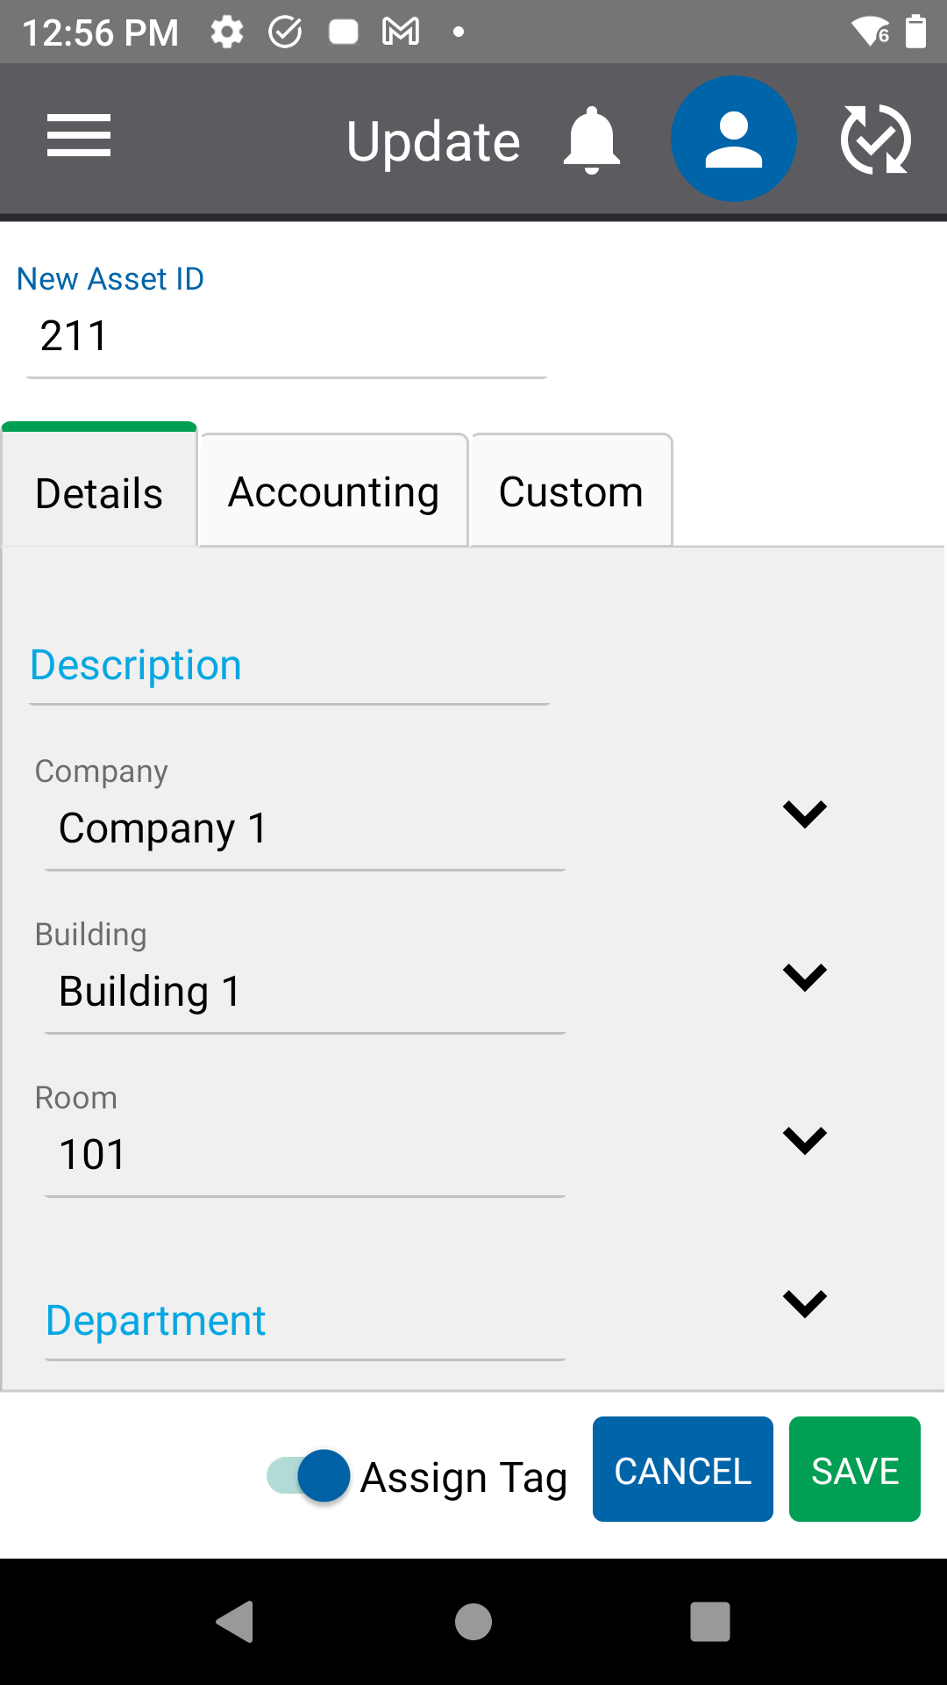

To assign this asset to an RFID tag from this screen, have the desired RFID tag in the vicinity of the reader and make sure that the Assign Tag toggle is set to the right. The user should see that when activated, this toggle will appear light blue and the words “Assign Tag” will appear in black. Click Save. The RFID power slider will appear. Adjust as necessary and press the trigger on the RFID sled or click the blue icon below the power slider to activate the read.

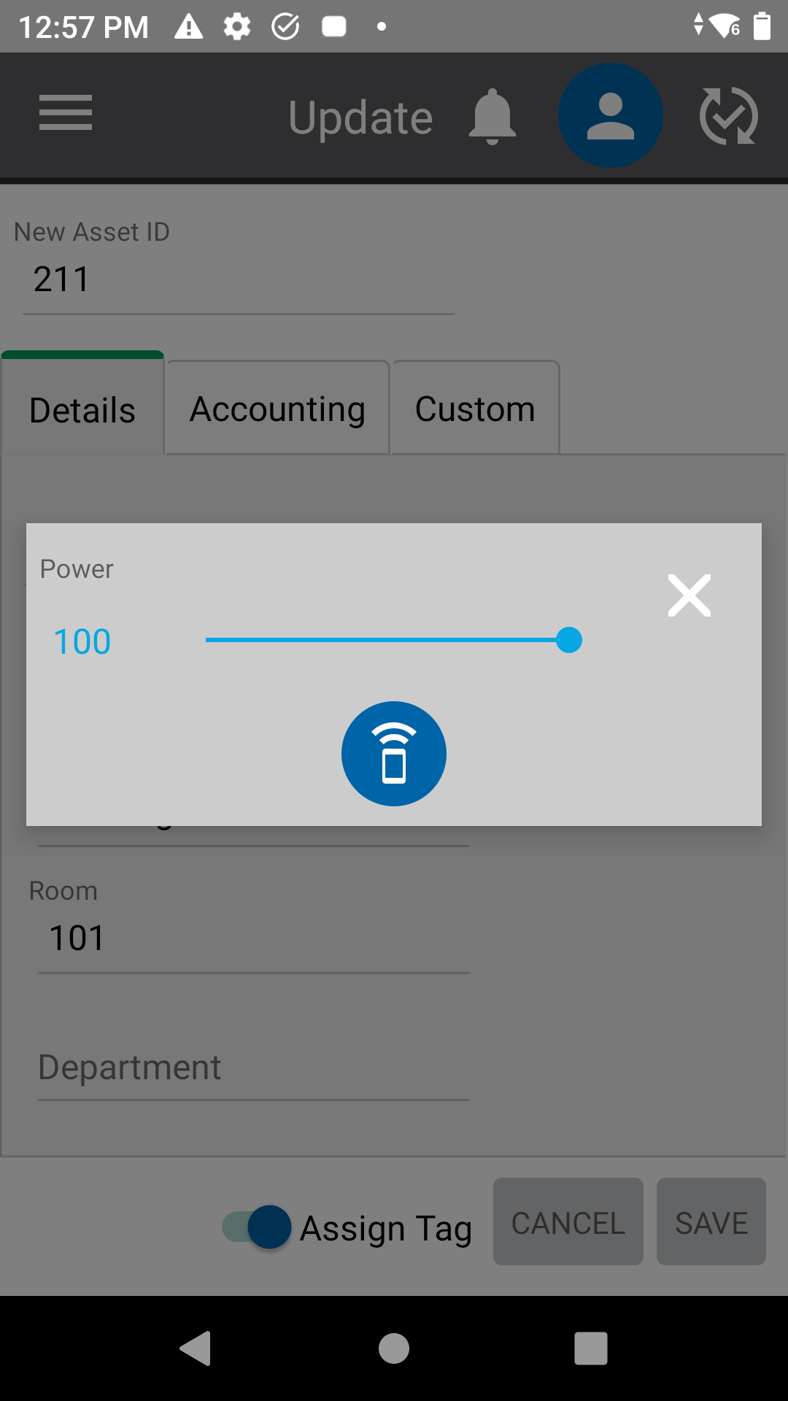

If successfully associated, the user will see a message saying “Assigning Tag ID.”

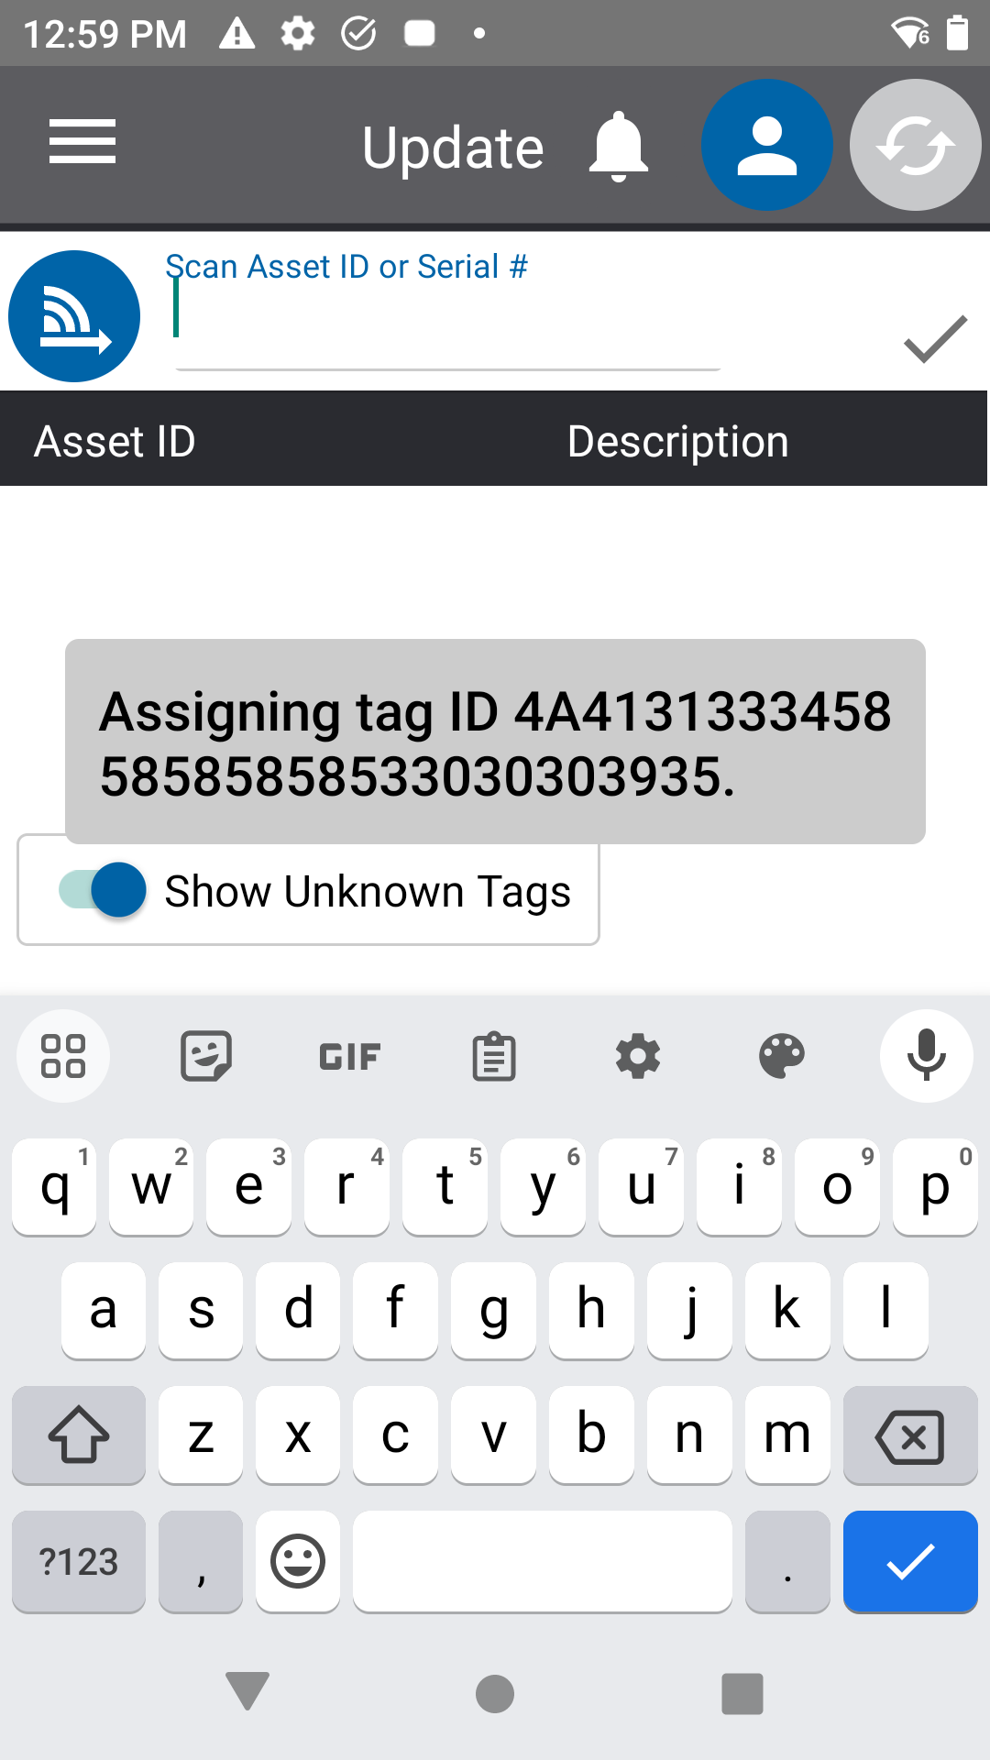

Details

Enter asset information under the Details tab including:

- Asset ID – This is the number used to uniquely identify the asset. For barcode scanning to work properly, this complete number (including any leading zeros) should be encoded in printed barcodes used to tag the assets.
- Description – This is a description of the asset.
- Company – This is the company to which the asset is assigned.
- Building – This is the building in which the asset is located.
- Room – This is the room in which the asset is located. Selecting a room is required when taking an inventory.
- Department – This is the department to which the asset belongs.
- Asset Type – This is the asset category that generally describes the asset.
- Person – This is the person to whom the asset is assigned.
- Serial # – This is the serial number of the asset. If an asset barcode is damaged or not visible, the user can scan or enter the serial number while updating or taking an inventory of the asset.
- Status – This is the status of the asset.
- Manufacturer – This is the manufacturer of the asset.
- Model – This is the model number of the asset.
- Condition – This is the condition of the asset.
- Notes – This is a free text field for additional information about the asset.
- Active – This is a Yes/No field. Assets marked as inactive, will not show in an Inventory or in Check In or Check Out transactions.

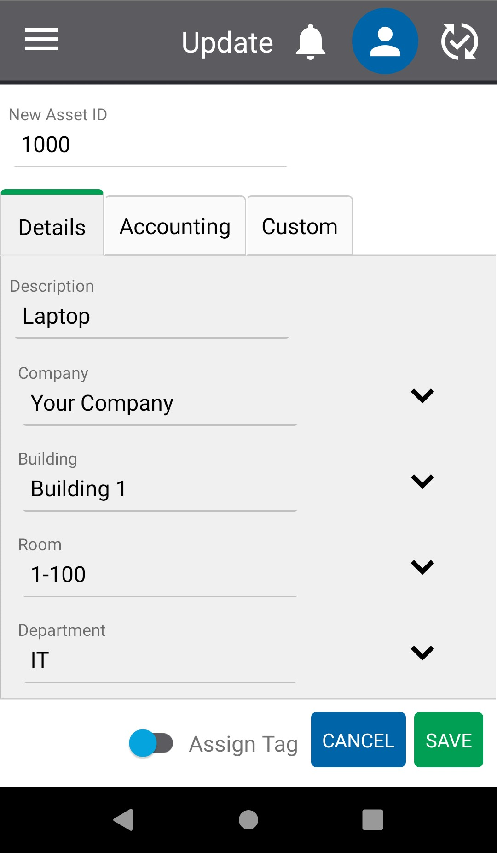

Accounting

Enter asset information under the Accounting tab including:

- PO # – This is the number of the purchase order on which the asset was purchased.
- Vendor – This is the vendor from whom the asset what purchased.
- Account – This is the financial reference account under which the asset was purchased.
- Acquisition Date – This is the date on which the asset was purchased.
- Cost – This is the price paid for the asset.
- Recovery Period in Year – This is the period during which an asset is depreciated.
- Scrap Value – This is the value an asset can be sold for once it is fully depreciated.
- Depreciated Value – This is a calculated value that represents the cost minus the scrap value minus the amount deprecated.
- Amount Depreciated – This is a calculated value that represents the amount of the asset’s value that has been depreciated. One month of the asset’s value is depreciated at the end of the first full month since the asset was acquired and subsequently at the end of each month after that until the asset is fully depreciated. The scrap value is subtracted from the cost prior to calculating depreciation.
- Warranty # – This the number associated with the asset’s warranty.
- Warranty Start Date – This the date that the asset’s warranty begins.
- Warranty End Date – This the date that the asset’s warranty ends.
- Lease # – This the number associated with the asset’s lease.
- Lease Start Date – This the date that the asset’s lease begins.
- Lease End Date – This the date that the asset’s lease ends.

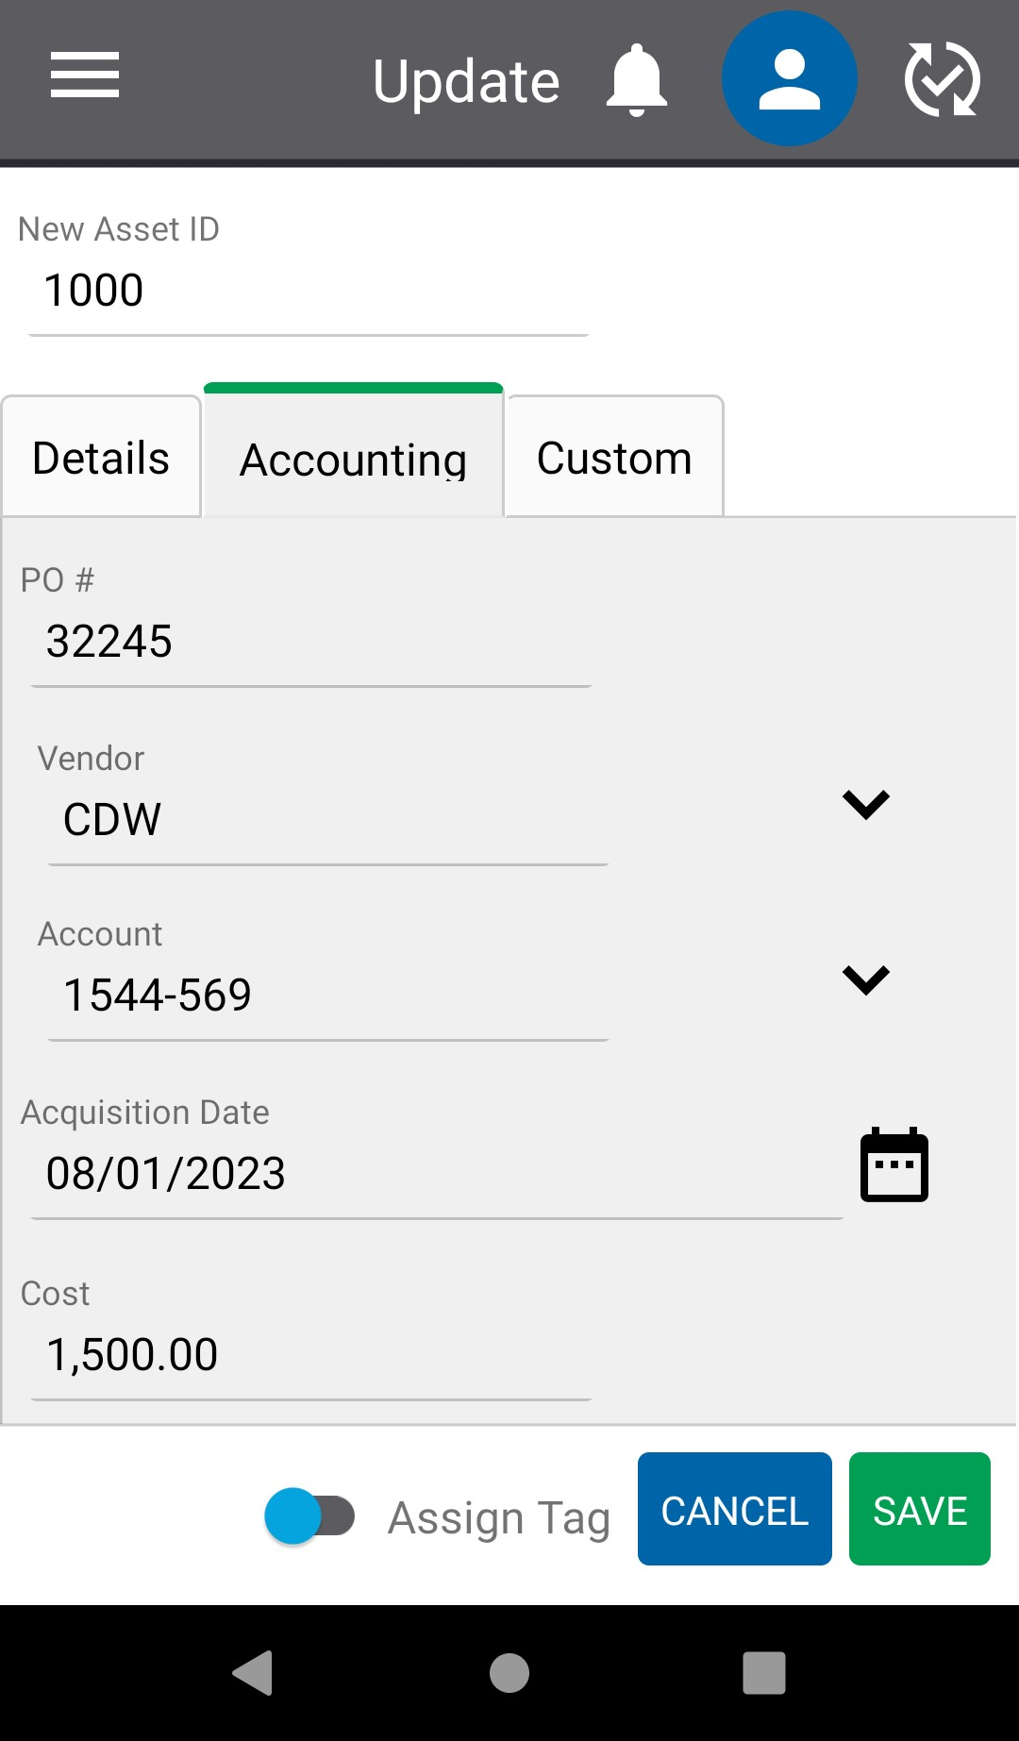

Checked Out

The Checked Out tab is only available through viewing an existing asset and shows information if the asset is actively checked out. Check out information includes:

- Checked Out To – This is the Person the asset is checked out to.
- Checked Out Date – This is the data and time the asset was checked out.
- Reference # - This is the Reference # entered in the Check Out transaction.
- Project – This is the Project entered in the Check Out transaction.
- Due Date - This is the Due Date entered in the Check Out transaction.

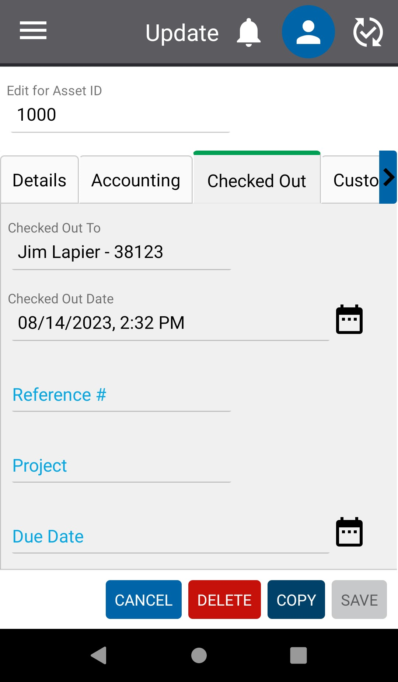

Custom

The Custom tab has additional free text, drop down, date and toggle fields if needed.

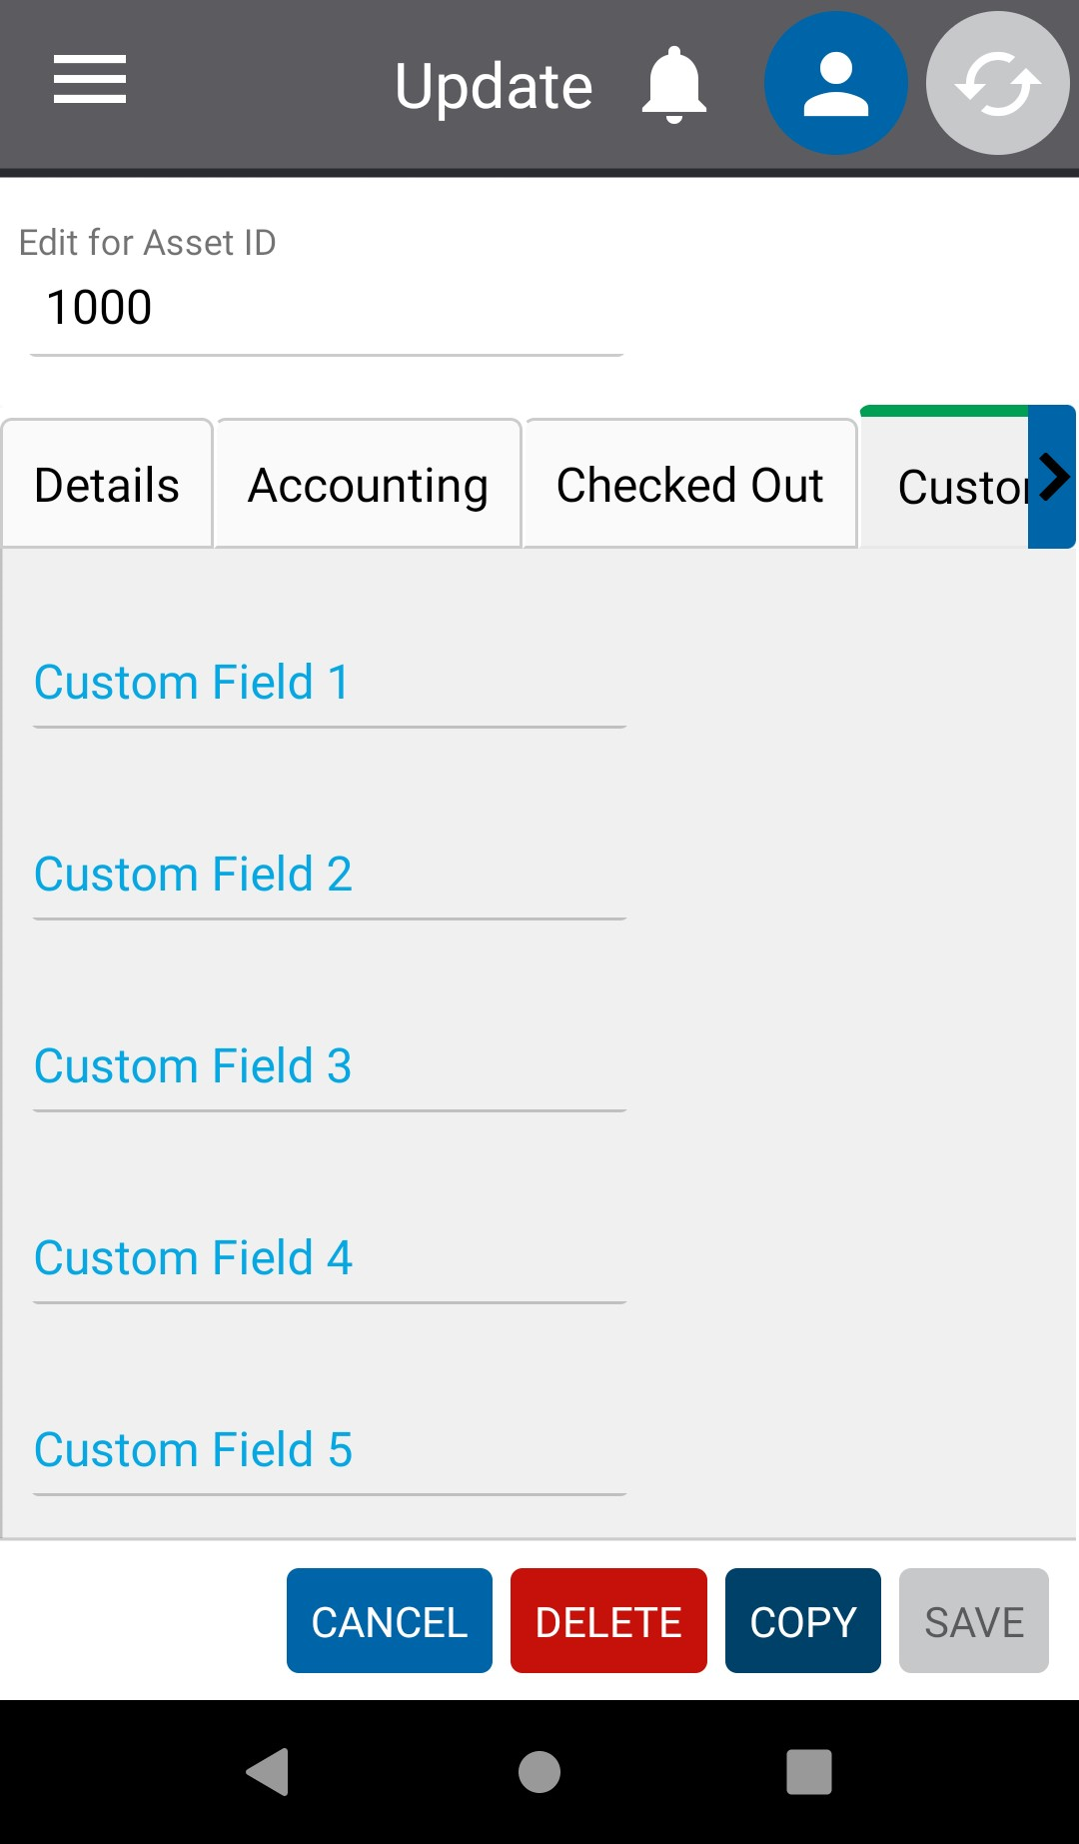

History

A full history of changes to an asset are displayed in the History tab. The History tab is only available through viewing an existing asset.

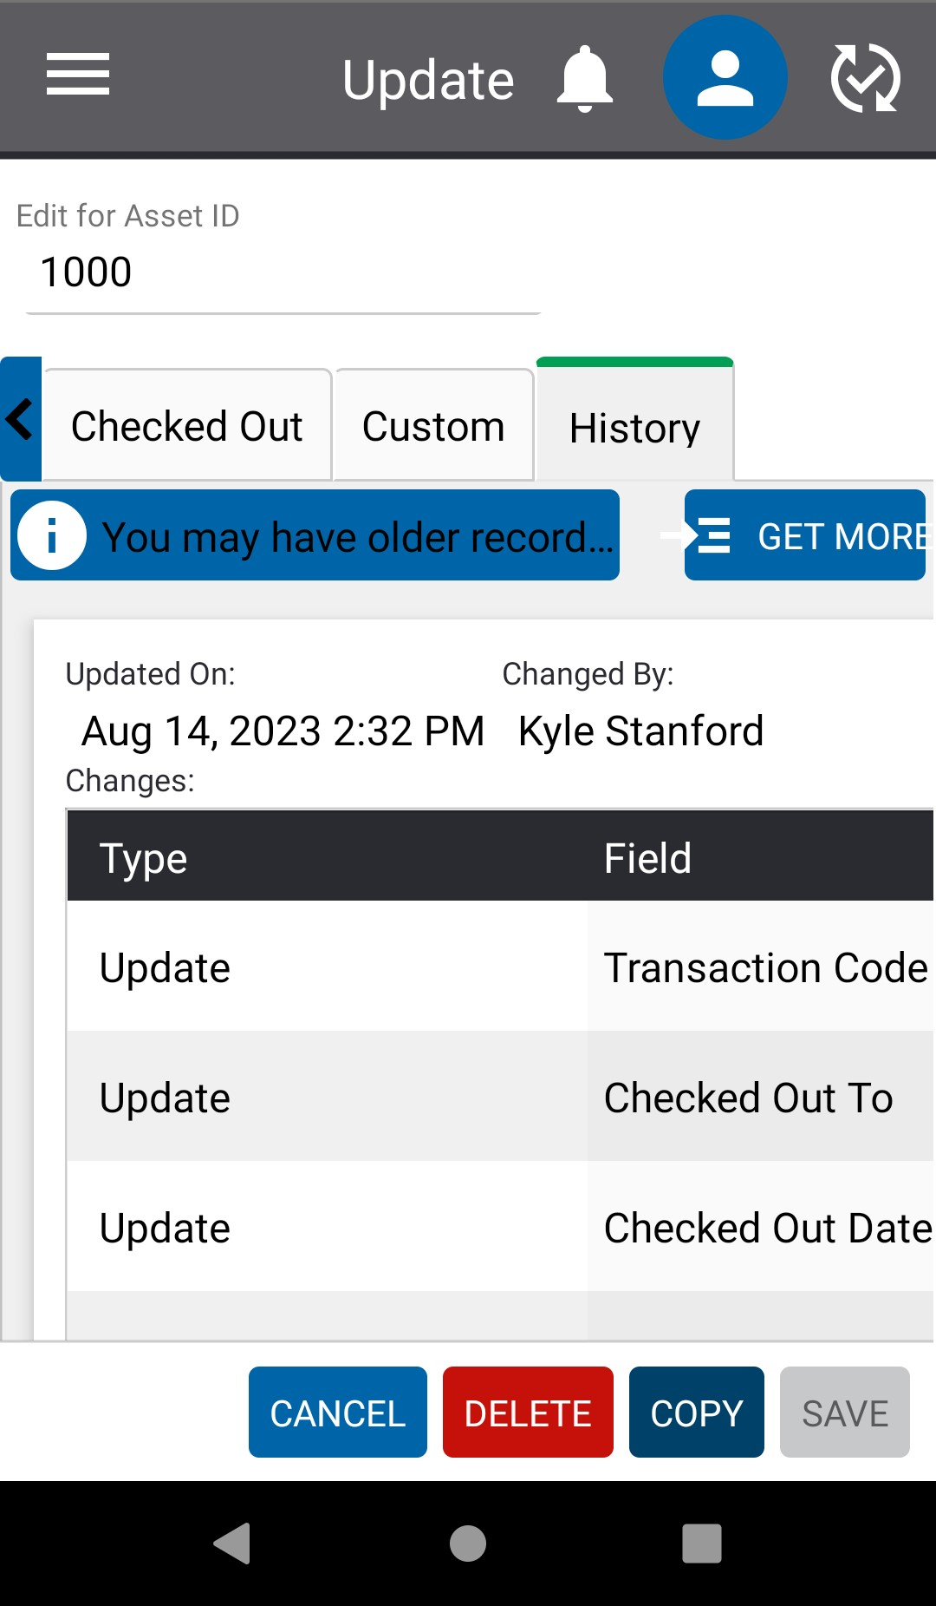

Inventory

To use the Inventory functions on the mobile device, an inventory must first be opened by an Admin User in the full application on a PC or laptop under Manage inventory. Once an inventory is open, mobile users can use the Take function to record assets as found.

Take
When taking a physical inventory, users will go from room to room in a building, find assets, and use RedBeam to make them as found.

Once this process is complete, users can view and export Reports by logging into RedBeam on a PC/Laptop and see which assets were found vs unfound.

To take audit inventory with RFID technology, first make sure that all of the assets are assigned to an RFID tag. See the Assign RFID section of this user guide for more information.

On the device, open the Inventory tab then the Take tab. Select the name of the inventory that the user is working in.

A list of all assets will display in the grid until location values are selected.

Select the Company, Building and Room where the user is located. If only one Company exists, only the Building and Room fields will display.

Note that the dropdown options listed are directly tied to the locations designated for the specifically named inventory a user is working in. These values are determined by the Admin User who initially created/opened the audit inventory that the user is working in.

Once the Room is selected, only the assets in that Room will be displayed on the asset grid, with Unfound assets defaulted to the top of the list.

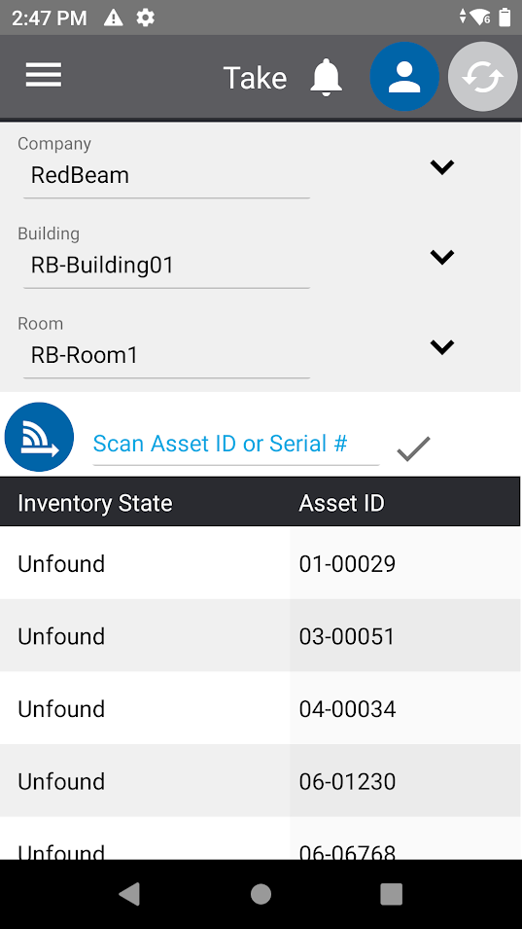

Next, press the trigger on the RFID sled or click the blue icon with the connection and arrow symbols. The user will be prompted with the RFID power slider. Adjust as necessary, then pull the trigger or click on the blue icon while aiming the device at the tagged assets.

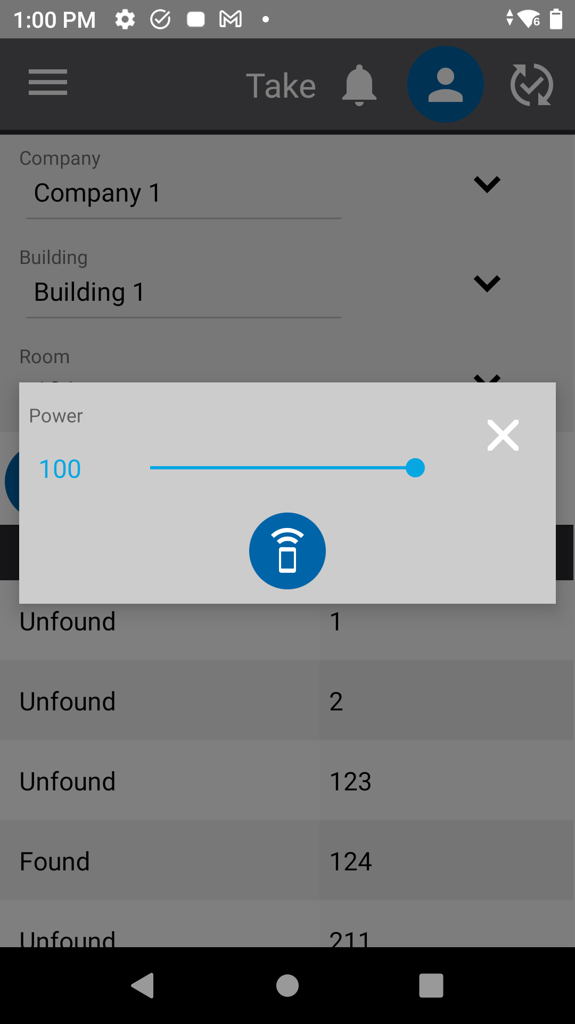

The user will be directed to a page showing the assigned Asset IDs and any Unassigned RFID tags that were detected by the RFID scan. The user can toggle the “Show Unknown Tags” button at the bottom of the screen to turn on or off the visibility of the Unassigned Tags.

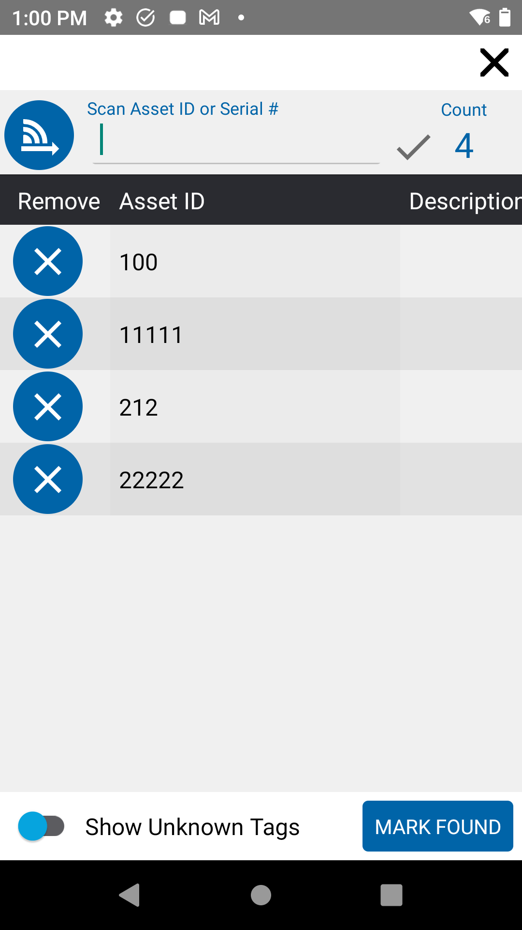

Once the user clicks MARK FOUND from this screen, all assets and tags shown in the screen will be marked as found for the audit-inventory take-session.

To only mark some of the shown items as found, click the X button beside the items that should not be marked as found prior to clicking the MARK FOUND button. Also, a user can click on the asset in the grid prior to clicking the MARK FOUND button in order to make changes to the Details, Accounting or Custom Tab of that asset.

To take audit inventory without RFID Technology, a user can type or use the mobile barcode scanner (click the buttons on either side of the mobile computer) to scan the Asset ID or Serial # of each asset one-by-one. Please note that the Asset ID and Serial # are case sensitive.

Once entered or scanned, the asset details will display. A user can make any other changes needed to the asset and then click Save to mark the asset as Found.

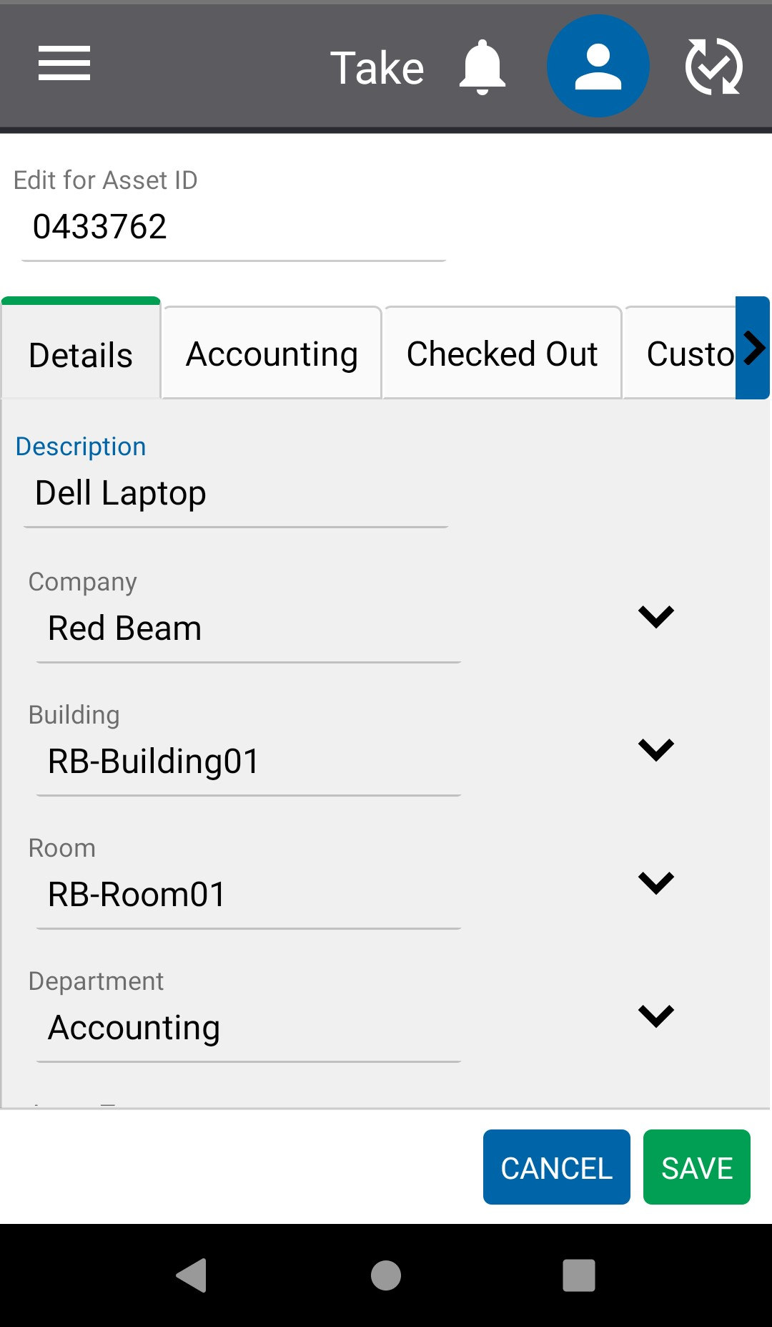

They can then scan the next asset in the room and repeat the process until all assets found in that room are updated.

After moving to the next room, the user changes the room value to the new location and then scans the assets in the next room and so on.

If the asset was found in a different room than the system expected, a message will notify the user and give them a choice to update the Room value to the new room or to keep the previous Room value.

If the asset is new to the system, a message will notify the user and ask if they want to add the asset. They can enter the new Asset ID and other relevant data and click Save to both create the asset and mark it as found. Assign the new asset to an RFID Tag the same way that a user would do so from the Update page.

